India and United Nations- a 75-Year-Old Alliance
This photo album will cover India’s engagement with the United Nations over the years as an active member of its mission and objective. India’s deepening engagement with the United Nations is based on its steadfast commitment to multilateralism and dialogue as the key for achieving shared goals and addressing common challenges faced by the global community.
India was among the select members of the United Nations that signed the Declaration by United Nations at Washington on 1 January 1942. India also participated in the historic UN Conference of International Organization at San Francisco from 25 April to 26 June 1945. As a founding member of the United Nations, India strongly supports the purposes and principles of the UN and has made significant contributions to implementing the goals of the Charter, and the evolution of the UN’s specialized programmes and agencies.
India strongly believes that the United Nations and the norms of international relations that it has fostered remain the most efficacious means for tackling today's global challenges. Independent India viewed its membership at the United Nations as an important guarantee for maintaining international peace and security.
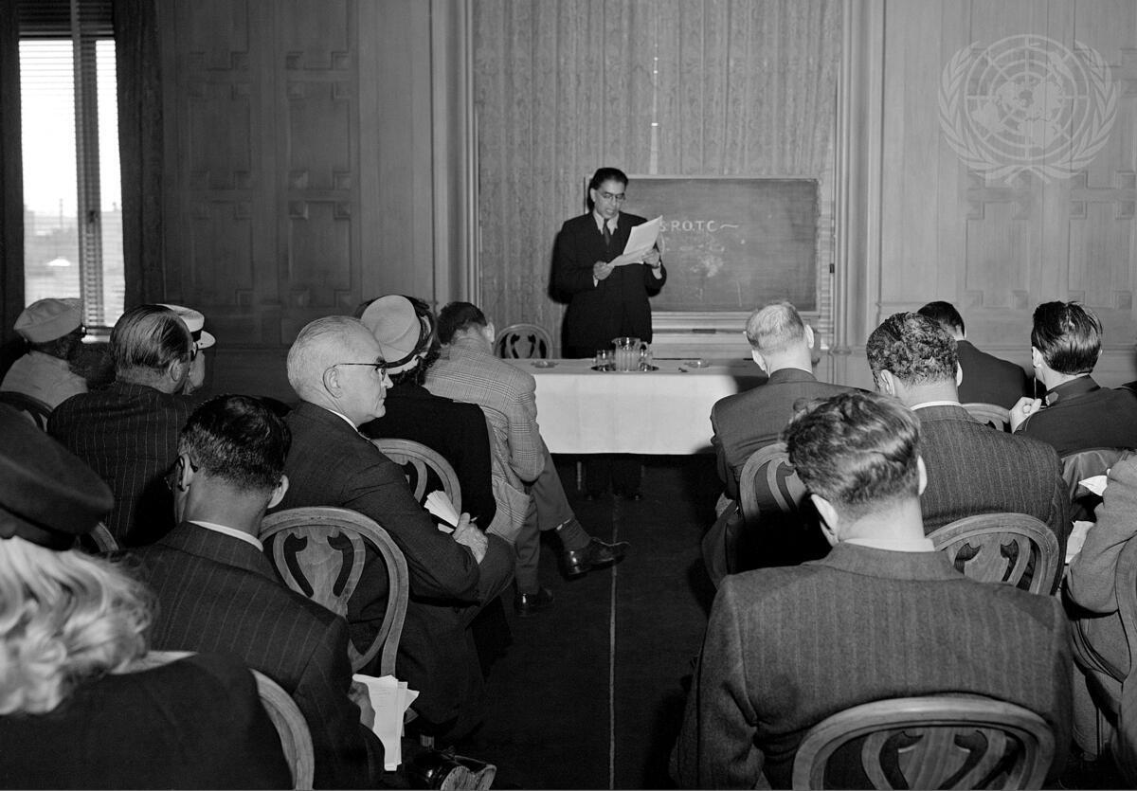

Headline: The San Francisco Conference, 25 April - 26 June 1945
Caption Description: Delegates of fifty nations met in San Francisco between April 25 and June 26, 1945. Working on the Dumbarton Oaks proposals, the Yalta Agreement, and amendments proposed by various Governments, the Conference agreed upon the Charter of the United Nations and the Statute of the New International Court of Justice. The Charter was passed unanimously and signed by all the representatives. It came into force on October 24, 1945, when China, France, the USSR, the United Kingdom, the United States and a majority of the other signatories had filed their instruments of ratification. Sir Firoz Khan Noon, Defense Member of the Governor General's Executive Council for India, addressing newsmen at the India Press Conference. [No exact date]
Production Date: 4/25/1945 10:36:56 AM
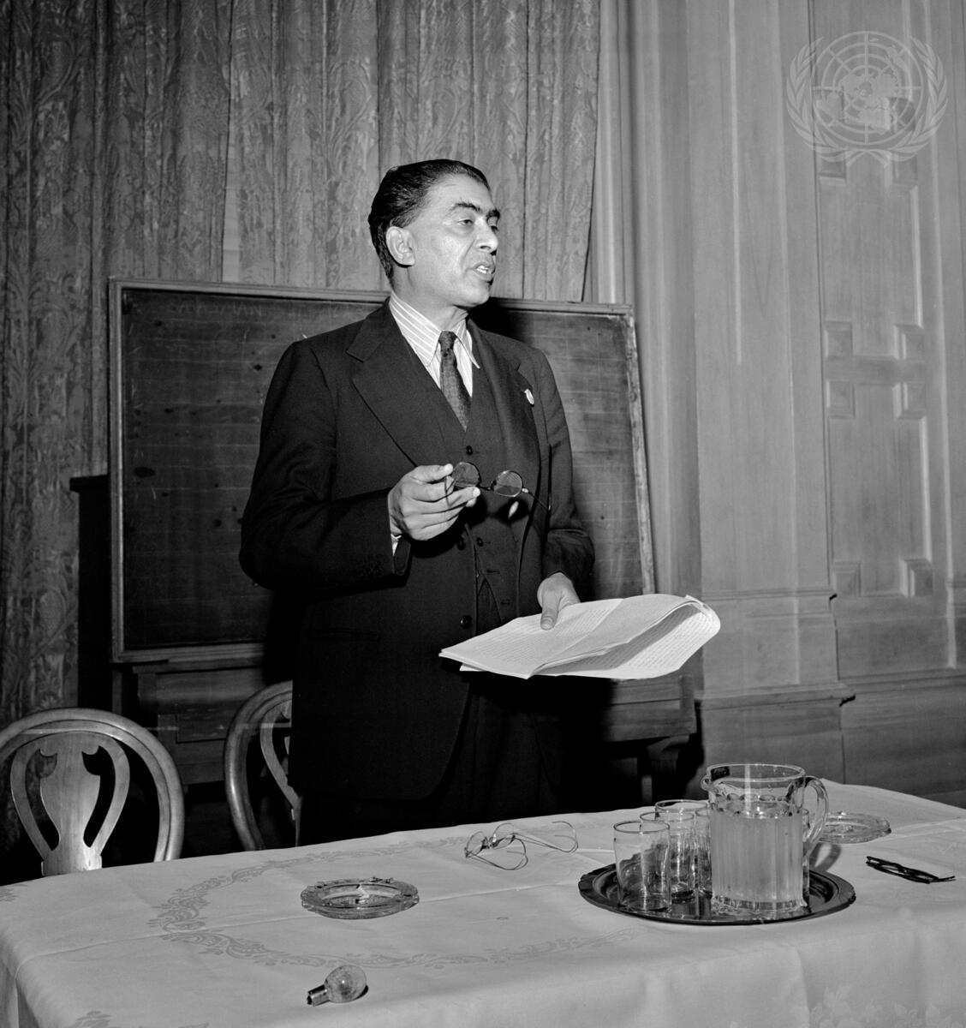
Headline: The San Francisco Conference, 25 April - 26 June 1945
Caption Description: Delegates of fifty nations met in San Francisco between April 25 and June 26, 1945. Working on the Dumbarton Oaks proposals, the Yalta Agreement, and amendments proposed by various Governments, the Conference agreed upon the Charter of the United Nations and the Statute of the New International Court of Justice. The Charter was passed unanimously and signed by all the representatives. It came into force on October 24, 1945, when China, France, the USSR, the United Kingdom, the United States and a majority of the other signatories had filed their instruments of ratification. Sir Firoz Khan Noon, member of the Delegation of India, Defense Member of the Governor General's Executive Council, addresses a press conference. [No exact date]
Production Date: 4/25/1945 11:20:51 AM
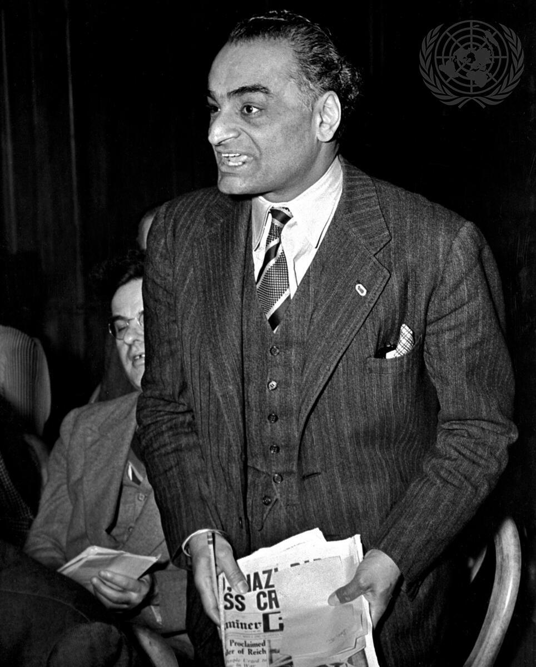
Headline: The San Francisco Conference, 25 April - 26 June 1945
Caption Description: Delegates of fifty nations met in San Francisco between April 25 and June 26, 1945. Working on the Dumbarton Oaks proposals, the Yalta Agreement, and amendments proposed by various Governments, the Conference agreed upon the Charter of the United Nations and the Statute of the New International Court of Justice. The Charter was passed unanimously and signed by all the representatives. It came into force on October 24, 1945, when China, France, the USSR, the United Kingdom, the United States and a majority of the other signatories had filed their instruments of ratification. J. J. Singh of the ""Hindustan Times"" directed a question at Sir Firoz Khan Noon, member of the delegation from India, at the India Press Conference. [No exact date]
Production Date: 4/25/1945 11:28:49 AM
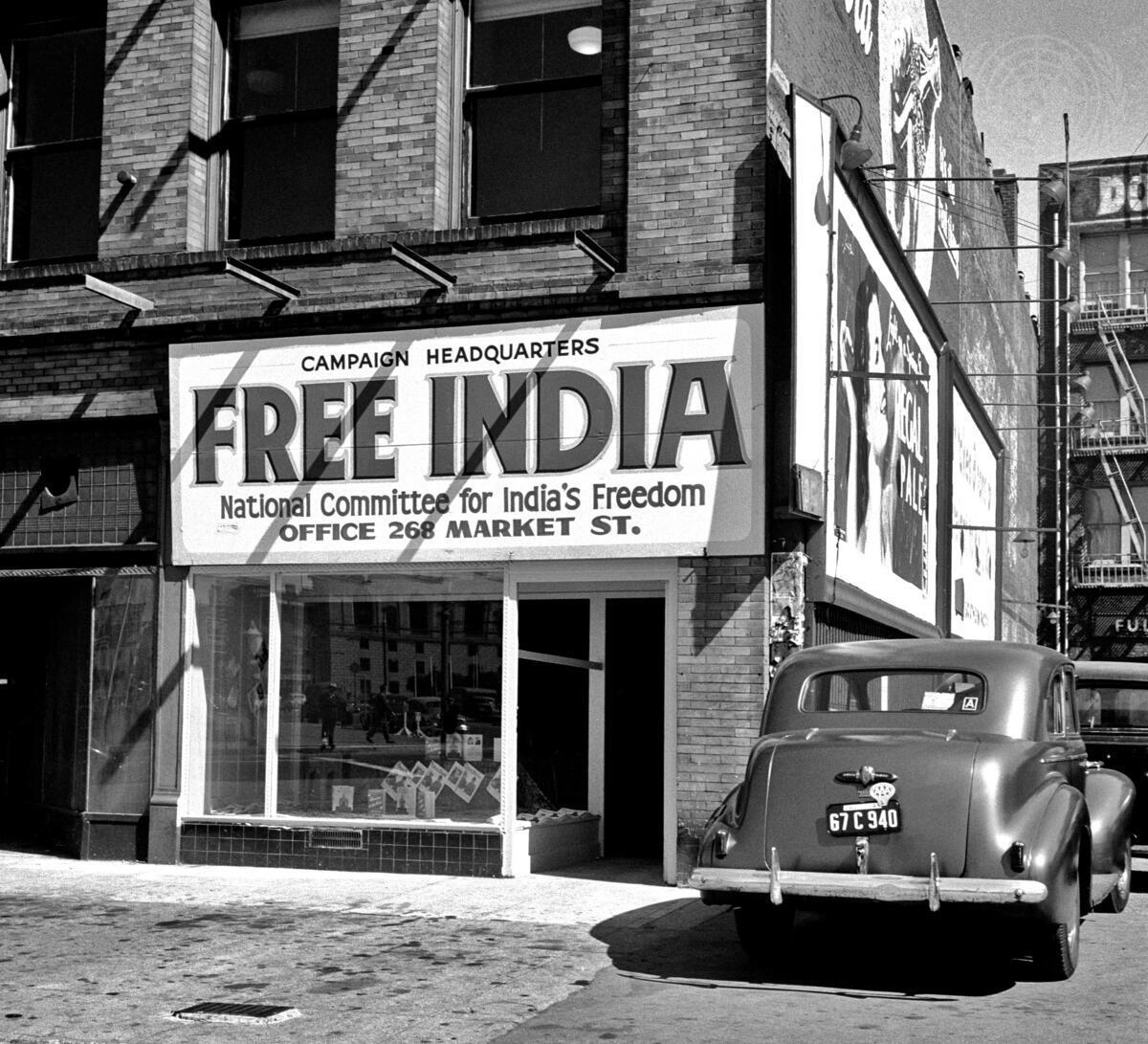
Headline: The San Francisco Conference, 25 April-26 June 1945
Caption Description: Delegates of fifty nations met at San Francisco between April 25 and June 26, 1945. Working on the Dumbarton Oaks proposals, the Yalta Agreement, and amendments proposed by various Governments, the Conference agreed upon the Charter of the United Nations and the Statute of the New International Court of Justice. The Charter was passed unanimously and signed by all the representatives. It came into force on October 24, 1945, when China, France, the USSR, the United Kingdom, the United States and a majority of the other signatories had filed their instruments of ratification. A Free India sign hangs at the Campaign Headquarters Office in San Francisco. [No exact date]
Production Date: 4/25/1945 12:14:02 PM
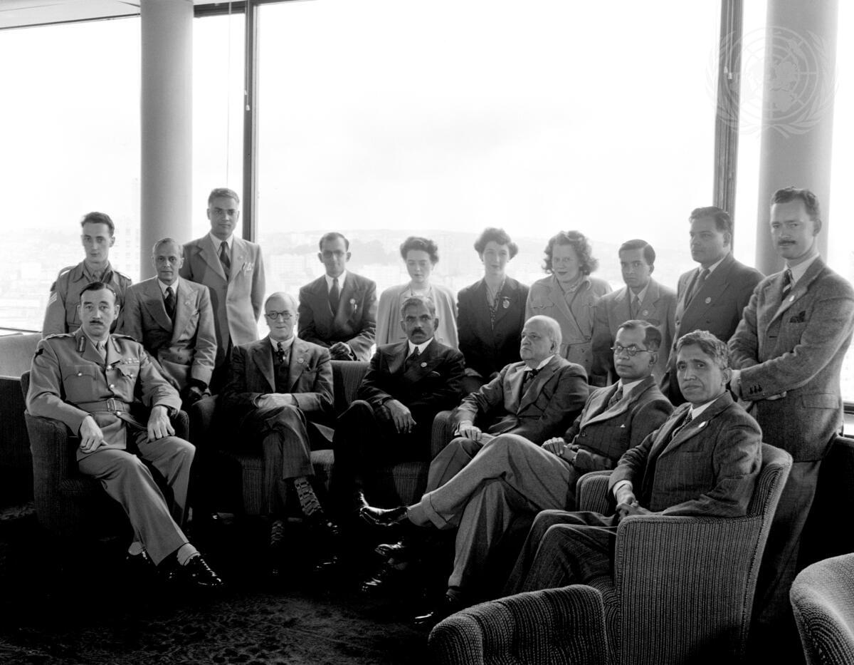

Headline: The San Francisco Conference: Delegations from India
Caption Description: Members of the Delegations from India. Standing (left to right): Sgt. Crickmay, Mr. Ollenbach, Mr. Nagar, Mr. Thampi, Miss Felton, Miss Jones, Miss Hull, Mr. P. A. Menon, Mr. Nair, Capt. Brownsdon. Seated (left to right): General Cawthorn, Mr. Bartley, Sir Ramaswami Mudaliar, (Chairman), Sir. V. T. Krishnamachari, Mr. K.P.S. Menon, Dr. Thomas. [no date]
Production Date: 4/25/1945 3:56:59 PM

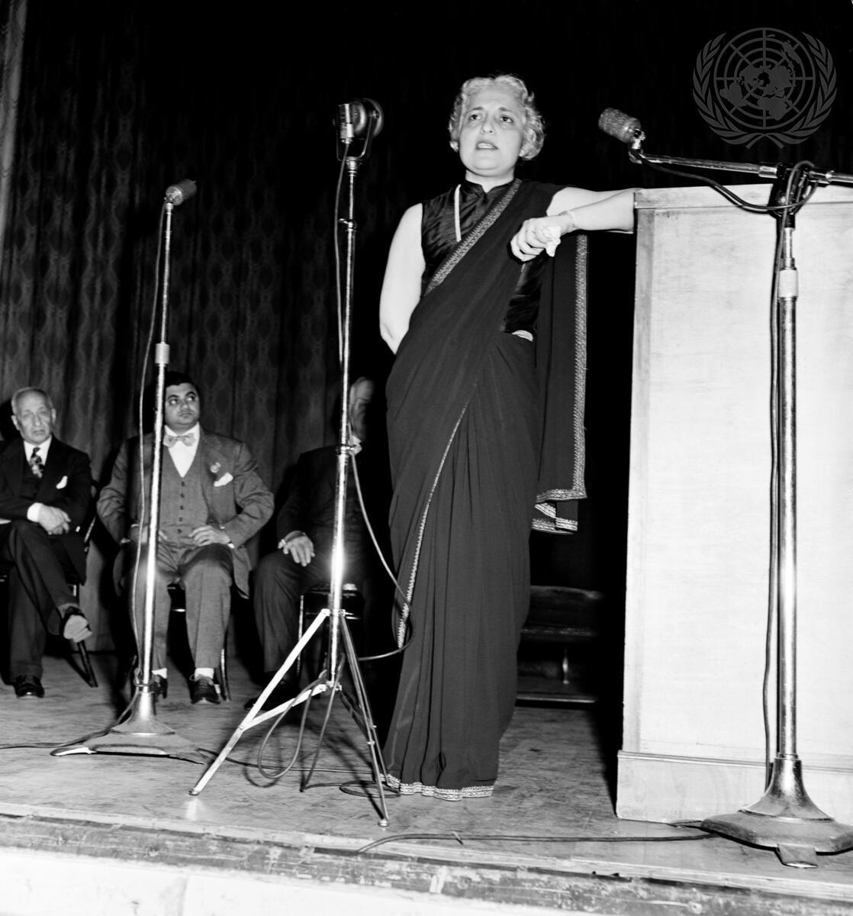

Headline: The San Francisco Conference, 25 April-26 June 1945
Caption Description: Delegates of fifty nations met at San Francisco between April 25 and June 26, 1945. Working on the Dumbarton Oaks proposals, the Yalta Agreement, and amendments proposed by various Governments, the Conference agreed upon the Charter of the United Nations and the Statute of the New International Court of Justice. The Charter was passed unanimously and signed by all the representatives. It came into force on October 24, 1945, when China, France, the USSR, the United Kingdom, the United States and a majority of the other signatories had filed their instruments of ratification. Vijaya Lakshmi Pandit, speaks during a meeting under the auspices of the National Committee for India's Freedom. A group active during the Conference with a temporary office set up near the Conference area. [Exact date unknown]
City/Location: New York
Country: United States of America
Production Date: 4/25/1945 4:20:40 PM
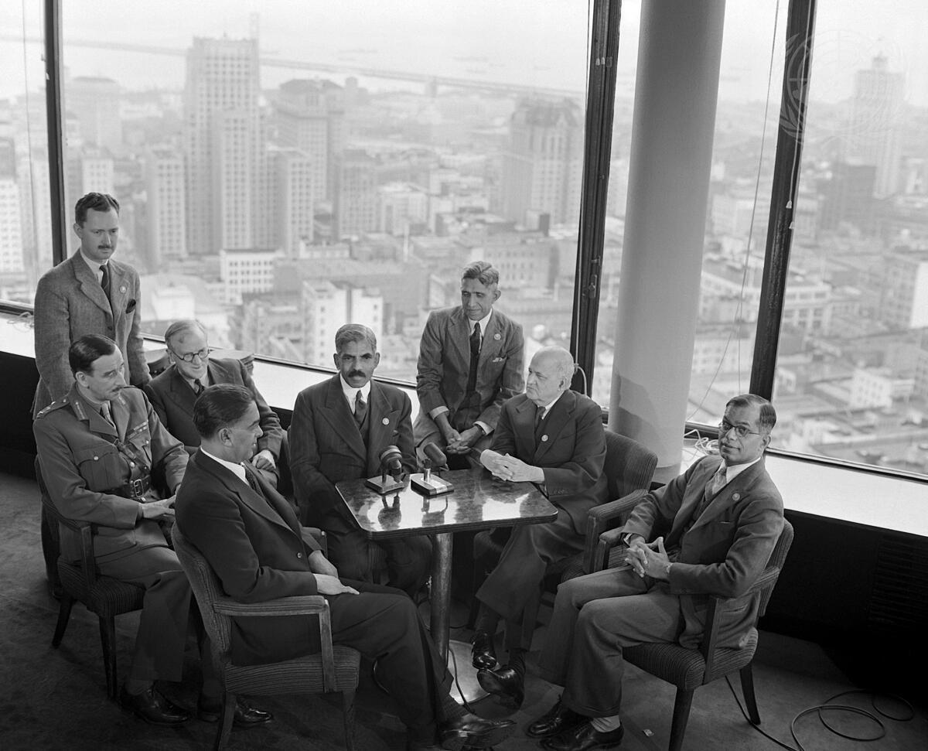
Headline: The San Francisco Conference: Delegation of India
Caption Description: Delegates of fifty nations met in San Francisco between April 25 and June 26, 1945. Working on the Dumbarton Oaks proposals, the Yalta Agreement, and amendments proposed by various Governments, the Conference agreed upon the Charter of the United Nations and the Statute of the New International Court of Justice. The Charter was passed unanimously and signed by all the representatives. It came into force on October 24, 1945, when China, France, the USSR, the United Kingdom, the United States and a majority of the other signatories had filed their instruments of ratification. Delegation of India. Left to right: Captain T.E. Brownsdon, Secretary; Major General W.J. Cawthorn, Military Adviser; Mr. John Bartley, Legal Adviser; Sir Firoz Khan Noon, Delegate; Sir A. Ramaswami Mudaliar, Chairman.
Production Date: 5/7/1945 11:00:27 AM
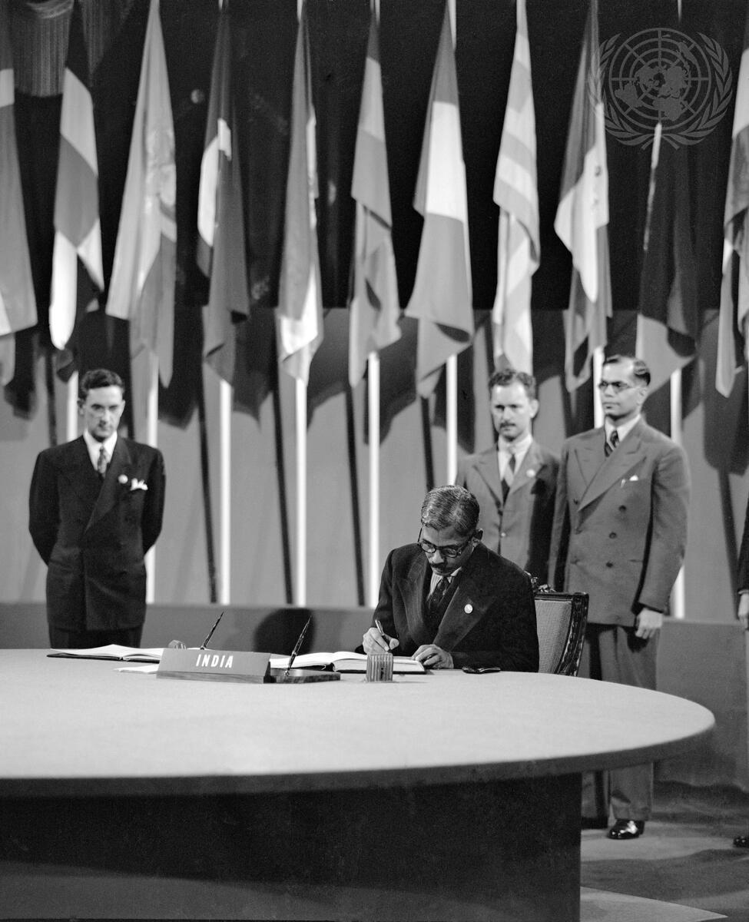
Headline: The San Francisco Conference, 25 April - 26 June 1945: India Signs the United Nations Charter
Caption Description: Sir A. Ramaswami Mudaliar, Supply Member of the Governor General's Executive Council; Leader of the Delegation from India, signing the Charter at a ceremony held at the Veterans' War Memorial Building on 26 June.
Production Date: 6/26/1945 11:10:00 AM
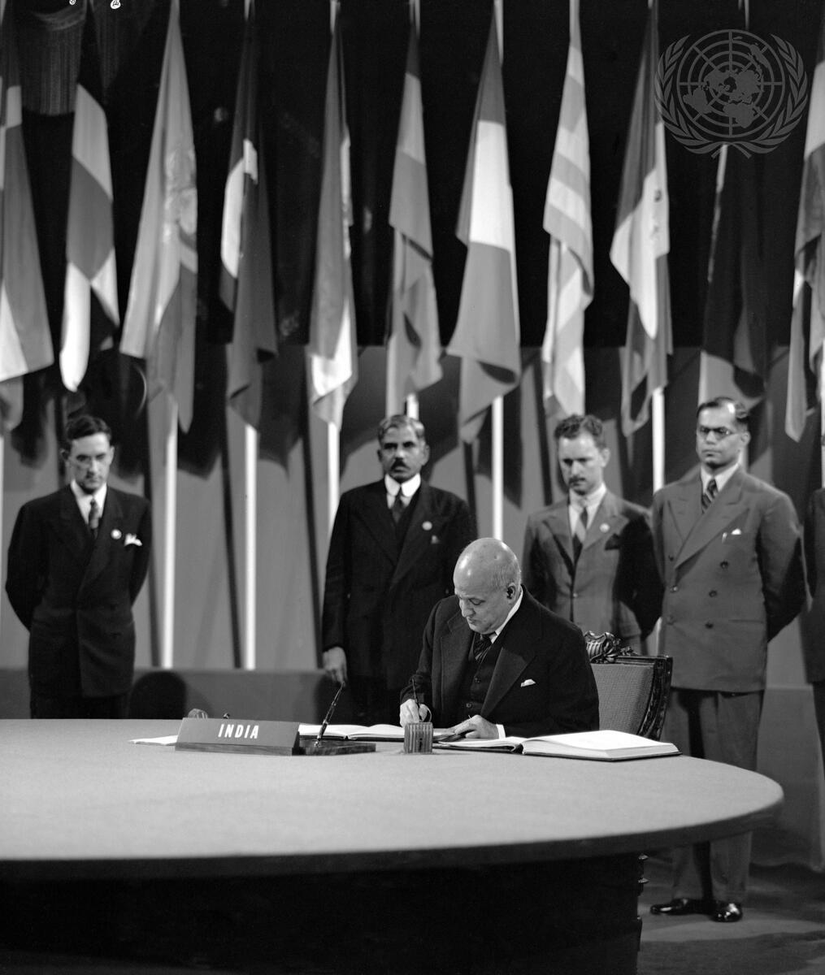
Headline: The San Francisco Conference, 25 April - 26 June 1945: India Signs the United Nations Charter
Caption Description: Sir V. T. Krishnamachari, Representative of the Indian States; member of the Delegation from India, signing the United Nations Charterat a ceremony held at the Veterans' War Memorial Building on 26 June.
Production Date: 6/26/1945 11:10:22 AM
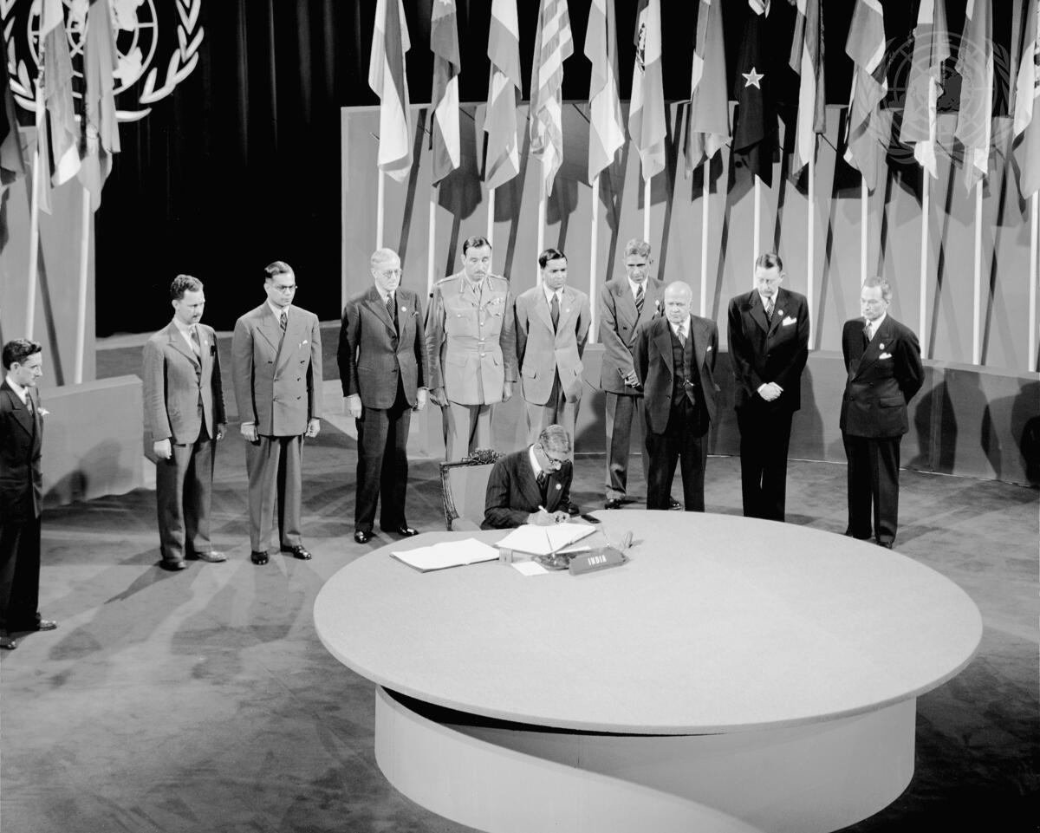
Headline: The San Francisco Conference, 25 April - 26 June 1945: India Signs the United Nations Charter
Caption Description: "Delegates of fifty nations met at San Francisco between April 25 and June 26, 1945. Working on the Dumbarton Oaks proposals, the Yalta Agreement, and amendments proposed by various Governments, the Conference agreed upon the Charter of the United Nations and the Statute of the new International Court of Justice. The Charter was passed unanimously and signed by all the representatives. It came into force on October 24, 1945, when China, France, the USSR, the United Kingdom, and the United States and a majority of the other signatories had filed their instruments of ratification. Sir A. Ramaswami Mudaliar, Supply Member of the Governor-General's Executive Council; Leader of the delegation from India, signing the UN Charter at a ceremony held at the Veterans' War Memorial Building on 26 June 1945."
Production Date: 6/26/1945 4:20:15 PM
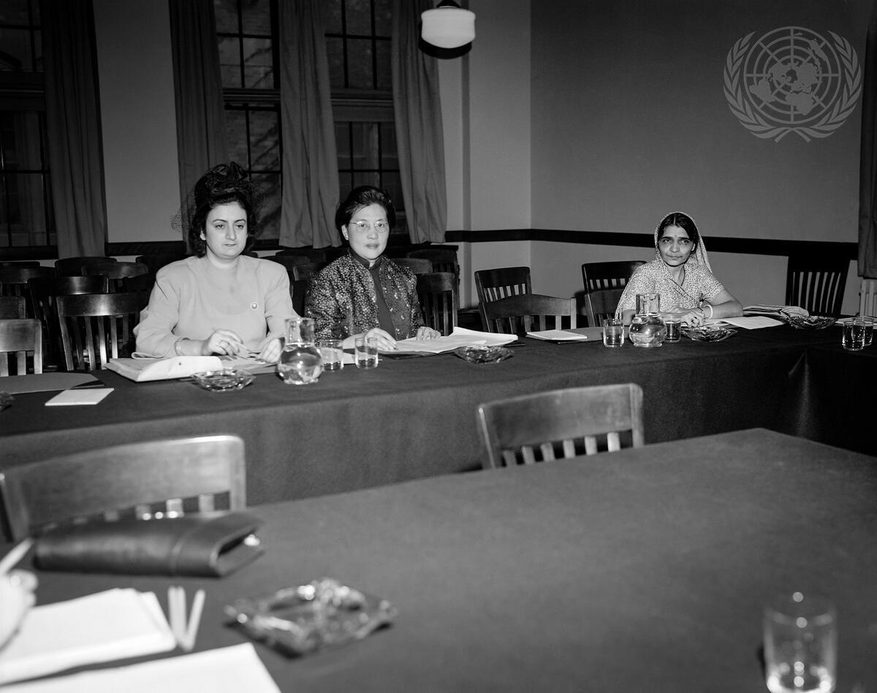
Headline: Sub-Commission on Status of Women of the UN ECOSOC Council
Caption Description: From left to right, at the first meeting of the Sub-commission on the Status of Women of the Commission on Human Rights at the United Nations Economic and Social Council: Miss Angela Jurdak, Lebanon; Mrs. W.S New, China; and Mrs. Hansa Mehta, India.
City/Location: New York
Country: United States of America
Production Date: 4/29/1946 2:00:01 PM
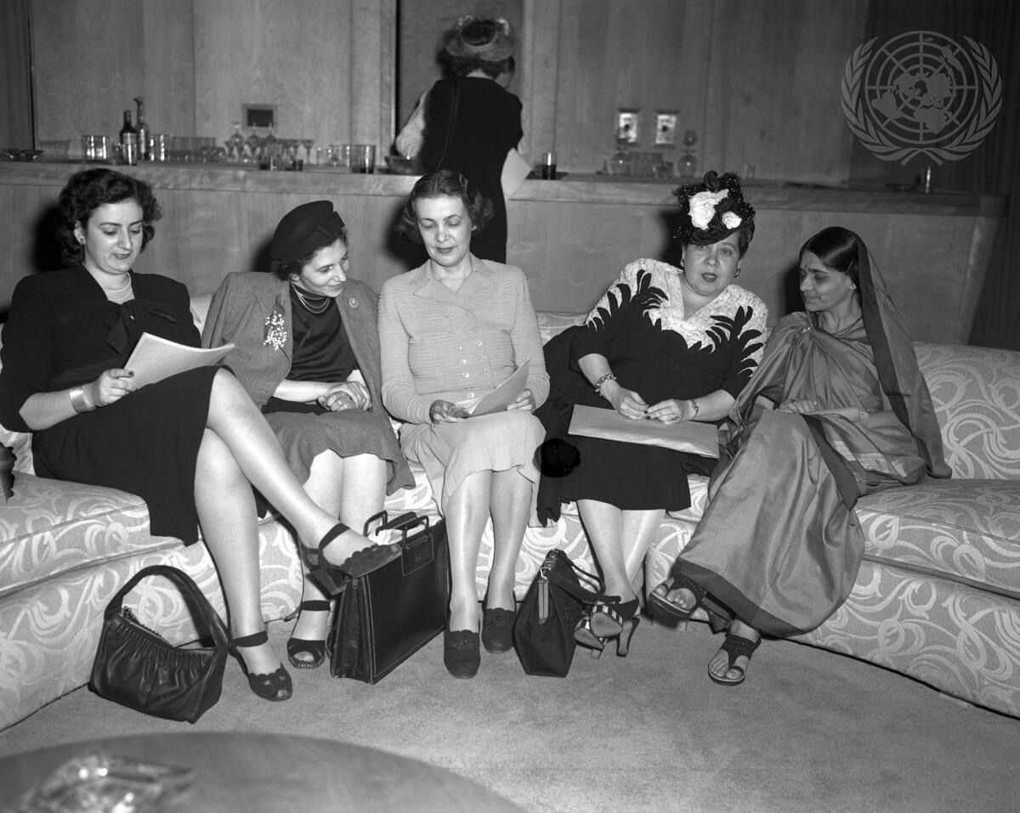
Headline: Sub-Commission on the Status of Women Holds Press Conference
Caption Description: As a finale to their last meeting at Hunter College, the Sub-commission on the Status of Women hold a press conference in the delegates lounge of the gym building. From left to right are: Miss Angela Jurdak, Lebanon; Miss Fryderyka Kalinowski, Poland; Mrs. Bodgil Begtrup. Denmark and Chairman of the committee; Miss Minerva Bernardino, Dominican Republic; and Mrs. Hansa Mehta, India.
City/Location: New York
Country: United States of America
Production Date: 5/14/1946 2:01:50 PM
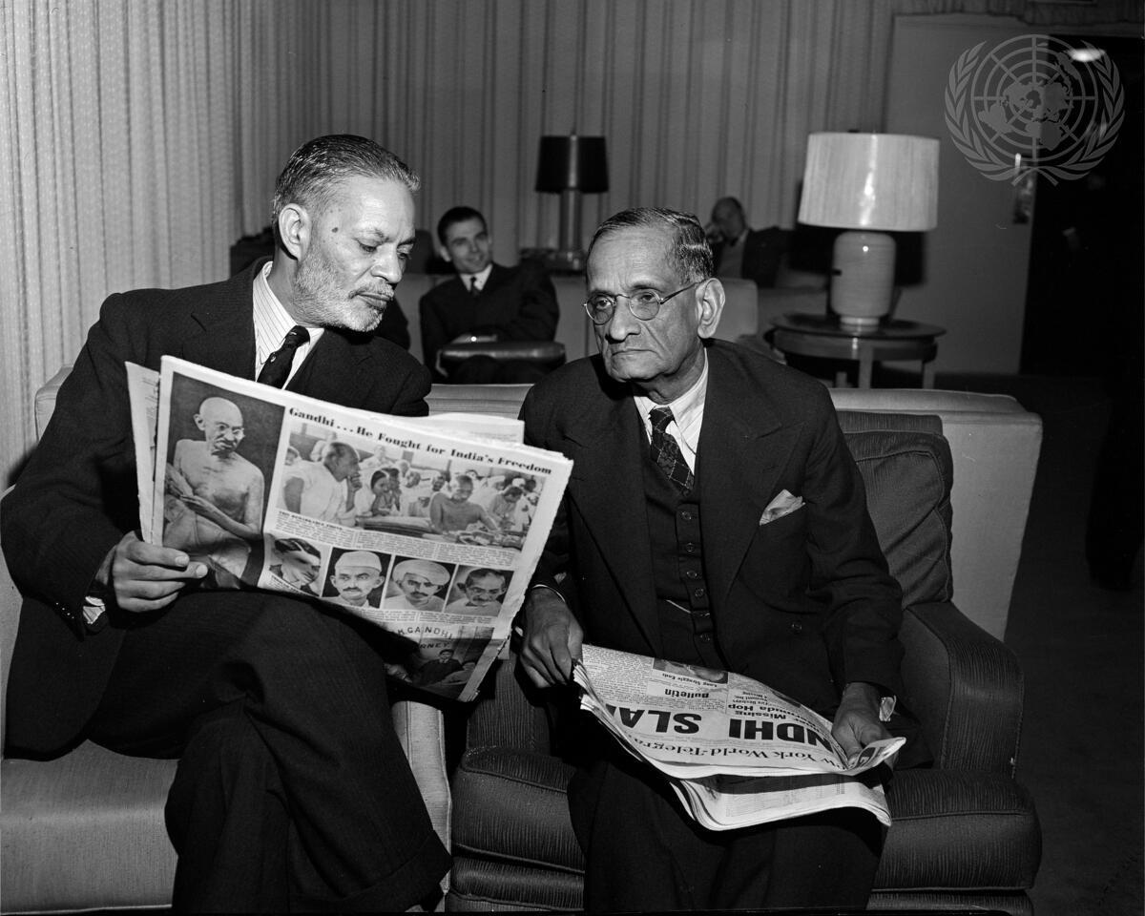
Headline: Representatives of India and Pakistan Read News of Gandhi's Assassination
Caption Description: N. Gopalaswami Ayyangar, Minister of India without Portfolio, and Sir Mohamed Zafrullah Khan, Minister for Foreign Affairs of Pakistan, read the news of the tragic death of Mahatma Gandhi, leader of India. The Security Council interrupted its consideration of the situation in Jammu and Kashmir to devote its meeting today to the memory of the assassinated Indian leader.
City/Location: New York
Country: United States of America
Production Date: 1/30/1947 6:40:05 PM

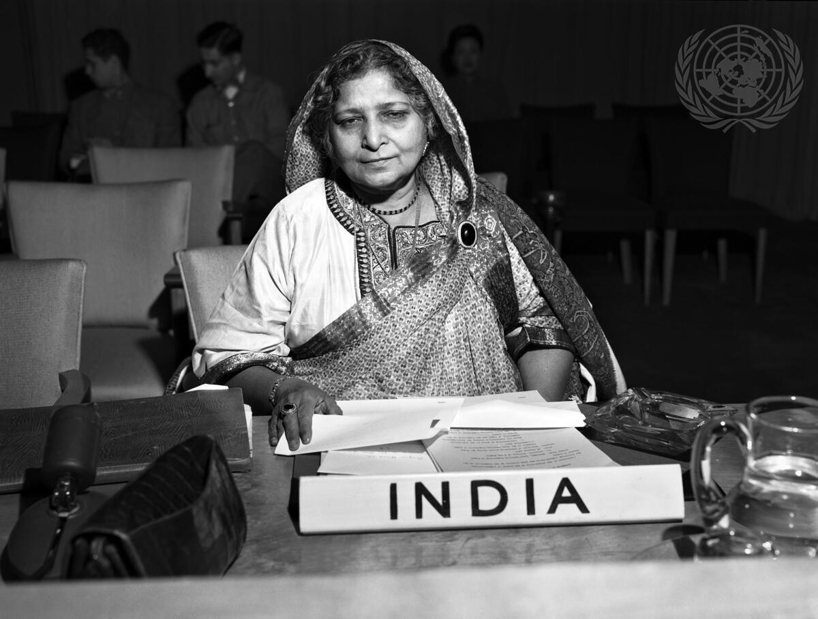
Headline: Commission on the Status of Women of the United Nations Economic and Social Council Caption Description: India's participation in the economic, social and humanitarian activities of the United Nations is active and lively. Begum Hamid Ali, a pioneer in the field of women's emancipation in India, represents her country on the UN Commission on the Status of Women. [Exact date unknown] City/Location: New York
Country: United States of America
Production Date: 2/12/1947 6:30:19 PM

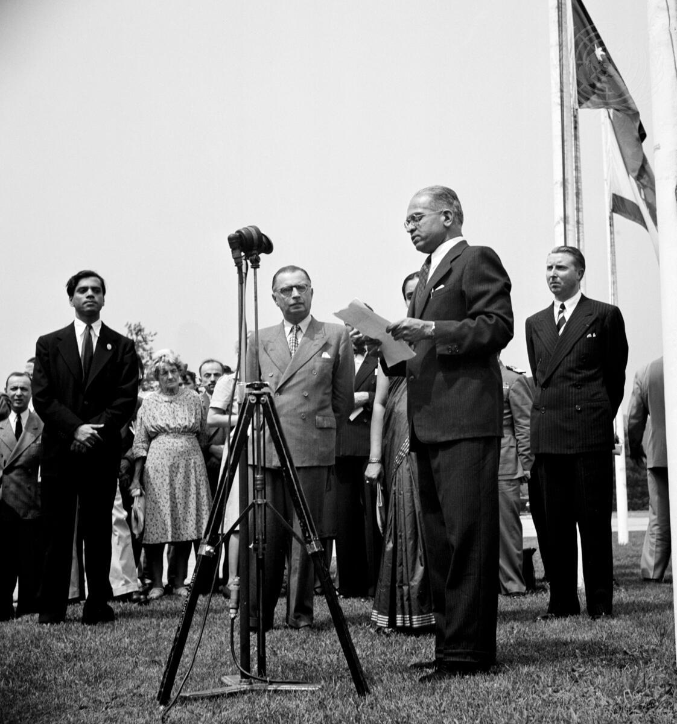
Headline: United Nations Observe Indian Independence
Caption Description: Dr. Padmanabha Pillai, newly appointed representative of India to the United Nations, speaking at the ceremony of hoisting the new flag of India to take its place at United Nations headquarters among the colours of 54 other member states. Also seen at the observance of the coming into force of the Indian Independence Act of 1947 are, left to right: Samarendranath Sen, Permanent Liaison Officer of the Indian delegation; Dr. Ivan Kerno, Acting Secretary-General of the United Nations, and Jehan de Noue, Chief of the United Nations Protocol and Liaison.
City/Location: New York
Country: United States of America
Production Date: 8/15/1947 1:08:52 PM
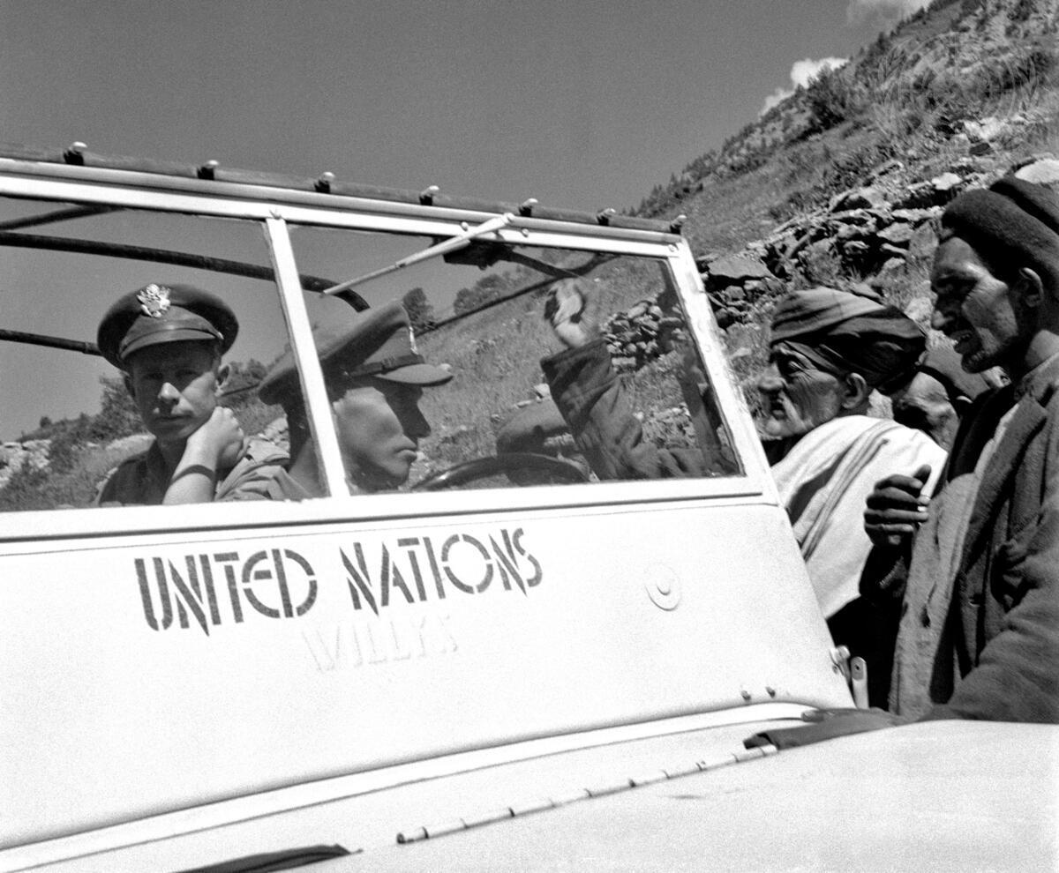
Headline: Day of a UN Observer
Caption Description: En route to the ""FRONT"" in their white-painted UN Jeep, the two UN observers encounter local inhabitants whose stories may help to clarify the situation. They explain their mission and ask for directions to the mountainous area in dispute.
Production Date: 1/1/1948 12:34:06 PM
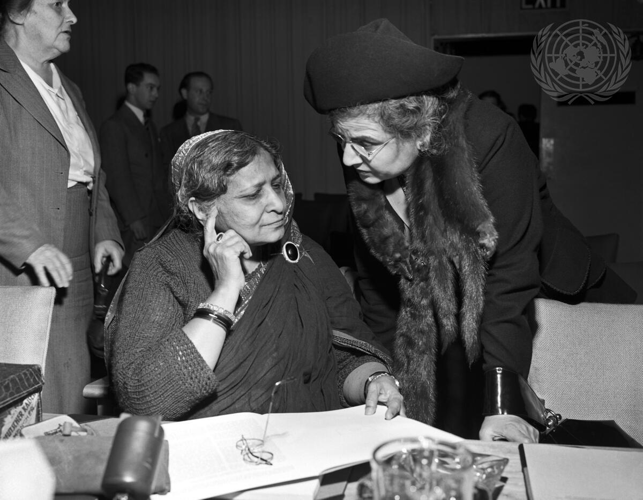
Headline: United Nations Commission on Status of Women Opens Its Second Session
Caption Description: The fifteen-member organ of the United Nations Economic and Social Council prepares recommendations and reports to the Council on promoting women's rights in political, civil, social and educational fields. The agenda for the present session includes methods of educating new women voters on the use of franchise; economic rights for women; and cooperation with the International Labour Organization (ILO); educational opportunities for women; and prevention of discrimination on grounds of sex.
Alice Kandalft Cosma, Syria, right, stops to talk to Begum Hamid Ali of India, before the opening of the Second Session of the Commission on the Status of Women.
City/Location: New York
Country: United States of America
Production Date: 1/5/1948 8:54:09 PM
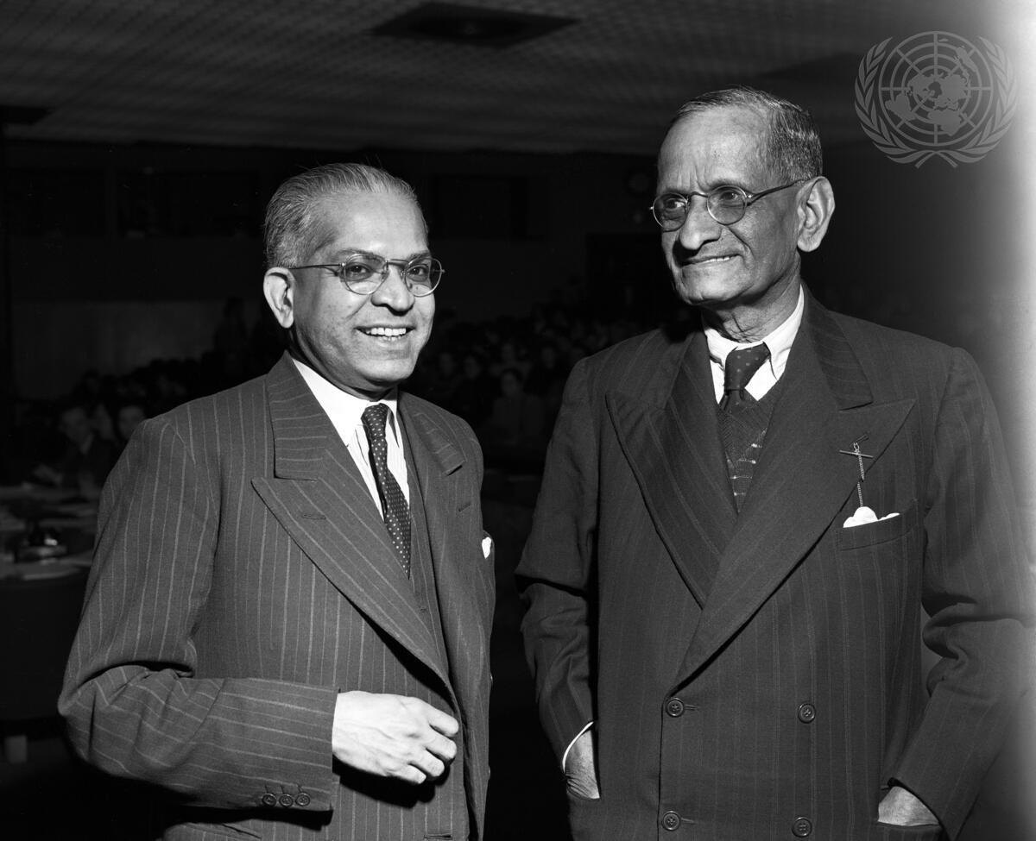
Headline: Security Council Considers Kashmir Question
Caption Description: N. Gopalaswami Ayyangar (right), Minister of India without Portfolio, confers with Dr. Padmanabha Pillai, representative of India to the United Nations, prior to the 227th Security Council meeting at which consideration of the Indian complaint against Pakistan on the Kashmir question was resumed. Mr. Ayyangar who presented India's case to the Council asked for action to eliminate the danger of an armed conflict between India and Pakistan, and to persuade the Pakistan Government to disassociate itself from the Kashmir raiders.
City/Location: New York
Country: United States of America
Production Date: 1/15/1948 6:28:53 PM
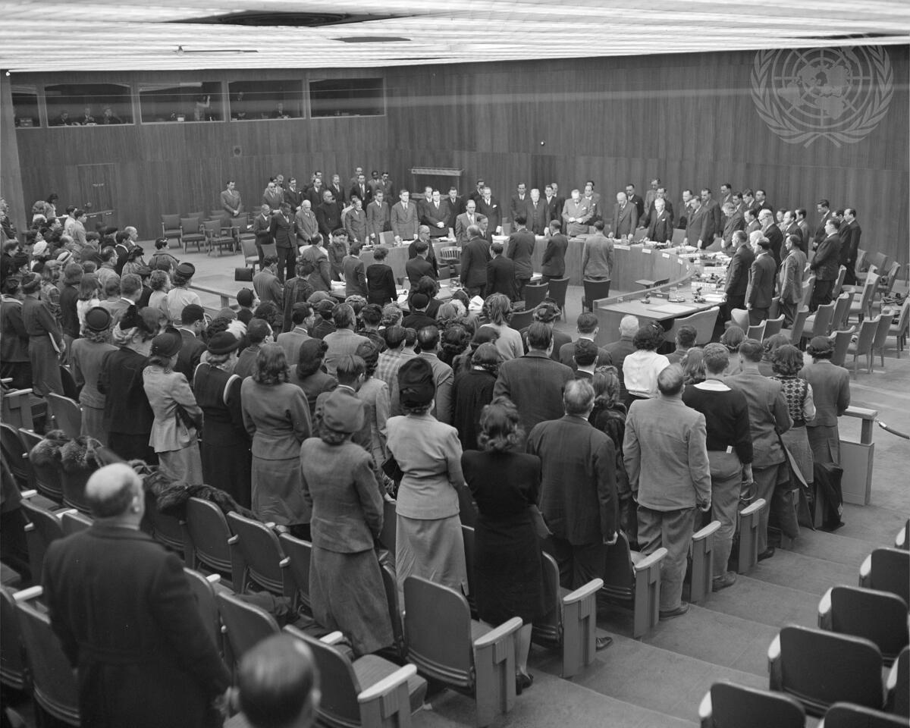
Headline: Council Members' Silent Tribute in Honour of Memory of Mahatma Gandhi, Leader of India
Caption Description: Members of the United Nations Security Council and representatives of Indiaand Pakistan rise in silent tribute to the memory of Mohandas K. Gandhi, India's leader, who was assassinated this morning. The Council interrupted its consideration of the situation in Jammu and Kashmir to pay homage to the Mahatma.
City/Location: New York
Country: United States of America
Production Date: 1/30/1948 6:40:02 PM

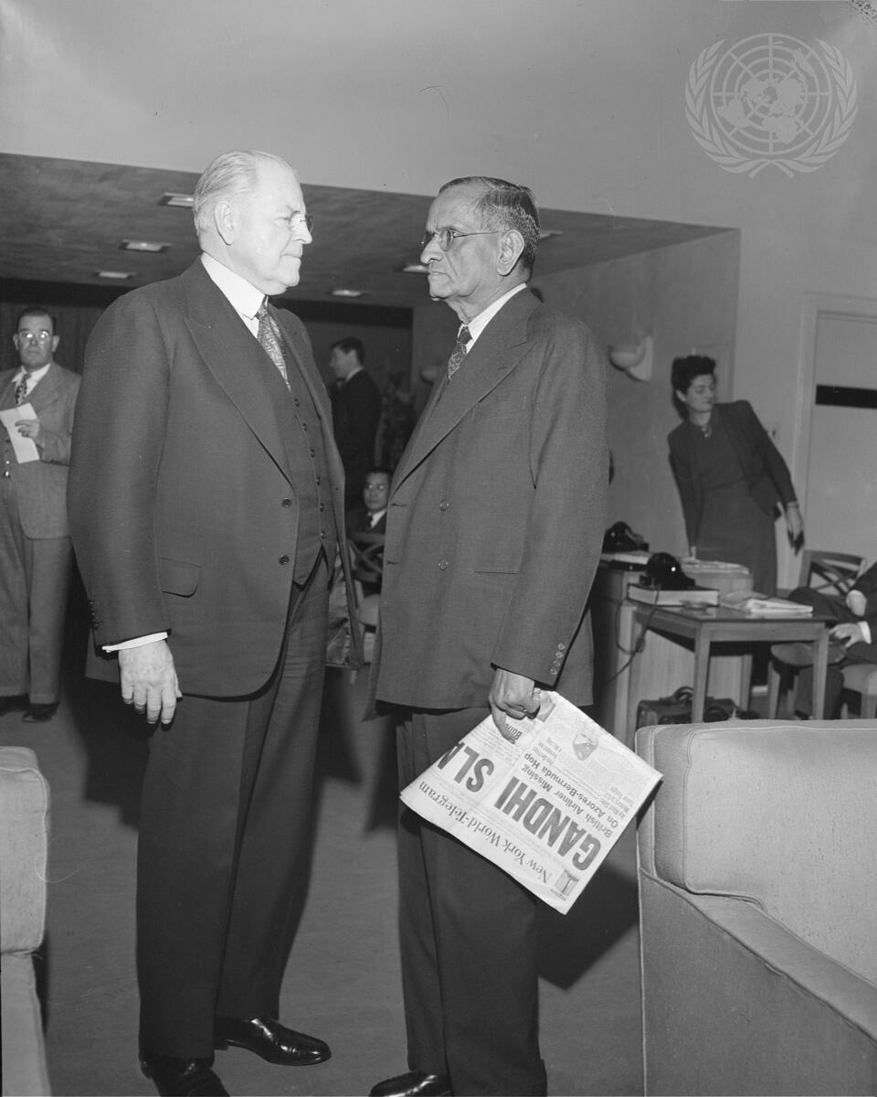

Headline: United States Representative Conveys his Country's Condolences on the Tragic Death of Mahatma Gandhi
Caption Description: Warren R. Austin, Permanent Representative of the United States to the United Nations (left), conveys condolences to N. Gopalaswami Ayyangar, Minister of India without Portfolio (right), on the tragic death of Mahatma Gandhi, leader of India.
City/Location: New York
Production Date: 1/30/1948 6:40:11 PM

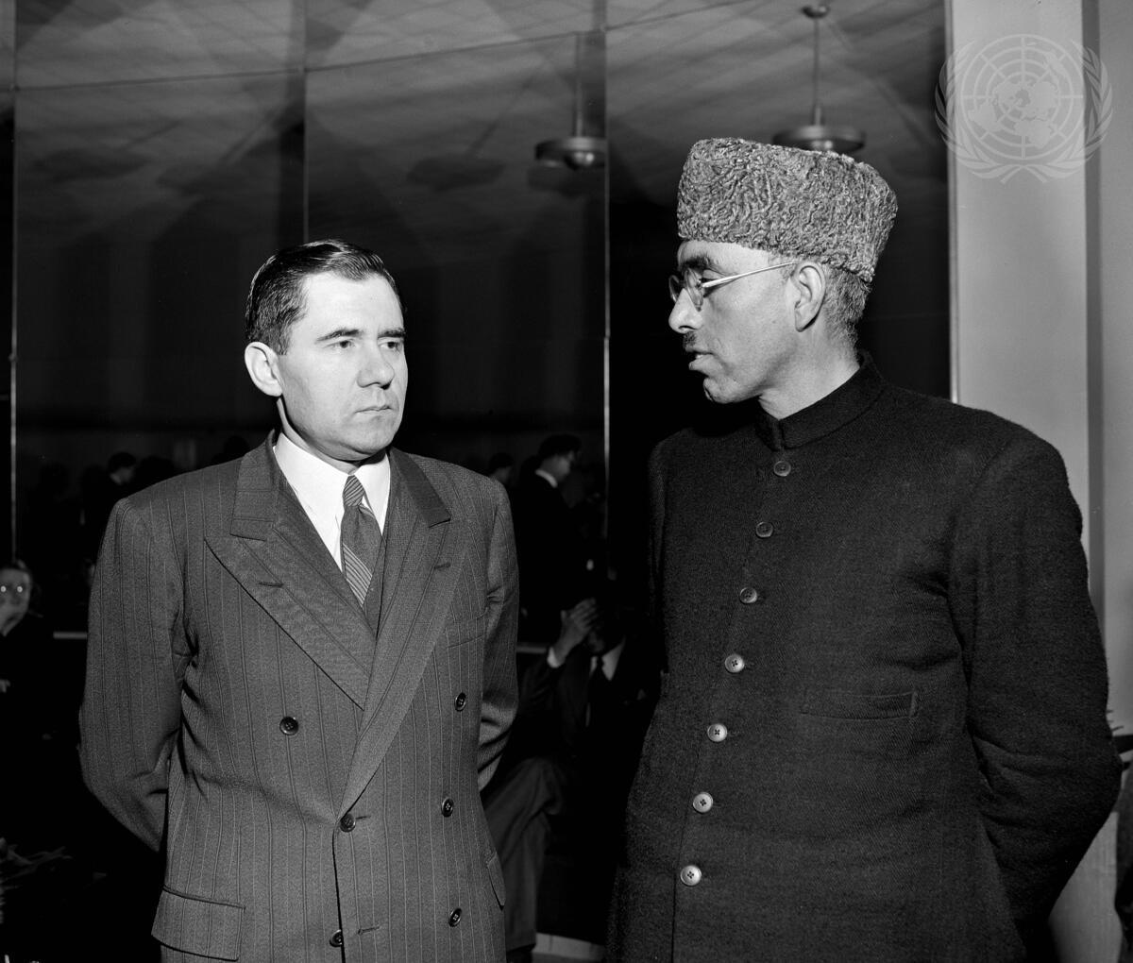

Headline: Kashmir Question Before United Nations Security Council
Caption Description: Sheikh Mohamed Abdullah, right, President of All-Jammu and Kashmir National Conference and head of the Kashmir State Administration, talks with Andrei A. Gromyko, Ambassador of the Union of Soviet Socialist Republics to the United States, before the 243rd meeting of the Security Council.
City/Location: New York
Country: United States of America
Production Date: 2/10/1948 6:40:20 PM

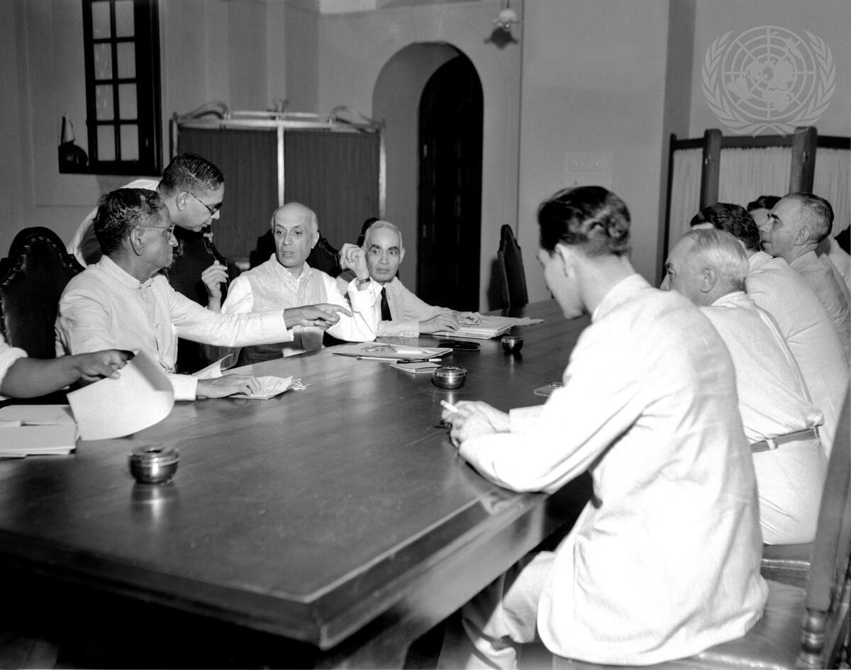
Headline: UNCIP Conferring with Indian Officials on Ceasefire Proposal
Caption Description: UNCIP conferring with Indian officials in New Delhi on Ceasefire proposal on August 18. Left to right - Gopaliswami Ayyangar, A.V. Pai, Pandit Nehru, Sir Girja Shanker Bajpai and on opposite side of table, left to right, Hernando Samper (Colombia), Egbert Graeffe (Belgium), Josef Korbel (Czechoslovakia), and J. Klahr Huddle (USA).
City/Location: New Delhi
Country: India
Production Date: 8/18/1948 5:28:51 PM

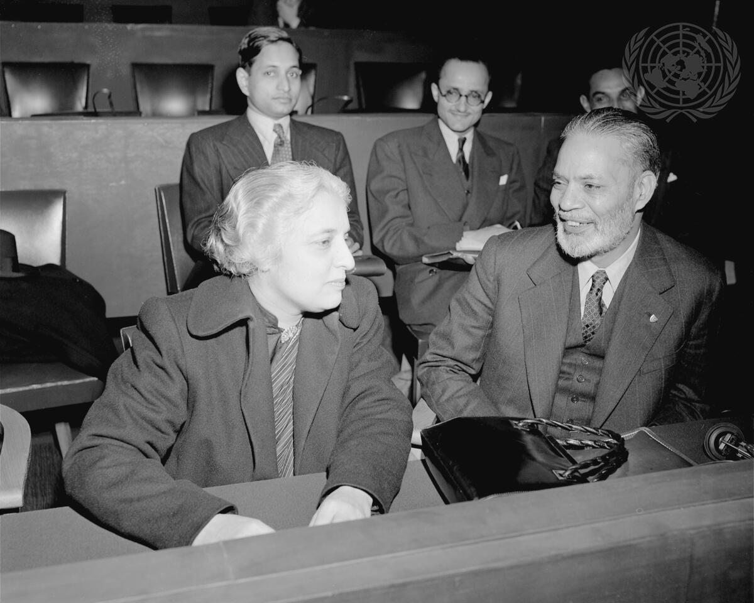
Headline: Security Council Meeting on Kashmir Question
Caption Description: Vijaya Lakshmi Pandit, Chairman of the delegation of India, and Sir Mohammed Zafrullah Khan, Minister for Foreign Affairs of Pakistan and Chairman of the delegation, shown together before taking their seats at the Council table to participate in the discussion of the Kashmir Question at the invitation of the Council Chairman.
City/Location: Paris
Country: France
Production Date: 11/25/1948 6:37:39 PM

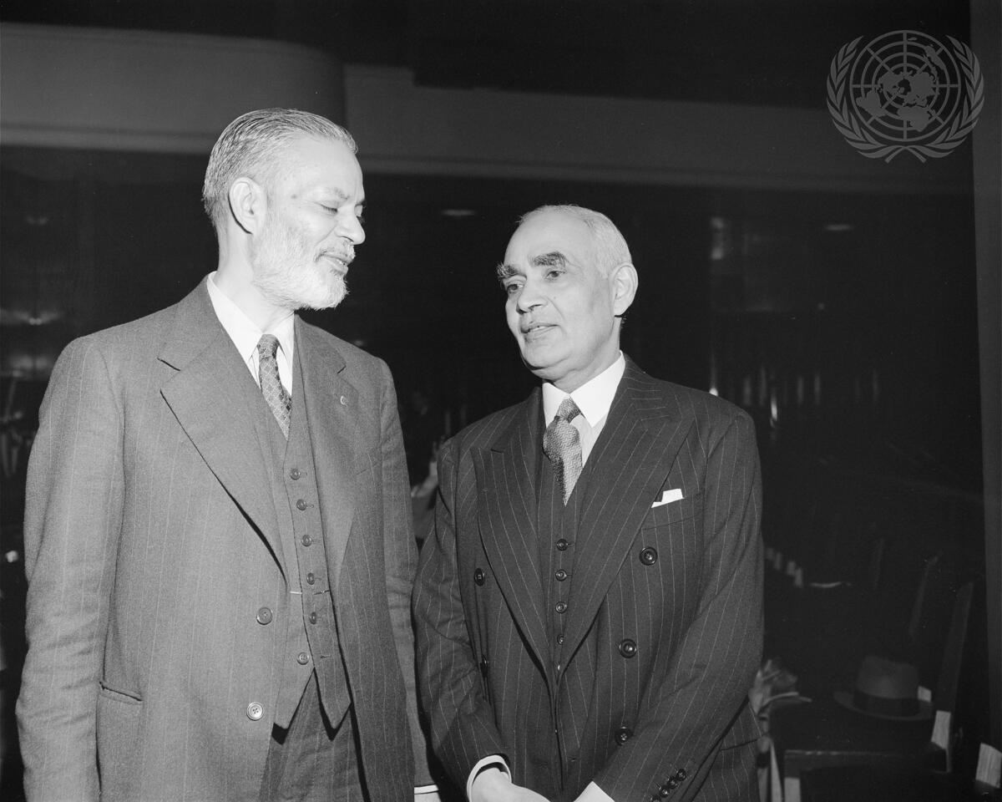
Headline: Security Council Meeting on Kashmir Question
Caption Description: Sir Mohammed Zafrullah Khan (left), Minister for Foreign Affairs of Pakistan and Chairman of the delegation, and Sir Girja Shankar Dajpai, member of the delegation of India, before taking their seats at the Council table to participate in the discussion on Kashmir. The main feature of the agreement suggested by the United Nations Commission for Indian and Pakistan is an immediate cease-fire, followed by a plebiscite to determine whether the people of Kashmir wishes to join India or Pakistan.
City/Location: Paris
Country: France
Production Date: 11/25/1948 6:37:43 PM

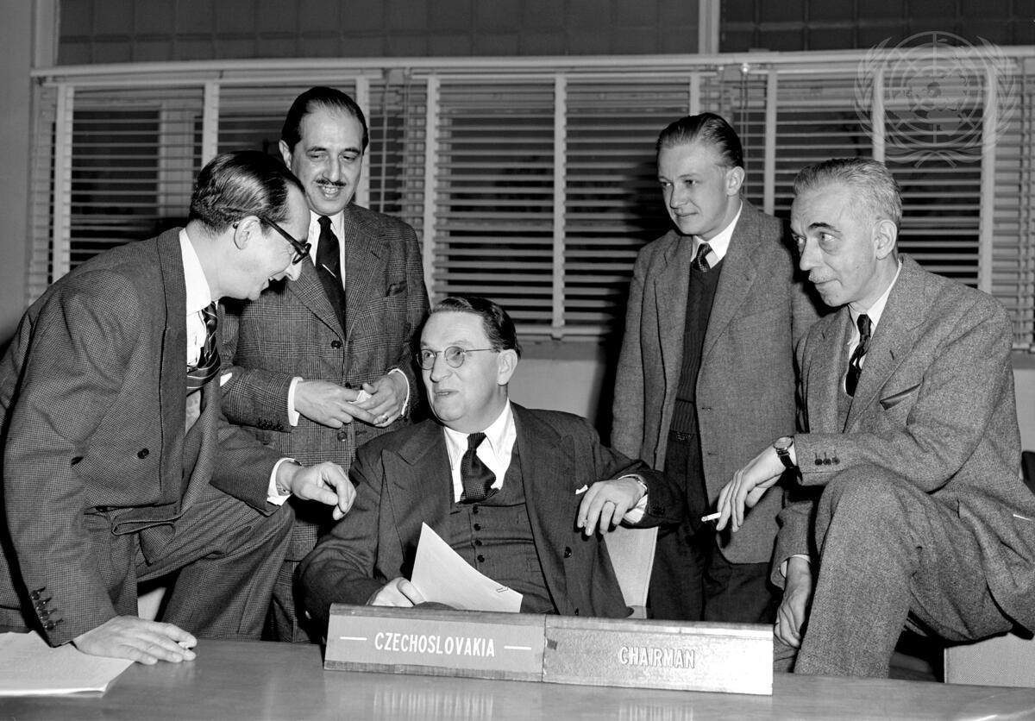
Headline: United Nations Commission for India and Pakistan
Caption Description: Members of the Commission for India and Pakistan established by the Security Council to investigate facts and through mediation to smooth away the difficulties between the two countries. Left to right: Dr. Alfredo Lozano, Colombia; Carlos Alberto Leguizamon, Argentina ‌ Chairman Josef Korbel, Czechoslovakia; Harry Graeffe, Belgium, and J. Klahr Huddle, United States.
City/Location: New York
Country: United States of America
Production Date: 1/1/1949 12:19:29 PM

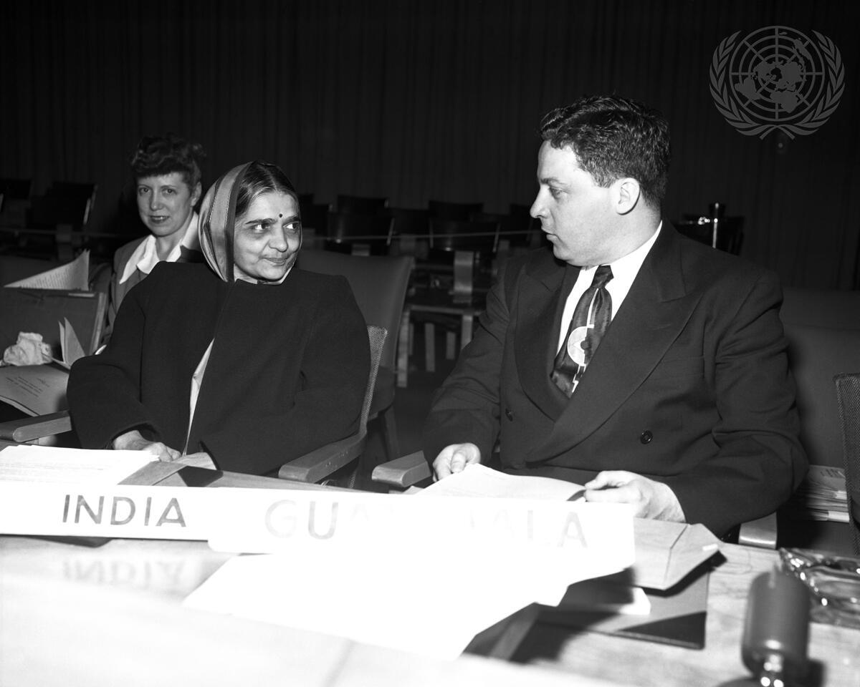

Headline: U.N. Commission on Human Rights
Caption Description: Mrs. Hansa Mehta of India, left, with Mr. Carlos Garcia Bauer, before a meeting of the UN Commission on Human Rights.
City/Location: New York
Country: United States of America
Production Date: 6/1/1949 9:58:00 PM

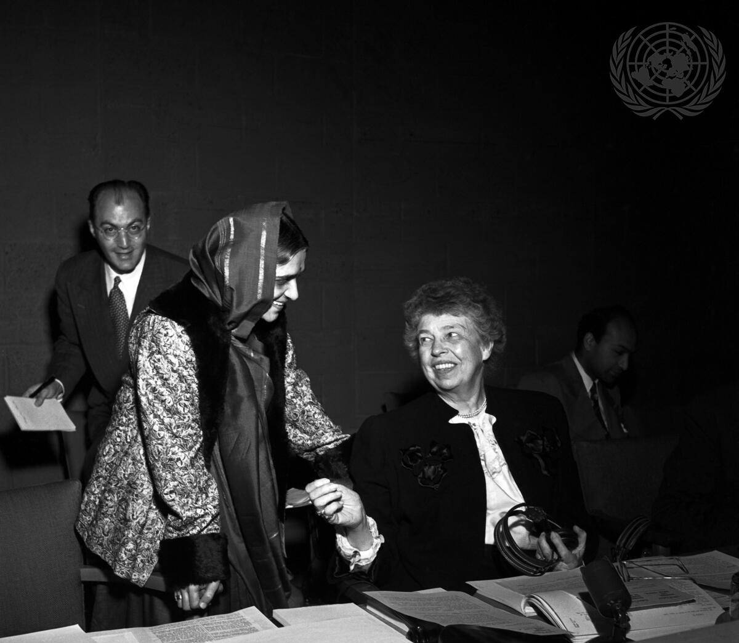
Headline: U.N. Commission on Human Rights
Caption Description: The Universal Declaration of Human Rights, the first document in history to set up an international standard of rights for all mankind, was approved last fall by the U.N. General Assembly in Paris. But the Declaration at present is simply a standard for the nations to achieve by individual action, it is not binding. U.N., however, is already taking the first steps to write the Declaration into international law. The Commission on Hunan Rights is now shaping up the concrete articles of an international Convention on human rights which, when finished, and approved by the General Assembly, will be the world's first binding instrument to provide for the protection of the rights of individuals, everywhere under international law.
The Commission Chairman, Mrs. Eleanor Roosevelt (right) with Mrs. Hansa Mehta of India. City/Location: New York
Country: United States of America
Production Date: 6/1/1949 10:21:50 PM
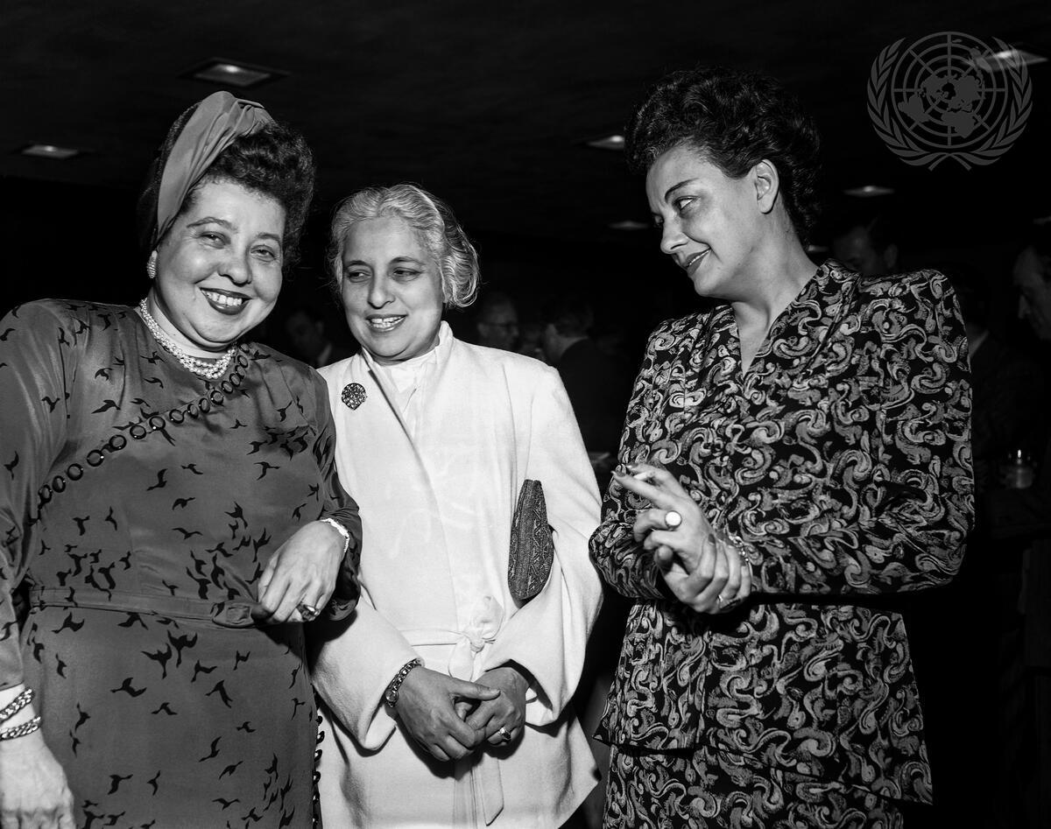
Headline: Human Rights Commission Opens Fifth Session
Caption Description: Two members of the Commission: Mrs. Minerva Bernadino of the Dominican Republic, left; and Miss Ana Figueroa, of Chile, right, are seen with a distinguished visitor to U.N., Mrs. Vijaya Lakshmi Pandit, India’s Ambassador to Washington, centre. On the Commission's agenda are items relating to the protection of minorities; international bill of human rights, and measures for its implementation; right of asylum; old age rights; and a Year-Book on Human Rights which will contain information on provisions of constitutions, ordinary laws, international treaties, and court decisions affecting human rights.
City/Location: New York
Country: United States of America
Production Date: 5/5/1949 9:22:37 PM
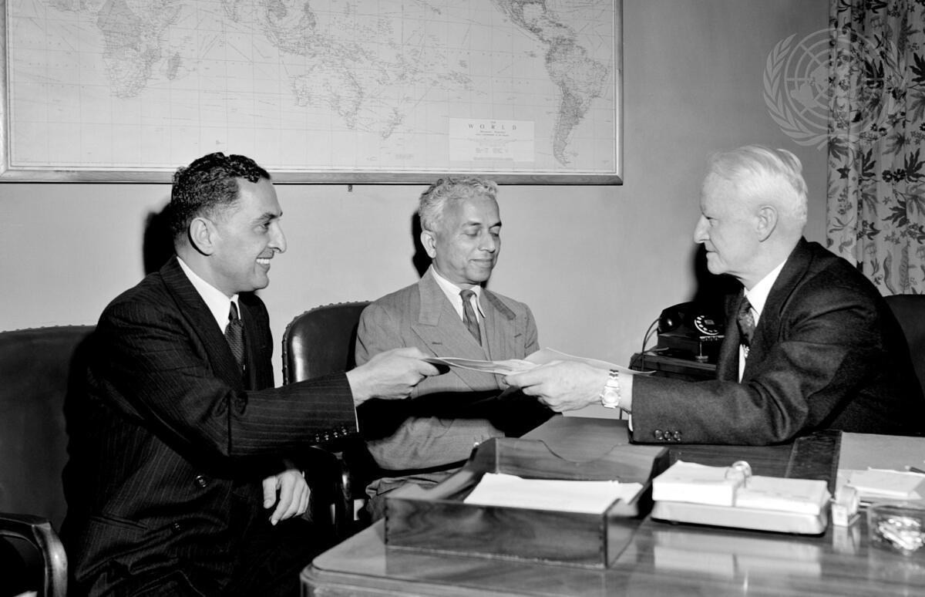
Headline: UN Plebiscite Administrator for Kashmir
Caption Description: Admiral Chester W. Nimitz is seen in his office at Lake Success, giving
autographed photographs to Abdur Rahim Khan, Representative of Pakistan to the United Nations, left, and Sir Benegal Narsing Rau of India, centre.
City/Location: New York
Country: United States of America
Production Date: 5/6/1949 4:37:46 PM

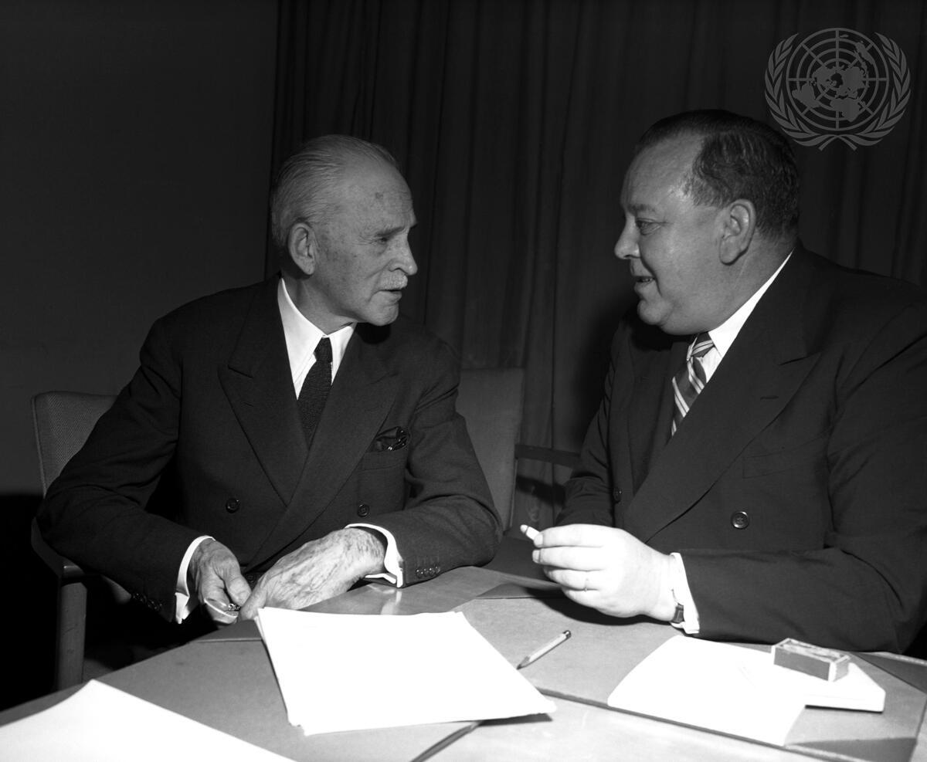
Headline: United Nations Commission for India and Pakistan
Caption Description: U.N. Secretary-General Trygve Lie (right) with his personal representative to the U.N. Commission for India and Pakistan, Ambassador Eric Colban, of Norway.
City/Location: New York
Country: United States of America
Production Date: 12/16/1949 6:55:38 PM

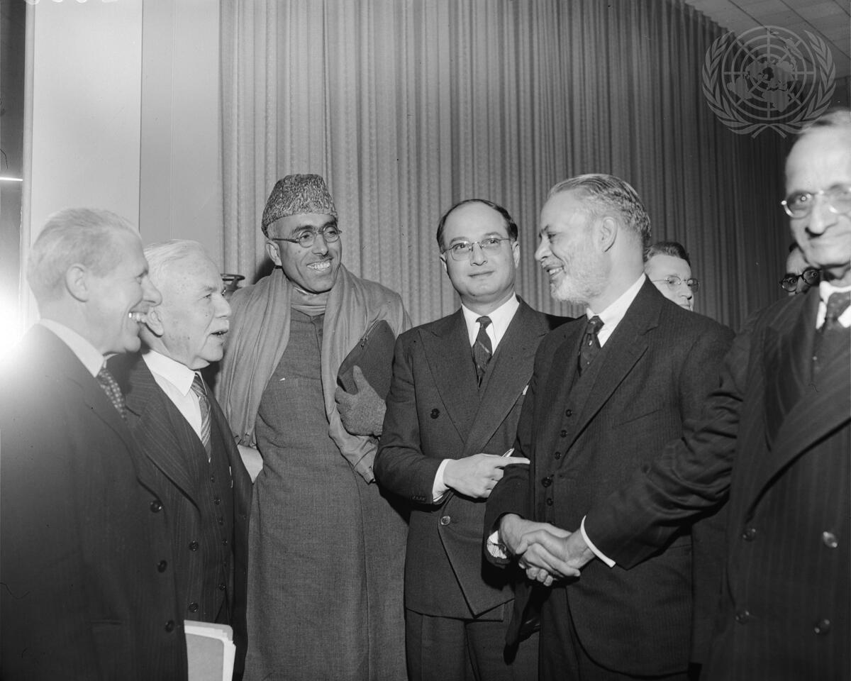
Headline: Security Council Meeting on India-Pakistan Question
Caption Description: From left to right: Sir Gerja S. Bajpai, Secretary-General, Ministry of Foreign Affairs of India; Sheikh Mohammad Abdullah, Prime Minister of Kashmir; and Sir Benegal N. Rau, Permanent Representative of India to the United Nations, prior to the meeting at which the UN Security Council instructed its President to hold informal discussions with the parties to the Kashmir Question.
City/Location: New York
Production Date: 12/17/1949 6:38:27 PM

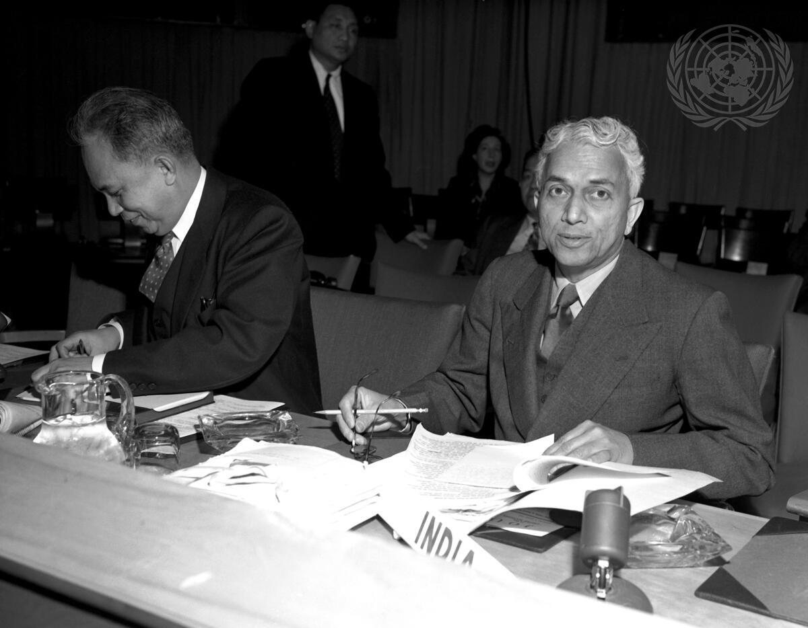

Headline: Report of Committee on Ceasefire in Korea
Caption Description: Benegal Rau, Permanent Representative of India to the United Nations, submitted the report of the Committee of Three on Cease-Fire in Korea to the First (Political) Committee.
City/Location: New York
Country: United States of America
Production Date: 1/3/1950 9:01:02 PM

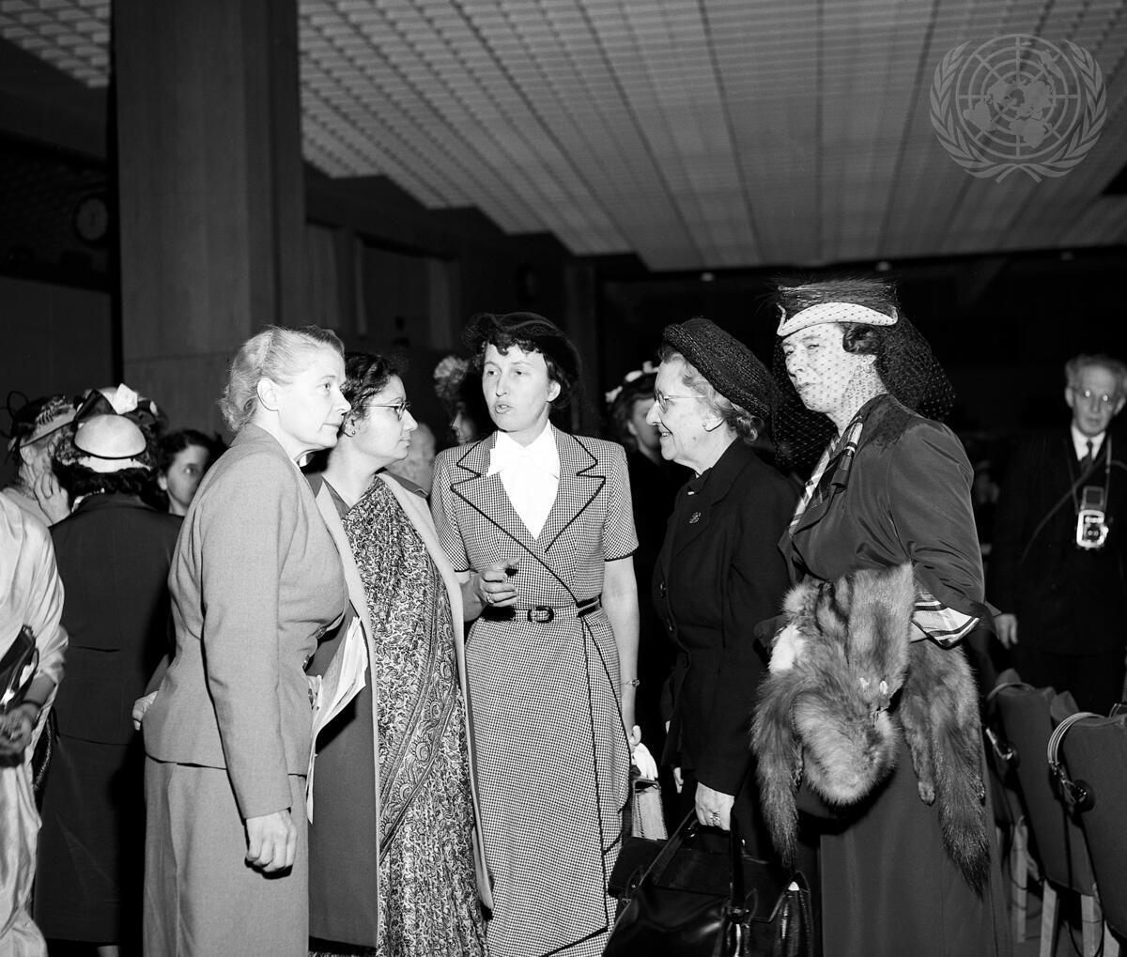
Headline: Fourth Session of United Nations Commission on the Status of Women
Caption Description: Before opening meeting, from left to right, are: Mrs. Alva Mirdal, Principal- Director, UN Department of Social Affairs, Representative of UN Secretary-General; Mrs. Hannah Sen, of India, Vice-Chairman; Madame Marie Helene Lefaucheux, of France, Chairman; Madame Lina P. Tsaldaris, of Greece; and Mrs. Olive Remington Goldman, of the United States.
City/Location: New York
Country: United States of America
Production Date: 5/8/1950 10:27:41 AM
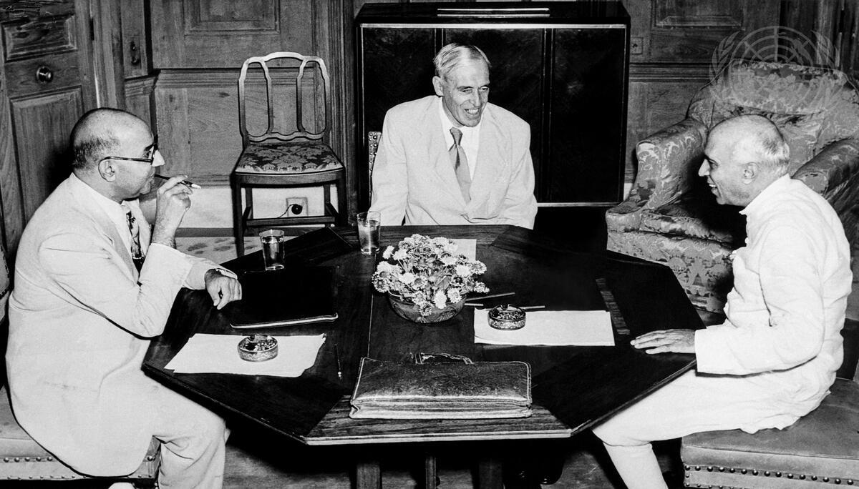
Headline: Sir Owen Dixon Meets Pandit Nehru
Caption Description: His Excellency Mr. Liaquat Ali Khan (left), Prime Minister of Pakistan, photographed with Sir Owen Dixon (center), United Nations Mediator on Kashmir, and the Hon’ble Pandit Jawaharlal Nehru (right), Prime Minister, at a meeting held at Government House, in New Delhi, on July 20, 1950.
City/Location: New Delhi
Country: India
Production Date: 7/20/1950 10:18:47 PM

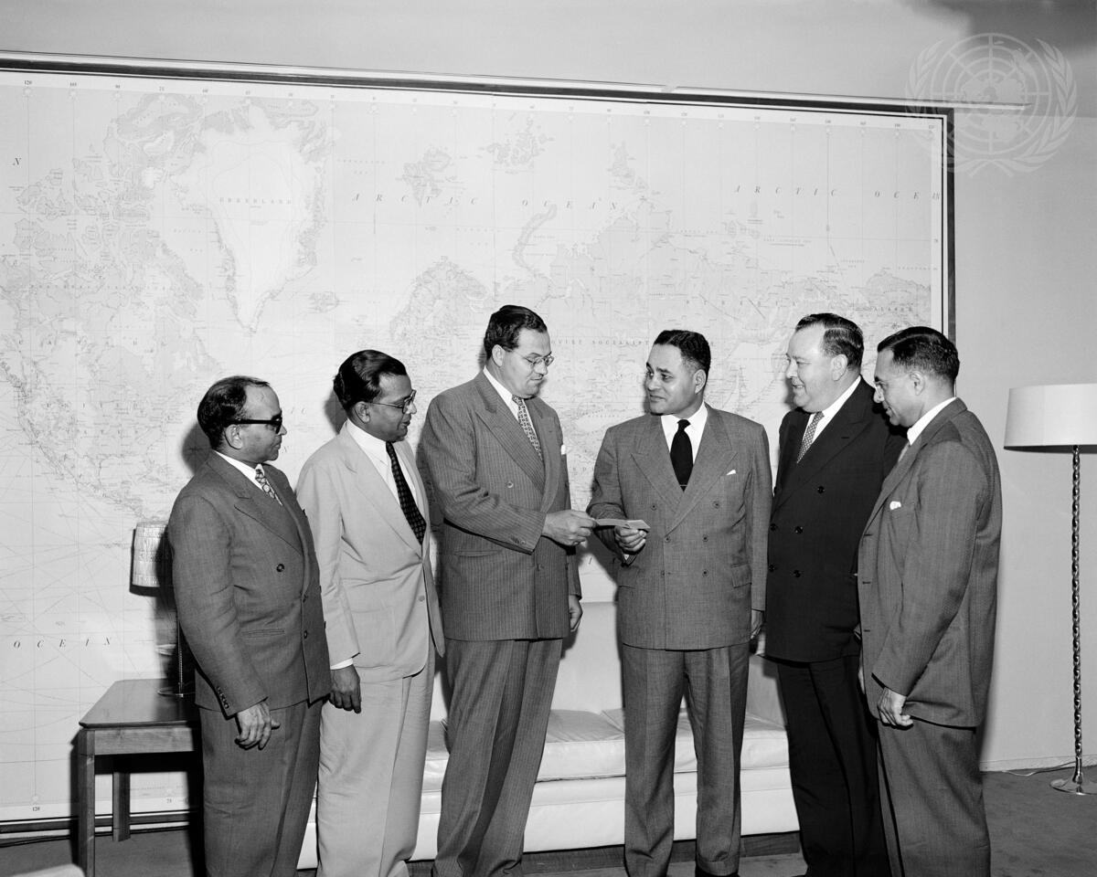
Headline: Relief to India
Caption Description: In the Secretary-General's office, at UN Headquarters, Dr. Ralph Bunche (third from the right), Principal Director of the UN Division of Trusteeship and Chairman of the United Nations Secretariat Committee for Food Relief to India, presents a cheque for $11,000 to Mr. George E.H. Marshall, Chief of the Procurement , Section of UNICEF. The cheque represents the money contributed by UN Secretariat members to buy grain for famine-stricken India. Looking on are (left to right) Mr. Syed H. Ahmed, of the Department of Public Information, and Mr. T. A. Raman, Chief of the UN Publication Services and Secretary of the Committee; Mr. Trygve Lie, UN Secretary-General, and Mr. Shamaldharee Lail, Assistant Secretary-General in charge of the UN Department of Conference and General Services. City/Location: New York
Country: United States of America
Production Date: 5/24/1951 2:19:15 PM
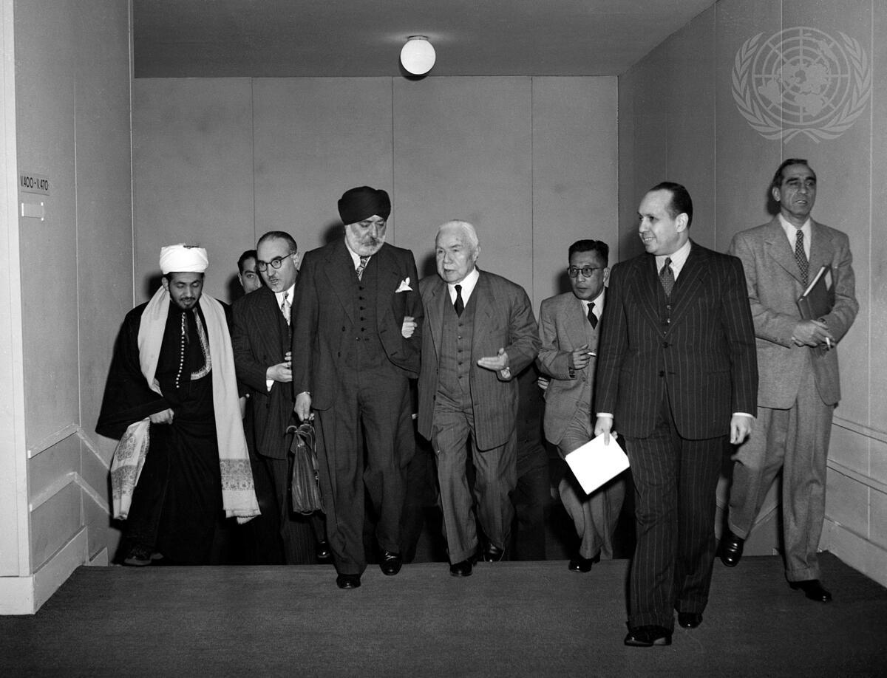
Headline: Representatives of Arab Countries and India Discuss Question of Tunisia
Caption Description: Shown here after a conference held by the representatives of India and the Arab countries on the subject of Tunisia are, from left to right: Said Hassan Ibrahim, Yemen; Dr. Rachad Pharaon, Saudi Arabia; Mr. Sardar H.S. Malik, India; Faris El-Khoury Bey, Syria; and Salah El-Din Pasha, Egypt. January 1952.
City/Location: Paris
Country: France
Production Date: 1/1/1952 3:19:16 PM

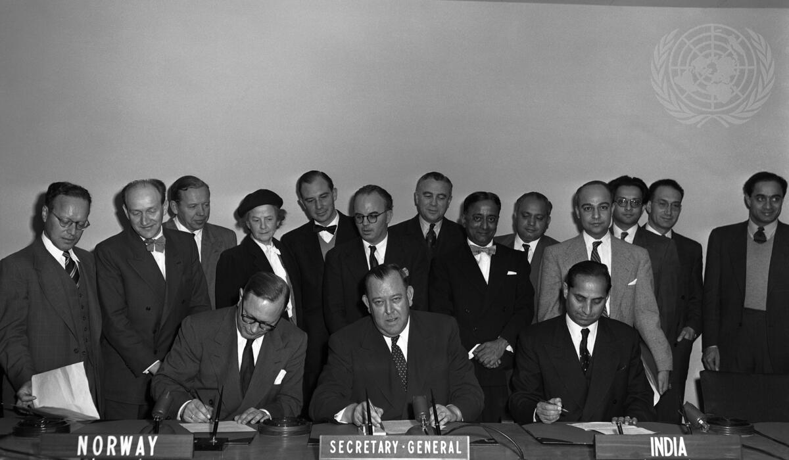
Headline: U.N. Norway and India Sign Tripartite Agreement on Economic Development
Caption Description: Mr. Hans Engen (left), Permanent Representative of Norway to the U.N.; Mr. Trygve Lie (center), United Nations Secretary-General; and Mr. Rajeshwar Dayal, Permanent Representative of India, sign a tripartite agreement between the United Nations, the Government of Norway and the Government of India, concerning economic development.
Norway has created a Foundation for Assistance to Under-Developed Countries and has appropriated for it 10,000,000 kroners (US$ 1,400,000). It expects to raise additional funds through a public campaign.
City/Location: New York
Country: United States of America
Production Date: 10/17/1952 8:29:57 PM
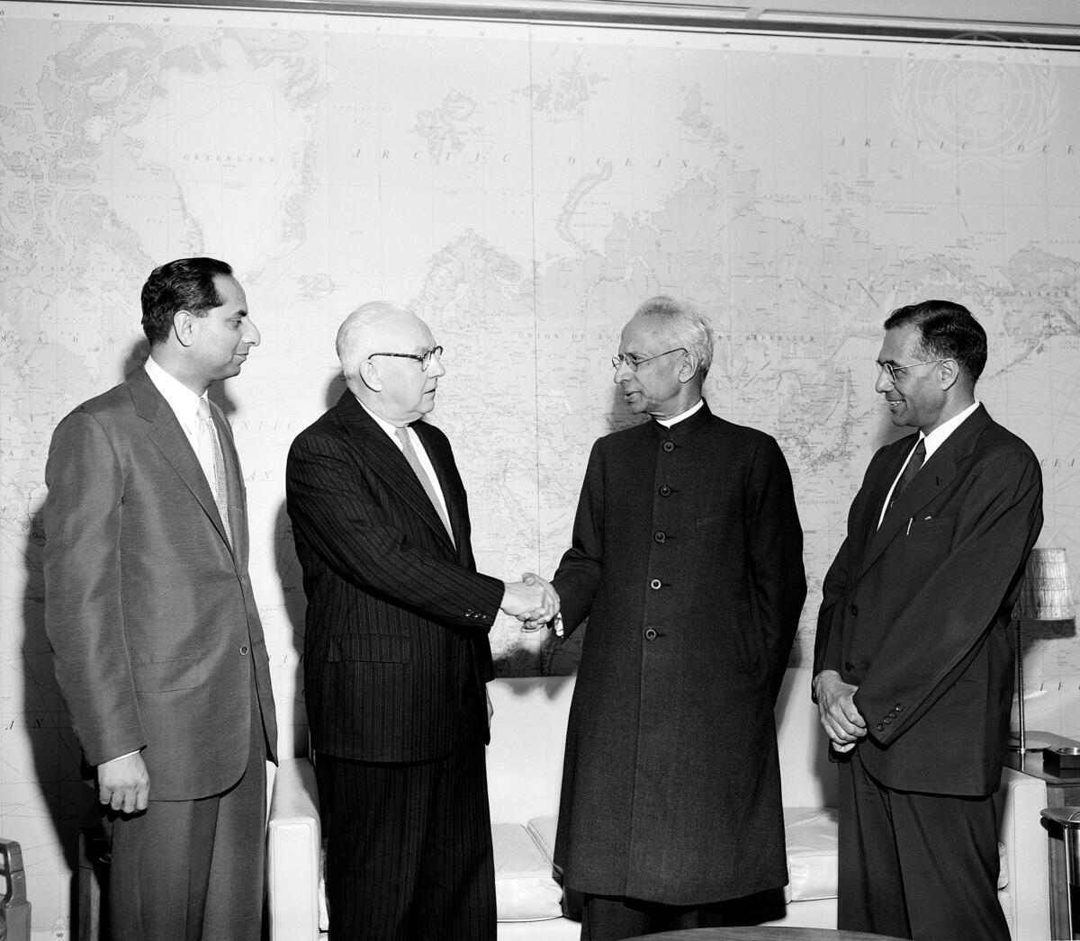
Headline: Vice-President of India Visits United Nations
Caption Description: The Vice-President of India, Dr. Sarvepalli Radhakrishnan, who is in the United States for a good-will tour of that country and Canada, today paid an official visit to U.N. headquarters in New York. Dr. Radhakrishnan is seen here (right) shaking hands with Mr. Byron Price, Acting Secretary-General of the U.N., as Mr. Rajeshwar Dayal (left), India's Permanent Representative to the United Nations, and Mr. Shamaldharee Lall, Assistant Secretary-General of the U.N. in charge of the Department of Conference and General Services, look on.
City/Location: New York
Country: United States of America
Production Date: 6/4/1953 12:56:44 PM
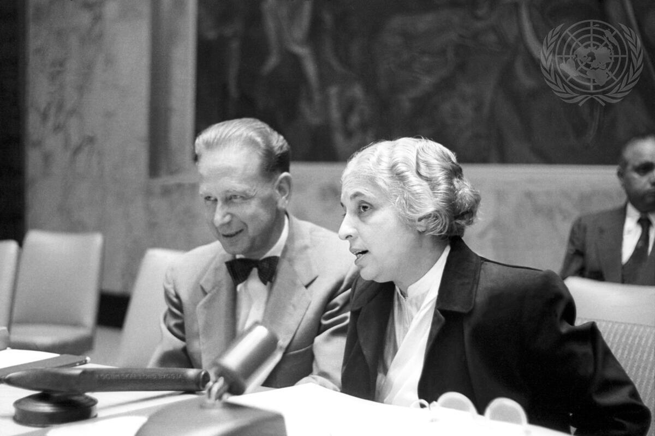
Headline: Madame Pandit, President of the U.N. General Assembly
Caption Description: The eighth session of the United Nations General Assembly, which convened yesterday at U.N. Headquarters, elected Madam Vijaya Lakshmi Pandit, of India, as its President. Madam Pandit is photographed here with U.N. Secretary - General Dag Hammarskjöld. (Picture taken is the Security Council chamber before the meeting of Steering Committee). Madame Pandit is the first woman president ever elected by a U.N. General Assembly.
City/Location: New York
Country: United States of America
Production Date: 9/16/1953 9:47:04 PM

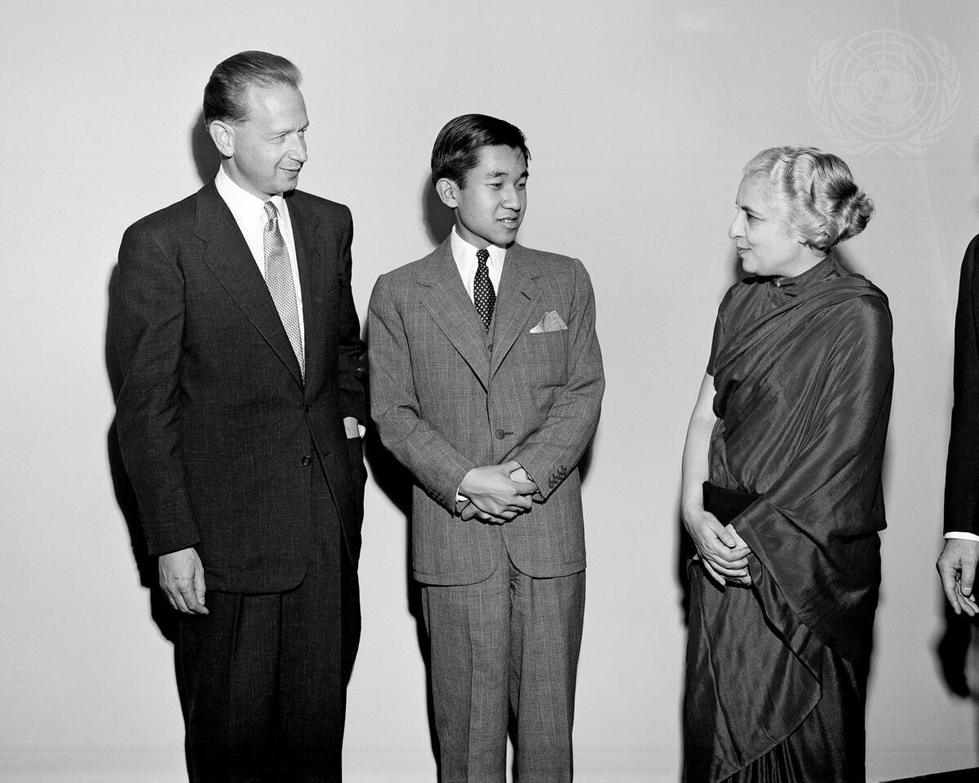

Headline: Crown Prince of Japan Visits U.N. Headquarters
Caption Description: The Crown Prince Akihito, who is seen here with U.N. Secretary-General Dag Hammarskjöld and Mrs. Vijaya Lakshmi Pandit, of India, President of the General Assembly, said: ""I consider my visit today to be one of the highlights of my entire trip. As a Japanese, the desire has sprung in my heart to see the day as soon as possible when my country will become a member nation of this Organization, the embodiment of aspiration for world peace.""
City/Location: New York Country: United States of America
Production Date: 9/17/1953 12:31:32 PM

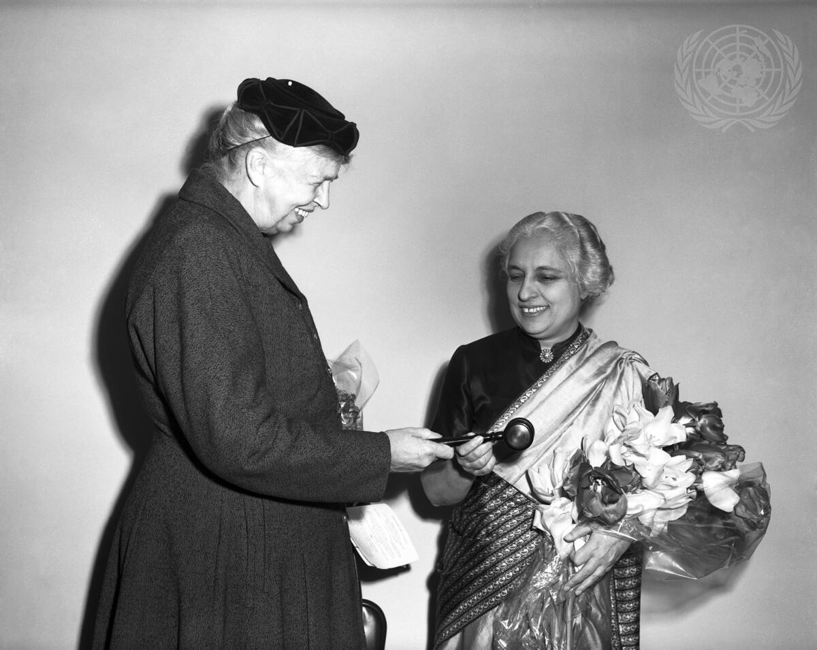
Headline: Eleanor Roosevelt Presents Madame Pandit with a Gavel
Caption Description: On the occasion of the celebration of United Nations Day, Eleanor Roosevelt (left), member of the United States delegation to the United Nations General Assembly, presents a gavel to Vijaya Lakshmi Pandit, Chairman of the delegation of India and President of the current session of the United Nations General Assembly.
Mrs. Roosevelt, who was presenting the gavel in the name of WE THE PEOPLE, told Madame Pandit: ""We hope that you will use it and that in the future it will remind you of the services that you have rendered and of the gratitude which We The People feel for all you are doing for us and for the world."" City/Location: New York
Country: United States of America
Production Date: 10/24/1953 9:47:35 PM
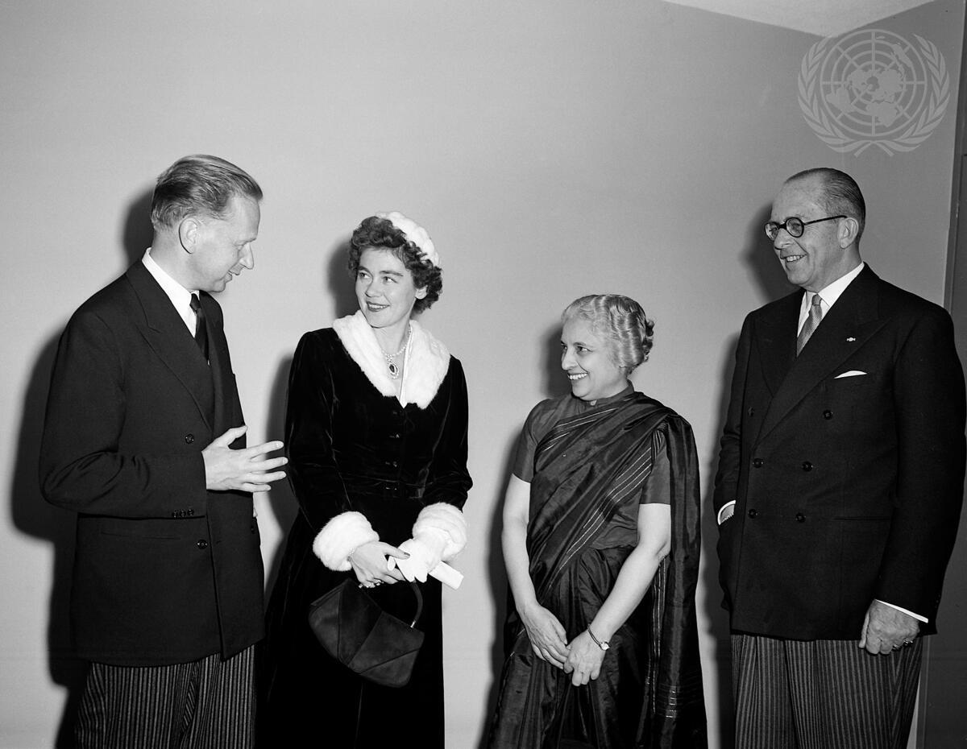
Headline: King and Queen of the Hellenes Visit United Nations
Caption Description: The King and Queen of the Hellenes [Greece], who are at present engaged in a month-long trip in the United States, today paid an official visit to United Nations Headquarters, in New York. This picture, taken during Their Majesties' visit, shows (left to right) : Mr. Dag Hammarskjöld, Secretary-General of the U.N.; Queen Frederika; Madame Vijaya Lakshmi Pandit, of India, President of the current session of the General Assembly; King Paul.
City/Location: New York
Country: United States of America
Production Date: 11/3/1953 5:10:38 PM

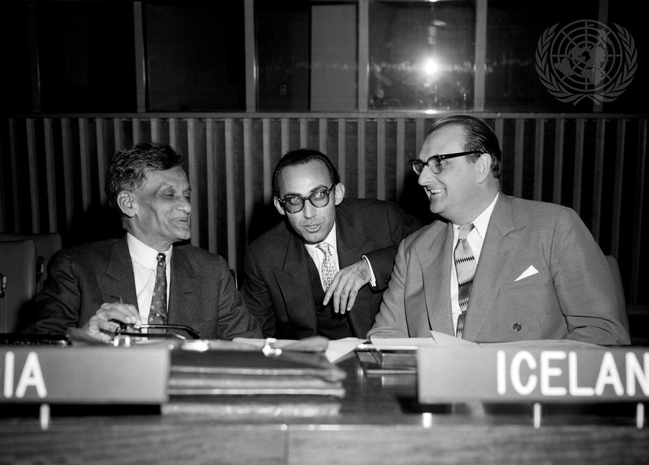
Headline: Sixth Committee Continues Debate on Diplomatic Intercourse and Immunities
Caption Description: The Sixth (Legal) Committee of the UN General Assembly this morning
continued its general debate on Chapter III of the International Law Commission's report dealing with diplomatic intercourse and Immunities. Here, exchanging views shortly before the meeting got under way, are (left to right): Mr. Akbar Ali Khan (India); Dr. F. Adamiyat (Iran); and Mr. Petur Thorsteinsson (Iceland).
City/Location: New York
Country: United States of America
Production Date: 11/5/1953 5:50:04 PM

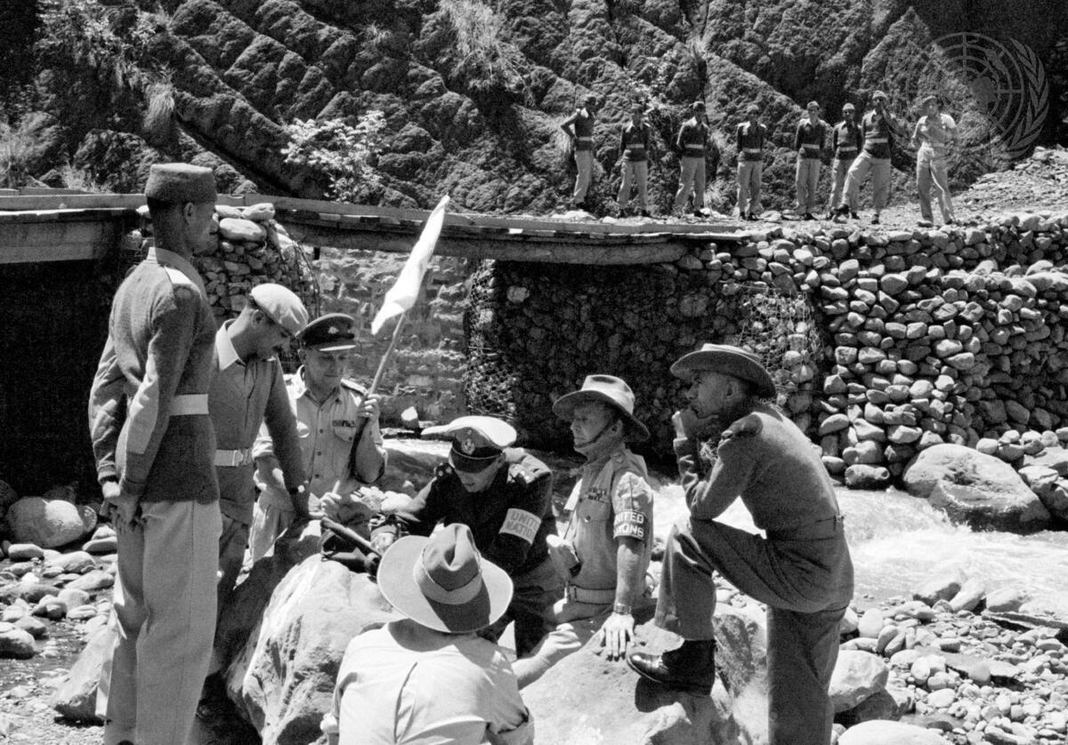
Headline: United Nations Military Observers in Kashmir
Caption Description: This picture, taken on the cease-fire line, shows a meeting between Indian and Pakistani officers and members of the U.N. Military Observer Group. The meeting was held to investigate an incident and interrogate a witness.
Two Pakistani officers (l to r) Major J.D. Murray (Australia), Major Emilio Altieri (Uruguay), Lt. - Col. R.H. Marson (Australia), and an Indian officer. Back to camera is Major F.H. Moy (Australia). 1955.
Production Date: 1/1/1955 11:33:44 AM

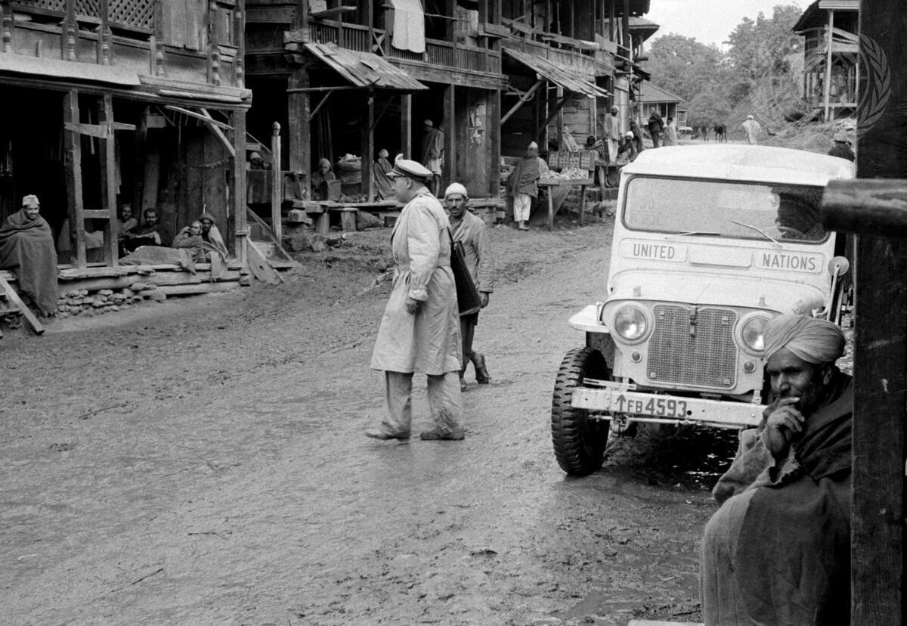
Headline: United Nations Military Observers in Kashmir
Caption Description: A member of the U.N. Military-Observer Group in India and Pakistan- Major Emilio Altieri (Uruguay)- on his way to a field station on the Kashmir cease-fire line, stops his jeep in front of the bazaar in a village to interview the inhabitants. [Exact date unknown]
Production Date: 1/1/1955 11:35:54 AM

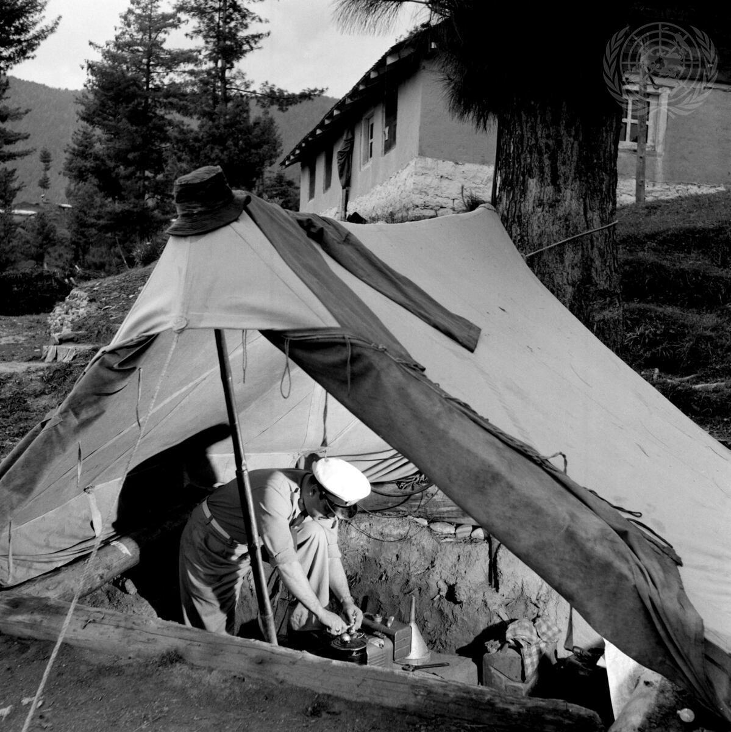
Headline: United Nations Military Observers in Kashmir
Caption Description: One of the radio operators of the U.N. Military Observer Group in India and Pakistan checks the electric generator at one of UNMOGIP's field stations. This gasoline-driven generator is sheltered under a tent outside the observer's building (seen in the background), it provides the electricity needed for the radio-communications with the Group's Headquarters. [Exact date unknown]
Production Date: 1/1/1955 12:19:53 PM

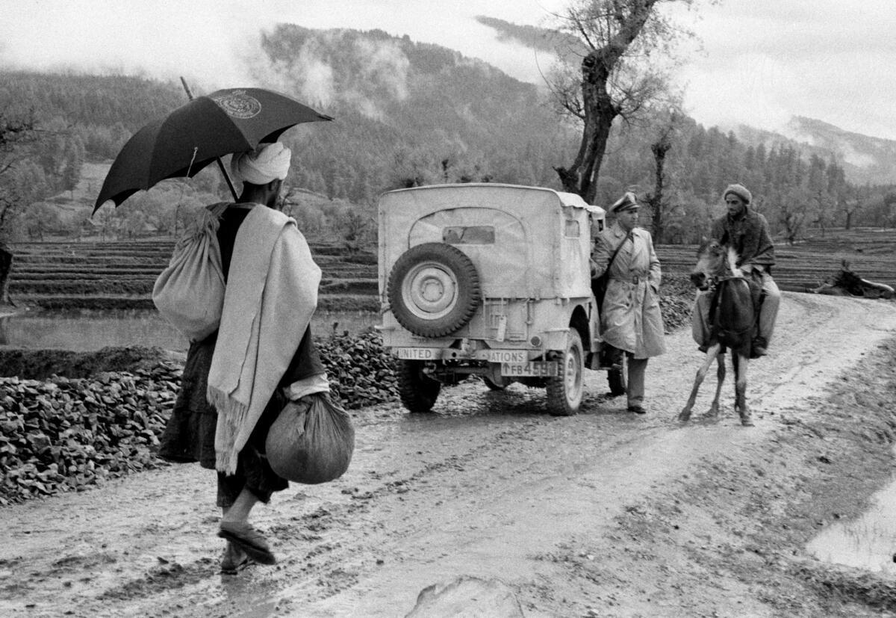
Headline: United Nations Military Observers in Kashmir
Caption Description: One of the members of the U.N. Military Observer Group in India and Pakistan - Major Emilio Altieri (Uruguay) - asks his way to a passing horseman, while going to the cease-fire line to investigate an incident. The road is typical of Kashmir. [Exact date unknown]
Production Date: 1/1/1955 12:21:27 PM

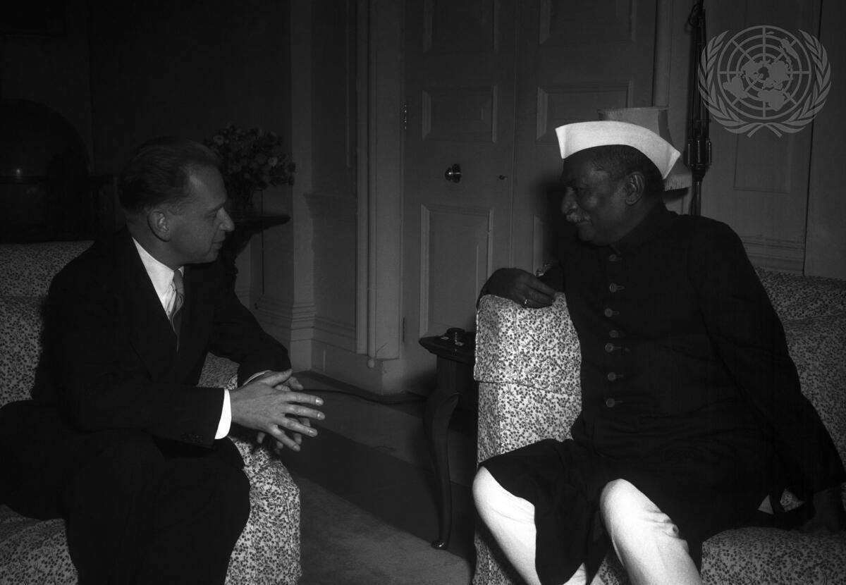
Headline: The Secretary-General of the U.N. at New Delhi
Caption Description: U.N. Secretary-General Dag Hammarskjold is on his way to Peiping, where he will hold discussions with the Prime Minister of the Chinese People’s Republic in fulfilment of the Assembly's request that he seek the release of all U.N. Command personnel detained against their will, including 11 U.S. airmen sentenced to imprisonment on espionage charges. Mr. Hammarskjold left New York on 30 December, accompanied by a party of six, and arrived in New Delhi yesterday afternoon, after brief stops in London, Paris and Karachi. Today, the Secretary-General had conversations with the President of India, Dr. Rajendra Prasad, and Premier Jawaharlal Nehru, with whom he also lunched. Here is a photograph of the meeting between Mr. Hammarskjold and Dr. Prasad.
City/Location: New Delhi
Country: India
Production Date: 1/3/1955 10:37:40 PM
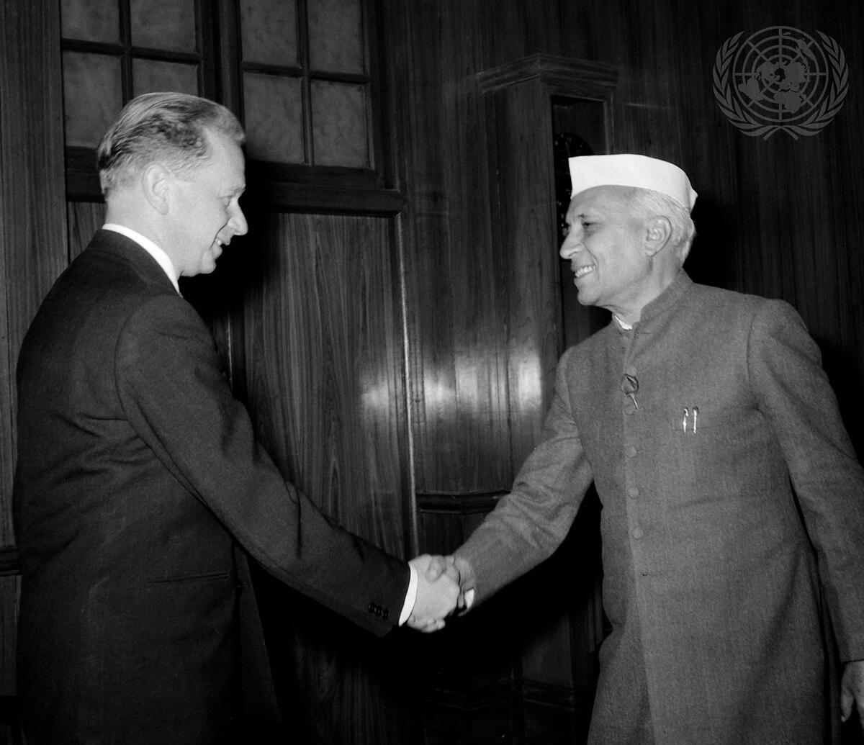
Headline: Secretary-General Visits New Delhi
Caption Description: Secretary-General Dag Hammarskjöld (left) meets with Jawaharlal Nehru, Prime Minister of India. The Secretary-General traveled to Peking to seek the release of all UN Command personnel detained against their will, including 11 U.S. airmen sentenced to imprisonment on espionage charges.
City/Location: New Delhi Country: India
Production Date: 1/3/1955 5:39:31 PM

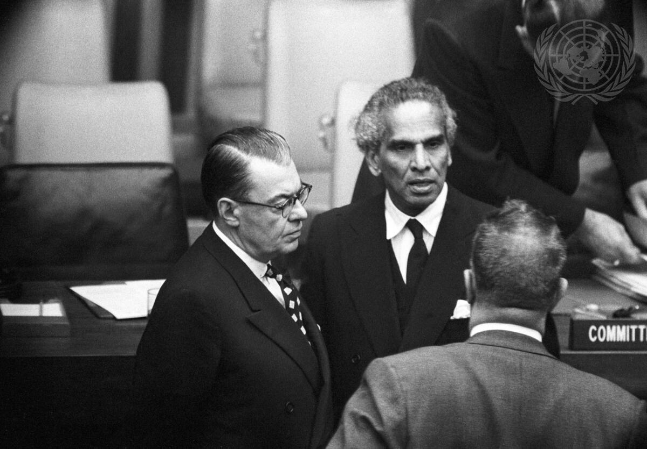
Headline: The "Atoms for Peace" Question before the 1st Committee
Caption Description: The General Assembly's 1st (Political & Security) Committee is now conducting its general debate on the question of the peaceful uses of atomic energy.
This picture, taken before today's meeting, shows Mr. Paul Martin (left), of Canada, and Mr. V.K. Krishna Menon, of India, exchanging views with Sir Leslie Munro (back to camera), of New Zealand, Chairman of the Committee.
City/Location: New York
Country: United States of America
Production Date: 10/10/1955 5:20:39 PM
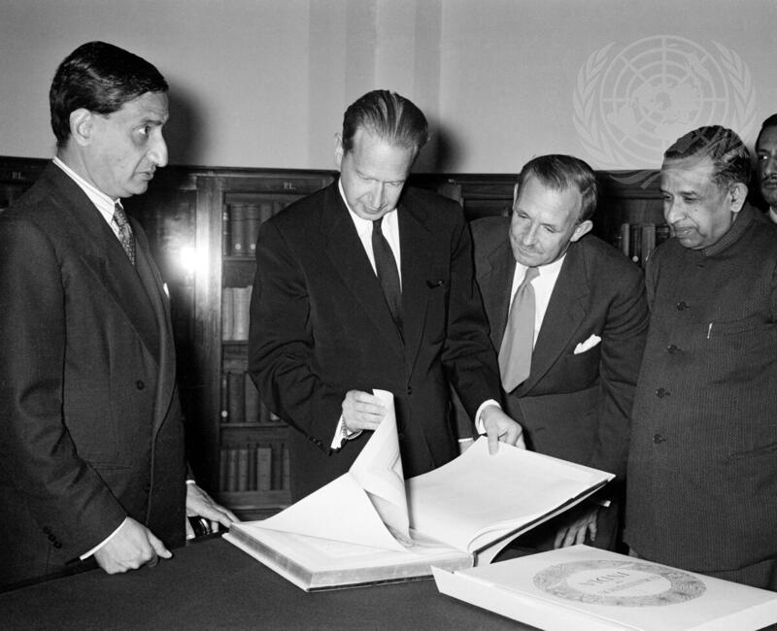
Headline: UN Secretary-General in New Delhi Caption Description: UN Secretary-General Dag Hammarskjöld is now in New Delhi for a three-day visit to the Indian capital. He is seen here looking at a special copy of the Constitution of India which was given to him today by the secretaries of the Lok Sabha (Parliament) and Rajyan Sabha (Upper House). Others in the picture are (l. to r.): Mr. M.N. Kaul, Secretary of the Lok Sabha; Mr. George Ivan Smith, Director of the UN Information Centre in London; and Mr. S.N. Mukherjee, Secretary of the Rajya Sabha. City/Location: New Delhi Country: India Production
Date: 2/4/1956 12:00:00 AM
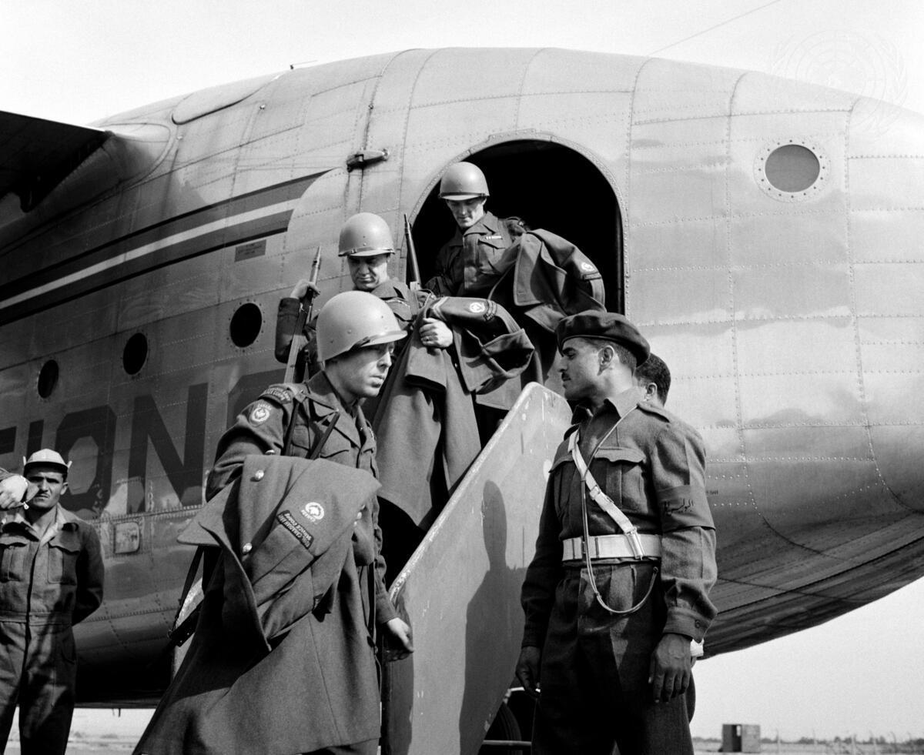
Headline: Visit to Units of the UN Emergency Force (UNEF) in Egypt
Caption Description: This picture is part of a series taken early this month, during visits by correspondents to units of the UN Emergency Force (UNEF). A Canadian contingent arriving at Abu Suweir, transit camp near Ismailia, after a flight from Capodichino Airport, near Naples, Italy. The men wear helmets painted UN blue to identify them as members of the Emergency Force. The plane is one of the C-119 ""flying boxcars"" provided by Canada to fly air transport support for the UN Force. December 1956.
Country: Egypt
Production Date: 12/1/1956 10:27:41 AM
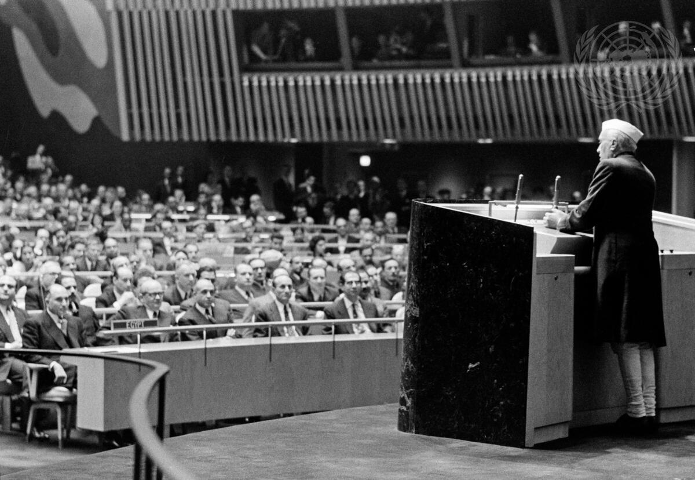
Headline: India's Prime Minister Visits UN Headquarters Caption Description: The Prime Minister of India, Pandit Jawaharlal Nehru, who is at present in the United States, came to New York today for a two-day visit at United Nations Headquarters. He is seen here at the rostrum of the General Assembly auditorium, addressing guests and delegates after a reception given in his honour by the Indian representatives at the UN.
City/Location: New York Country: United States of America Production
Date: 12/20/1956 1:44:47 PM
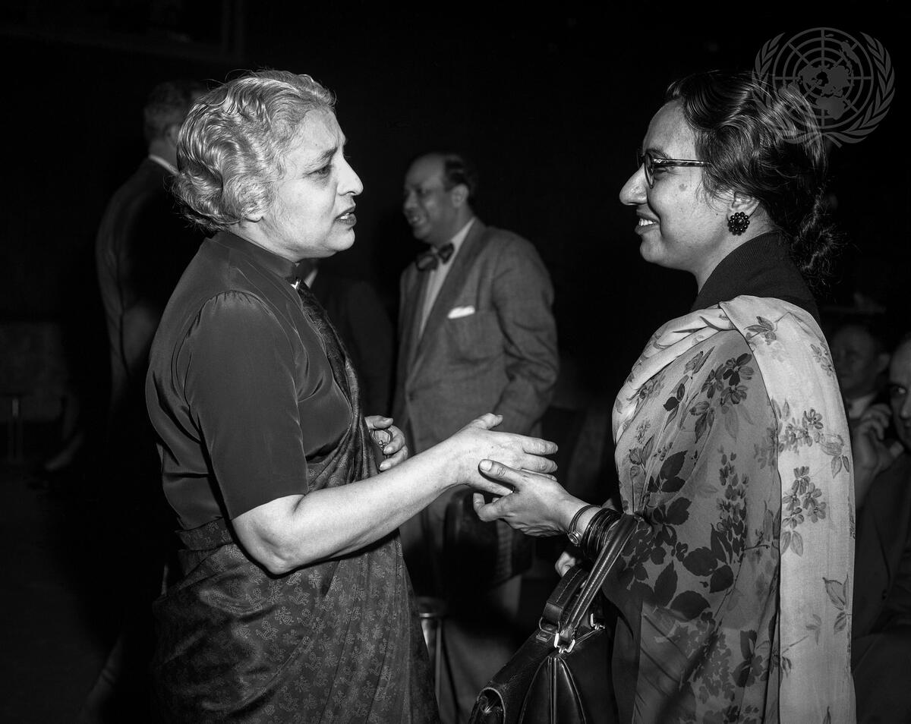
Headline: Security Council Hears India's Reply on Kashmir
Caption Description: The Security Council held morning and afternoon meetings today at which it heard India's reply to the charges on the Kashmir question made last week by Pakistani Foreign Minister Firoz Khan Noon. India's case was presented by V.K. Krishna Menon, Indian Minister without Portfolio, who started his address at the morning session and continued it in the afternoon. Here, the Begum Ikramullah (right), one of the Pakistani representatives to the current session of the General Assembly, and Mme Pandit, of India, are having an informal chat in the Security Council chamber, before the opening of the meeting.
(Mme Vijaya Lakshmi Pandit, who is the sister of Prime Minister Nehru of India, was President of the 8th session of the General Assembly, in 1953.)
City/Location: New York
Country: United States of America
Production Date: 1/23/1957 10:04:41 PM
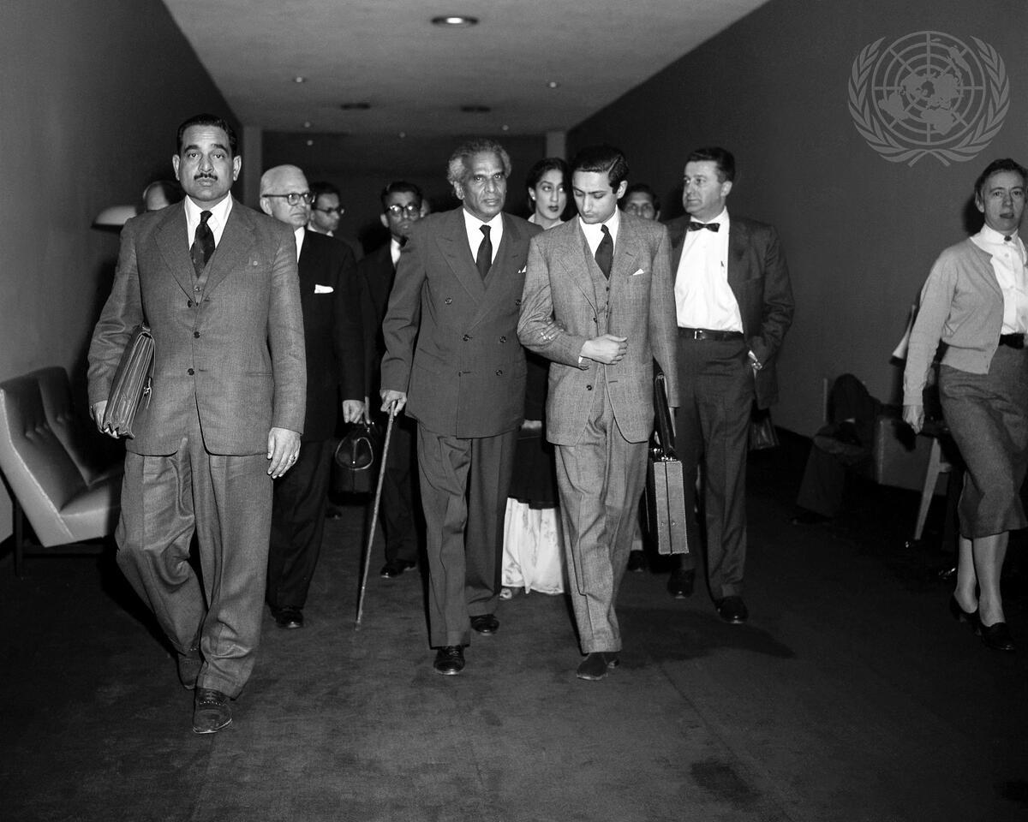
Headline: Security Council Concludes Kashmir Debate
Caption Description: By a vote of ten to none, with the USSR abstaining, the U.N. Security Council today approved a three-power resolution requesting its President, Gunnar Jarring of Sweden, to undertake a visit to India and Pakistan during which he will examine with the two governments proposals likely to contribute to a settlement of the Kashmir problem. This picture shows Mr. V.K. Krishna Menon, Chairman of the Indian delegation arriving for today’s meeting. Mr. Menon, who had been indisposed at the close of yesterday’s meeting, holds the arm of the arm of Mr. R. Bhandari, Under-Secretary at the Indian Ministry of External Affairs.
City/Location: New York
Country: United States of America
Production Date: 2/21/1957 9:50:17 PM
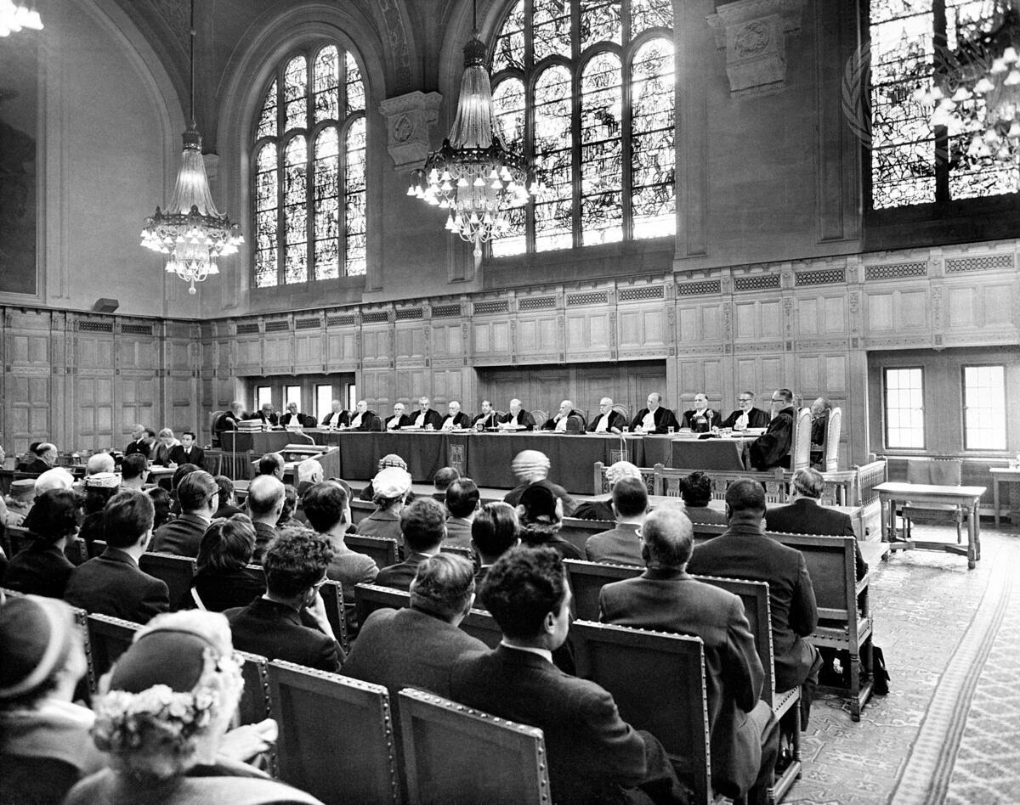
Headline: The International Court of Justice
Caption Description: Today, at the Peace Palace in The Hague, the International Court of Justice opened hearings in a case brought before it in December 1955 by the Government of Portugal against the Government of India, concerning the right of passage over Indian territory. A partial view of the courtroom during the opening session. At the bench are the fifteen judges of the Court and the ad hoc judges designated for this case.
City/Location: New York
Country: United States of America
Production Date: 9/23/1957 10:27:41 AM

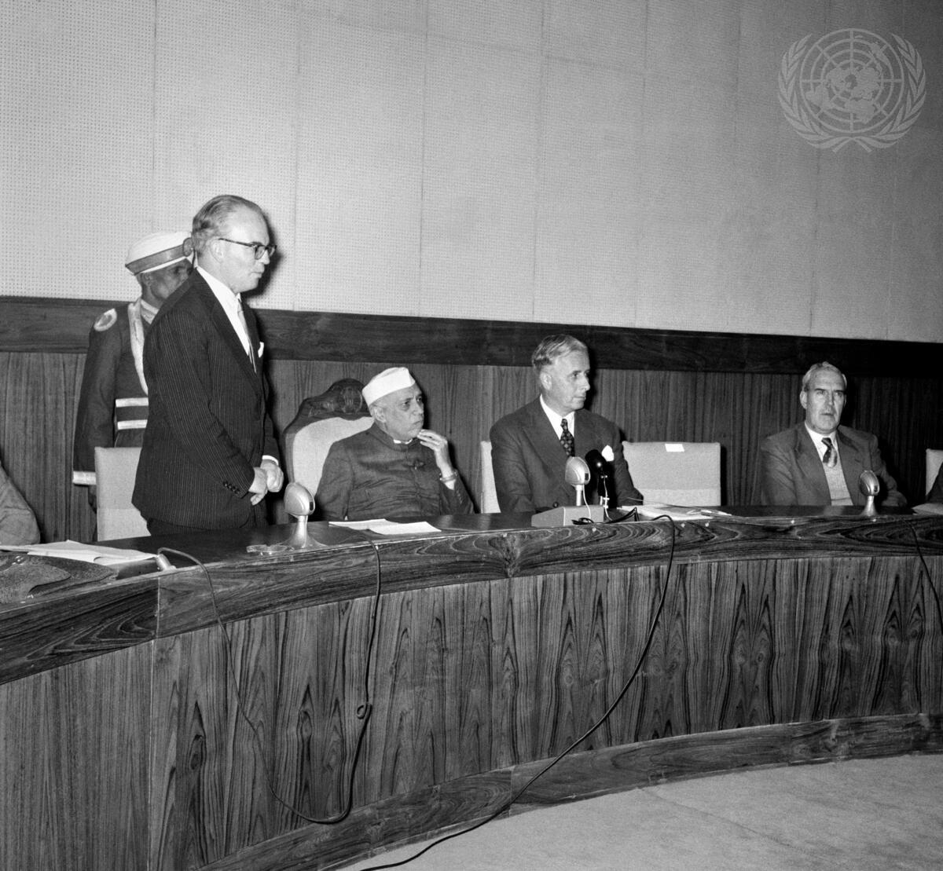
Headline: Prime Minister Nehru of India Addresses Meeting of Experts in New Delhi
Caption Description: Prime Minister Jawaharlal Nehru, of India, today addressed a meeting of foreign experts working in India under the United Nations Expanded Programme of Technical Assistance. The meeting took place at Vigyan Bhavan, New Delhi.
Mr. David Owen (left), Executive Chairman of the UN Technical Assistance Board, welcoming Mr. Nehru (2nd from left). At right of Mr. Nehru is Mr. James Keen, Resident Representative in India of the U.N. Technical Assistance Board. Sir Alexander Macfarquhar, Asian Regional Representative of UNTAB can be seen second from the right.
City/Location: New Delhi
Country: India
Production Date: 1/24/1958 12:20:06 PM
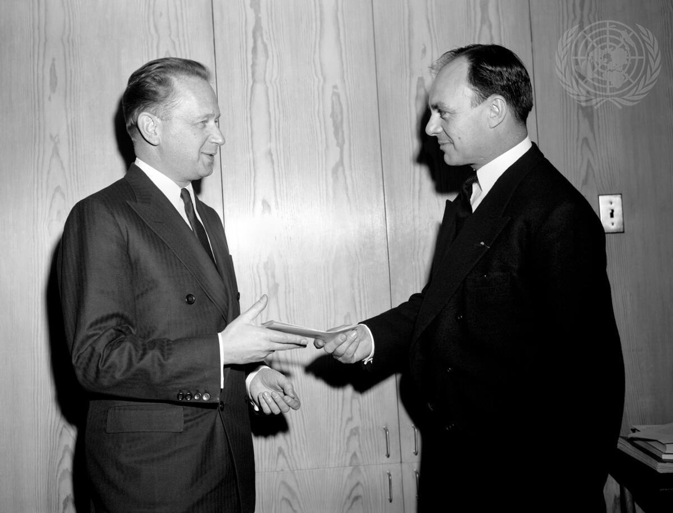
Headline: Pakistan's New Permanent Representative to UN Presents Credentials
Caption Description: Ambassador Aly Khan, the new Permanent Representative of Pakistan to the United Nations, is seen here (righe) as he presented his credentials today to U.N. Secretary-General Dag Hammarskjold.
City/Location: New York
Country: United States of America
Production Date: 3/4/1958 12:17:47 PM
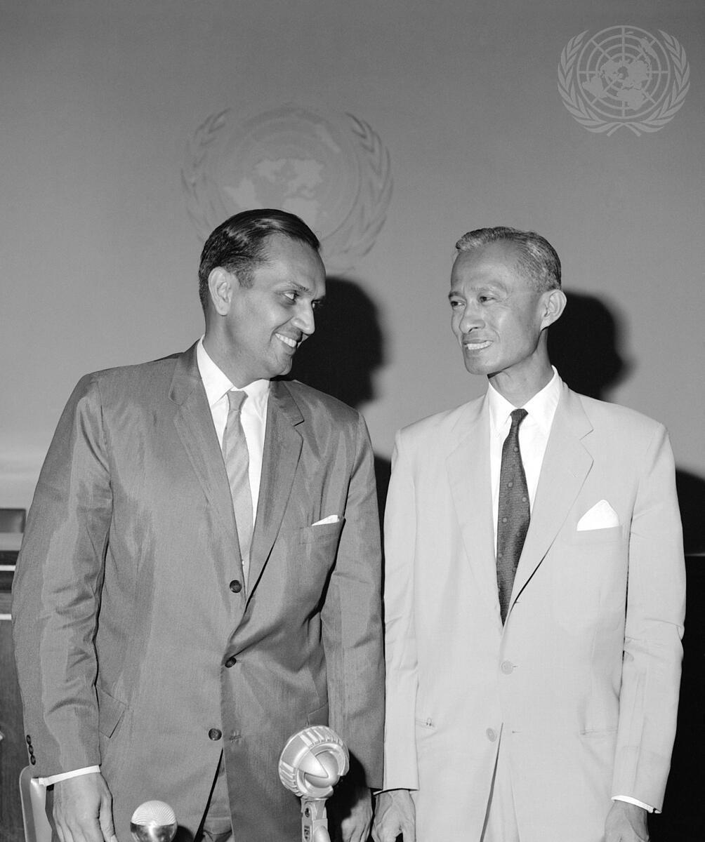
Headline: Former and New ECAFE Chiefs Hold Joint Press Conference
Caption Description: C.V. Narasimhan (left), Outgoing Executive Secretary of the Economic
Commission for Asia and the Far East (ECAFE) and his successor U Nyun, hold a joint press conference on the growing strength and stature of the Economic Commission for Asia and the Far East, at the Organization's headquarters in Bangkok, Thailand. Mr. Narasimhan is taking up a new position as UN Under-Secretary for Special Political Affairs at UN Headquarters in New York. The appointment of U Nyun as the new ECAFE Executive Secretary was announced by UN Secretary- General Dag Hammarskjold on 27 February 1959.
City/Location: New York
Country: United States of America
Production Date: 3/31/1959 12:28:18 PM
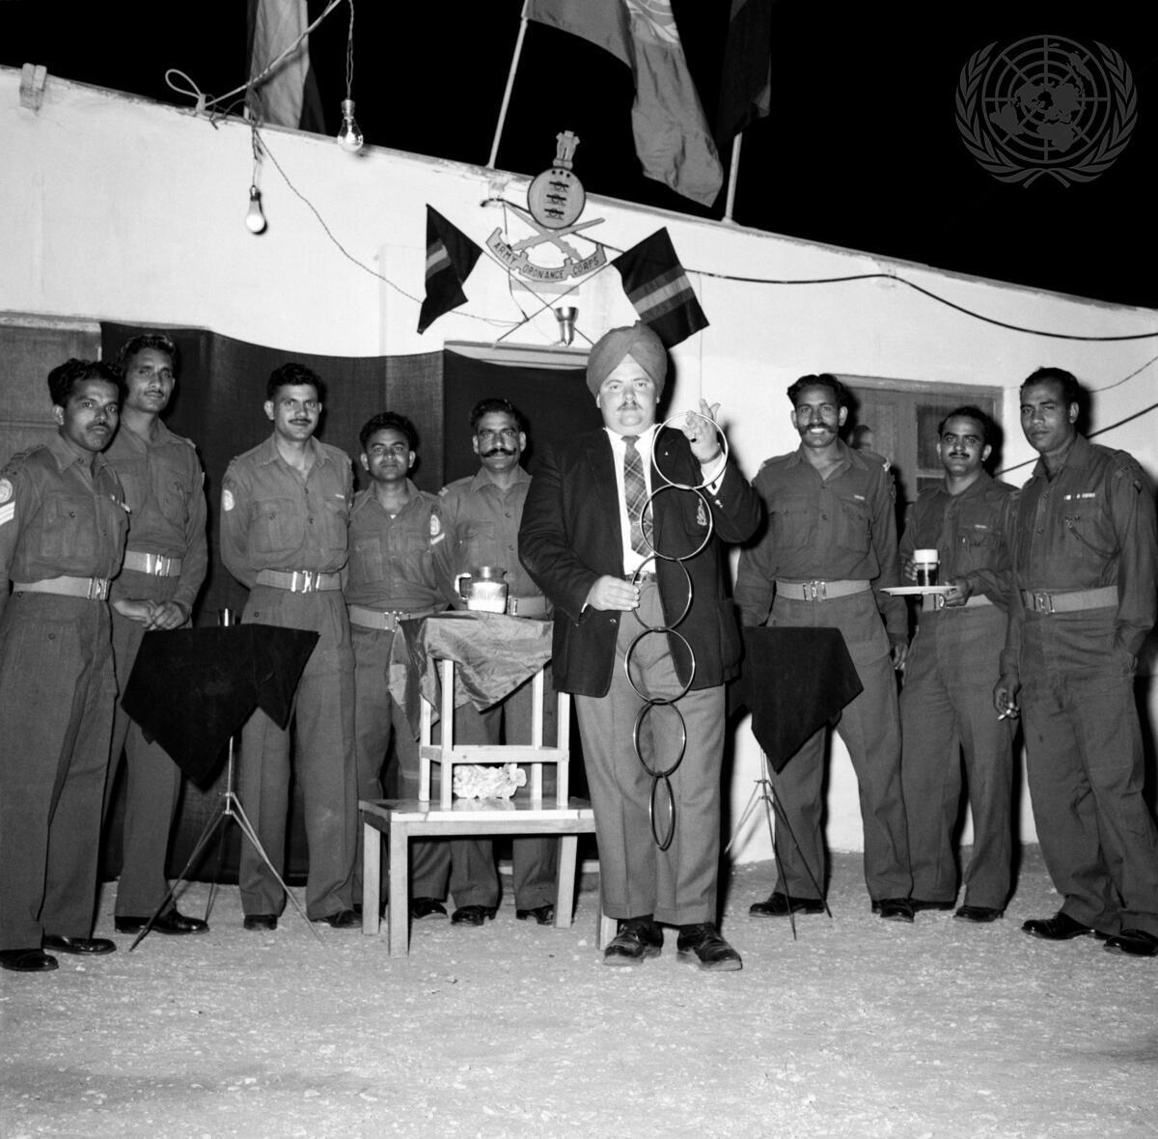
Headline: Indian Army Ordnance Corps Soldiers with UNEF Celebrate Anniversary
Caption Description: The Indian Army Ordnance Corps Detachment of the Indian Contingent with the United Nations Emergency Force (UNEF) today celebrated the 184th anniversary of their Corps, at the UNEF Maintenance Area in Rafah, at the southern end of Gaza Strip. The members of the Indian Ordnance Detachment arranged a special dinner for the occasion, inviting their colleagues of the Royal Canadian Army Ordnance Corps.
The members of the Royal Canadian Army Ordnance Corps with their Indian hosts. In the centre is Colonel W.H. Colling, of Canada, Commander of the UNEF Maintenance Area in Gaza Strip, at Rafah.
Production Date: 4/8/1959 3:37:40 PM

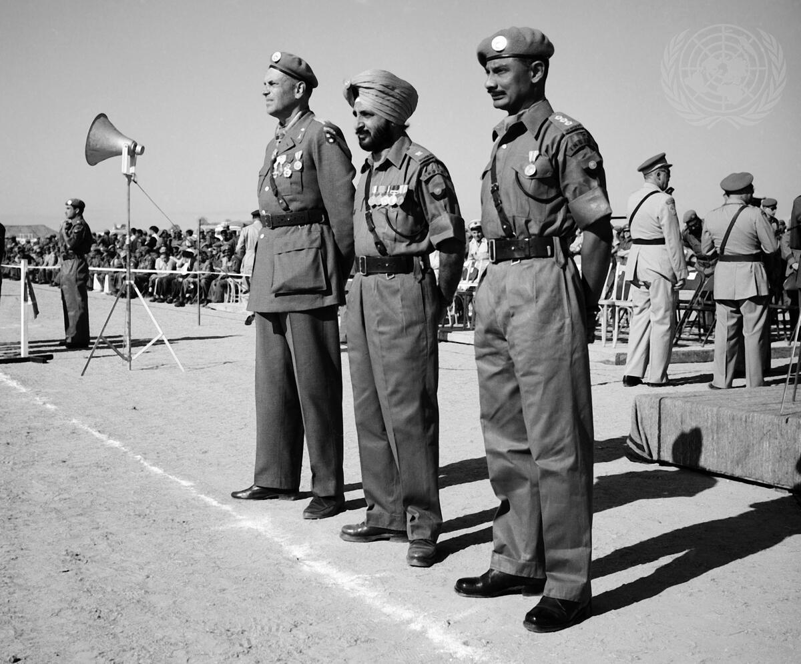
Headline: Members of UN Emergency Force in Gaza Observe United Nations Day
Caption Description: The activities of the United Nations Emergency Force in the Gaza Strip, in observance of United Nations Week, climaxed in a ceremonial parade held at Gaza airfield on 24 October, United Nations Day. Fifty men from each of the seven UNEP contingents – from Brazil, Canada, Denmark, India, Norway, Sweden and Yugoslavia – formed the parade, together with a number of armored scout cars from the Canadian and Yugoslav reconnaissance squadrons. The parade was commanded by the Chief of the Swedish UNEF Battalion, Colonel E. Gyllenstierna, who is seen in this picture (left) with two officers of the Indian Battalion, 2nd Grenadiers, Major Mohinder Michigan, parade adjutant.
Production Date: 10/24/1959 2:11:07 PM

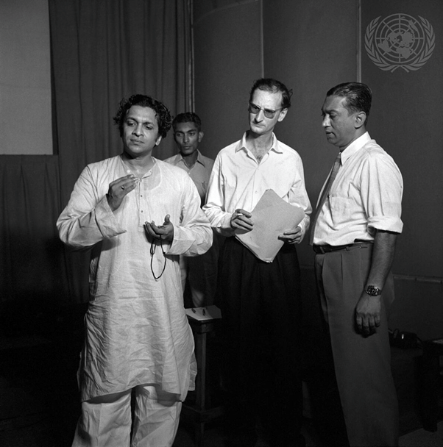
Headline: Ravi Shankar, Noted Indian Musician, Records Soundtracks for UN Asian Film Unit
Caption Description: Ravi Shankar, left, timing the music with stopwatch in hand. To his right are Audio personnel and members of the film unit.
City/Location: New Delhi
Country: India
Production Date: 1/1/1960 9:52:21 PM
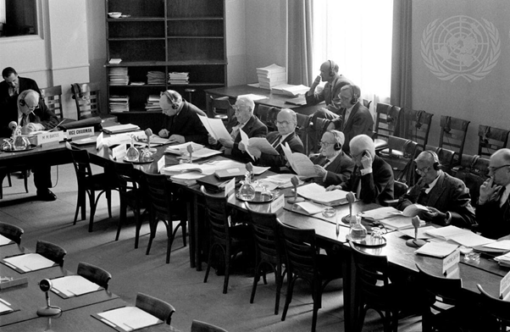
Headline: International Law Commission Holds 12th Session, 25 April-1 July 1960
Caption
Description: The current session of the International Law Commission opened on 25 April and will end on 1 July 1960. The main task of the 21 experts on international law now meeting in Geneva is the preparation of a draft convention on consular intercourse and immunities. Committee members, from left to right : Jaroslav Zourek (Czechoslovakia); Alfred Verdross (Austria); Grigory J. Tunkine (Soviet Union); Georges Scelle (France); A.E.F. Sandstrom (Sweden); Radhabinod Pal (India); and Ahmad Matine-Daftary (Iran).
Country: Switzerland
Production/Date: 4/25/1960 5:58:11 PM

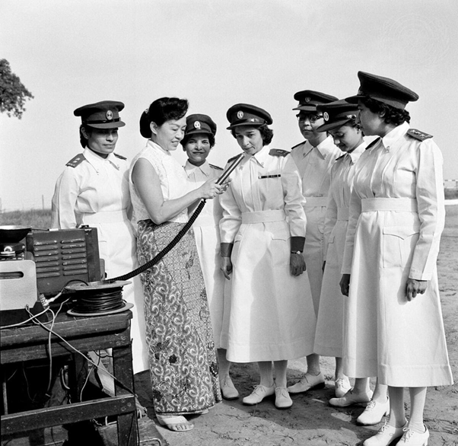
Headline: U.N. Assistance in the Congo
Caption Description: Some 19 medical and health teams provided by Red Cross and Red Crescent societies or by governments are now in the Republic of the Congo assisting the United Nations Civilian Operation to maintain normal health services in that country during the current emergency. The Government of India has provided the equipment and personnel necessary for setting up a 400-bed hospital in the Congo, at the request of the United Nations. Airlifting ofpersonnel of the Indian Armed Forces Medical Services began today at the PalamAirport where this photograph was taken as these female members of the medical corps were being interviewed over U.N. Radio.
City/Location: New Delhi
Country: India
Production Date: 9/8/1960 11:28:54 AM
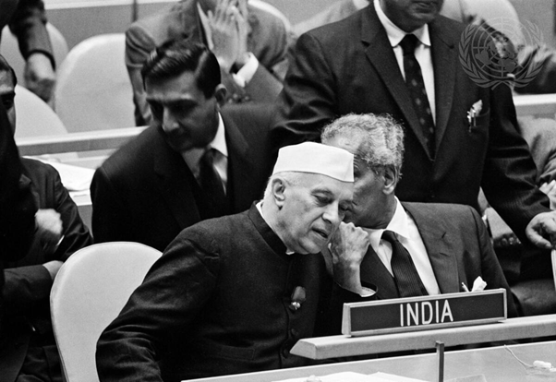

Description: The UN General Assembly, now holding its 15th session, continued general debate today. An unprecedented number of high officials are attending this session which has before it an 87-item provisional agenda, the longest in its history. Here, exchanging views in the Assembly Hall shortly before this morning's meeting got under way, are Prime Minister Jawaharlal Nehru (left), of India; and Mr. V.K. Krishna Menon, India's Minister of Defence. City/Location: New York Country: United States of America Production

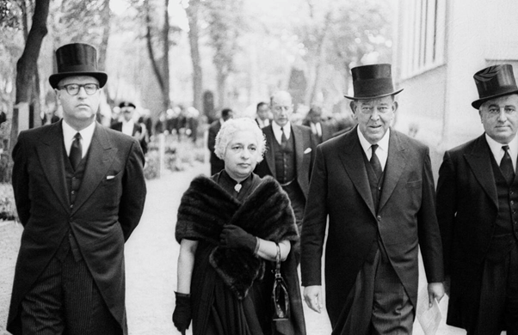
Headline: Dag Hammarskjöld Funeral Service in Sweden
Caption Description: Dignitaries from many lands came to the Swedish town of Uppsala today for the funeral service of the late U.N. Secretary-General Dag Hammarskjöld.
Uppsala – the ecclesiastical capital of Sweden – is the place where Dag Hammarskjöld was raised. Walking to the graveside is Uppsala cemetery here are (from left) Abba Eban, Israeli Minister of Education and Culture; Mme V.L. Pandit, of India, who was President of the 8th General Assembly; and Trygve Lie, of Norway, the UN’s first Secretary-General.
Country: Sweden
Production Date: 9/29/1961 3:57:52 PM
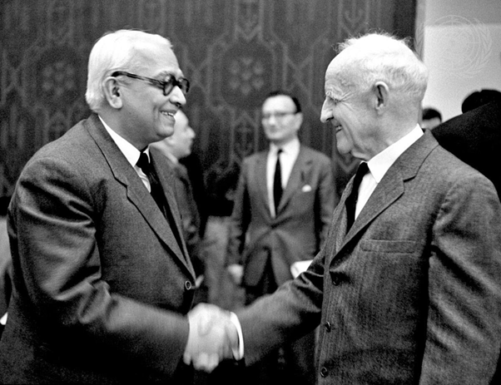

Headline: Security Council Defers Consideration of Kashmir Question
Caption Description: Mr. C.S. Jha of India, shaking hands with Dr. Frank P. Graham,
United Nations Representative for India and Pakistan.
City/Location: New York
Country: United States of America
Production Date: 2/1/1962 11:06:02 AM

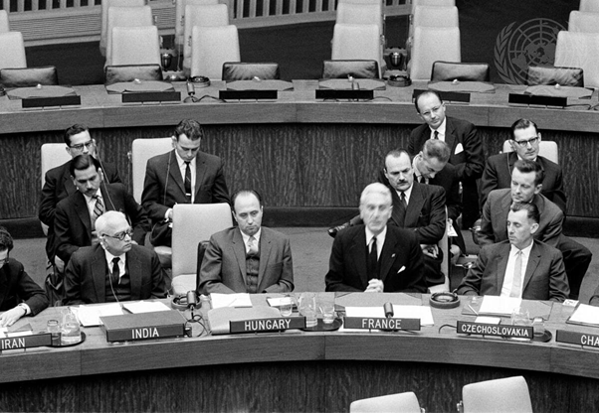
Headline: Speakers in UN Committee on Peaceful Uses of Outer Space Stress Need for International Cooperation in this Field
Caption Description: Mr. Armand BERARD (3rd from left, at table) of France, is seen here addressing the Committee. At the table, from left are: Mr. Chandra S. JHA (India), Mr. Karoly CSATORDAY (Hungary), Mr. BERARD, and Dr. Zdenik CERNIK (Czechoslovakia).
City/Location: New York
Country: United States of America
Production Date: 3/20/1962 1:18:49 PM

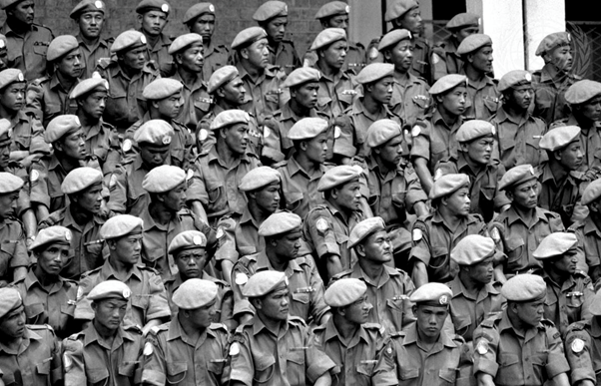
Headline: UN Troop Rotation in the Congo
Caption Description: In March, this year, some 2,400 officers and men, part of the Indian UN Congo contingent, were recalled to strengthen India's own defences. Those troops were replaced by new Indonesian forces.
Some of the homebound Indian soldiers, assembling in Elisabethville before leaving for Bombay via Mombasa in Kenya. March 1963.
Production Date: 3/1/1963 12:01:25 PM
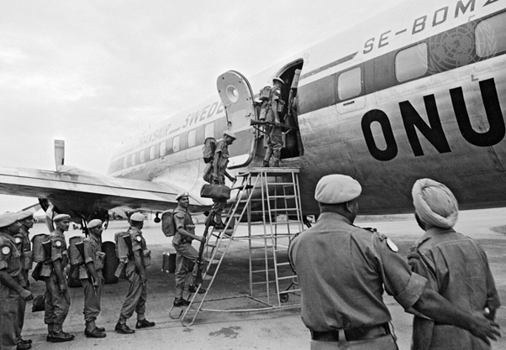

Headline: Indian Troops Return Home from the Congo Caption Description: Towards the end of 1962, the Government of India informed the Secretary-general of the United Nations, U Thant, that they needed to recall the Indian contingent of the UN Forces in the Congo (ONUC) to help strengthen India's own defences. At Elisabethville airport, Indian troops are seen departing for Mombasa in Kenya on their way to Bombay.
Production Date: 3/1/1963 10:26:06 AM

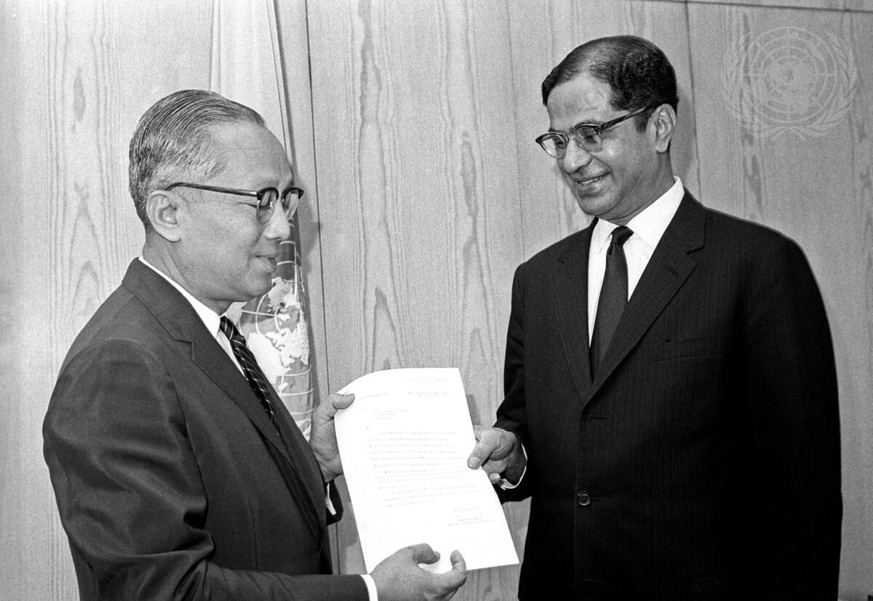
Headline: Permanent Representative of India Presents Credentials
Caption Description: Mr. Gopalaswami Parthasarathi (right), the new Permanent Representative of India to the United Nations, presenting his credentials to Secretary-General U Thant at United Nations Headquarters today.
City/Location: New York
Country: United States of America
Production Date: 8/19/1965 12:22:15 AM

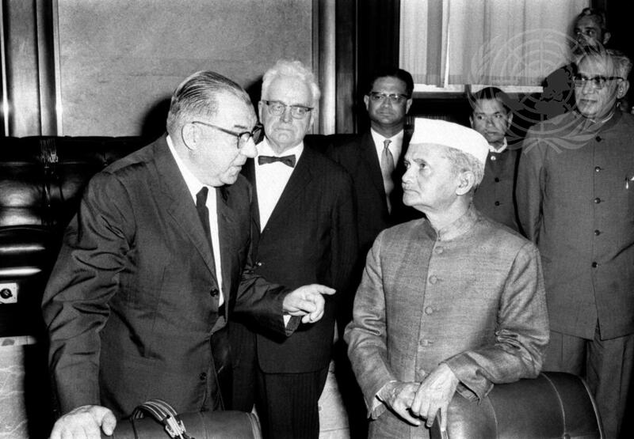
Headline: Prime Minister of India Visits UN European Office Caption Description: Prime Minister Lal Bahadur Shastri of India paid a brief visit today to the European Office of the United Nations in Geneva. Prime Minister during his visit to the Palais des Nations. Others, from left, are: Mr. Pier P. Spinelli, Under-Secretary, Director of the UN European Office, Mr. Jean Treina, President of the Council of State, Canton of Geneva and Mr. K.P. Lukose, Permanent Representative of India to the UN in Geneva. At right is Mr. V.C. Trivedi, Ambassador of India to Switzerland. Country: Switzerland
Production Date: 6/26/1965 10:27:41 AM

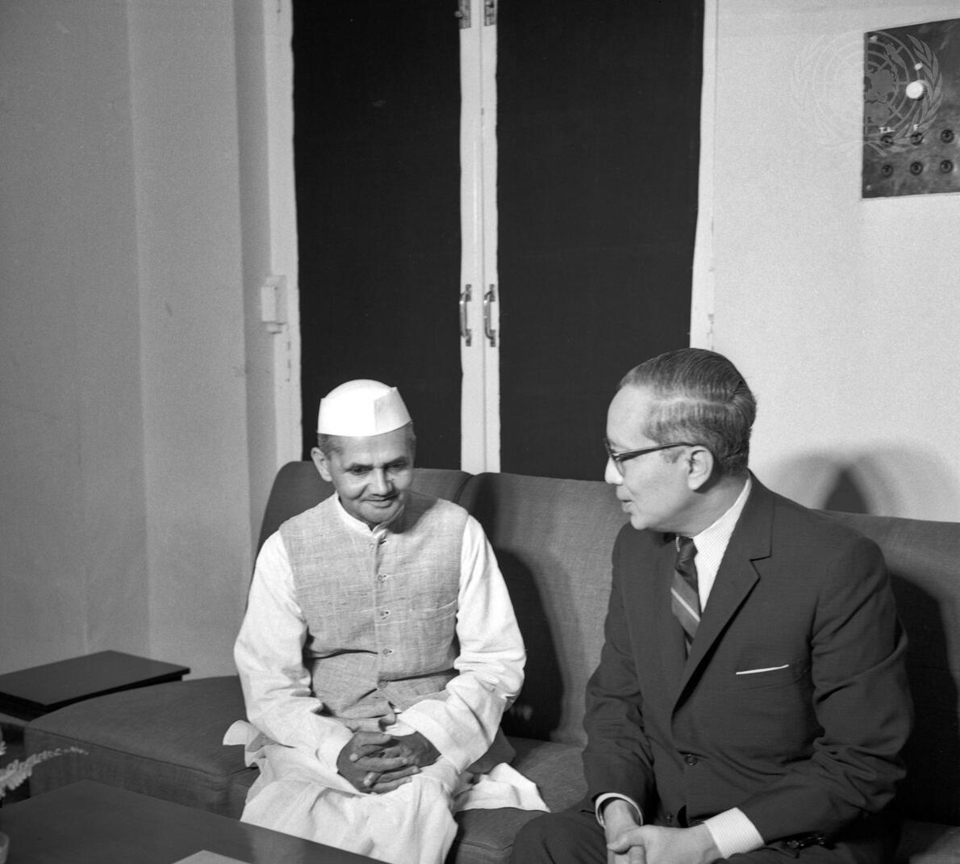
Headline: Secretary-General's Mission to India and Pakistan
Caption Description: Secretary-General U Thant left New York on 7 September for Rawalpindi and New Delhi to hold talks with Pakistani and Indian leaders on the implementation of two Security Council resolutions calling for an immediate cease-fire in the entire area of the conflict between India and Pakistan.
Secretary-General U Thant (right) conferring with the Prime Minister of India, Lal Bahadur Shastri, at the latter's residence.
City/Location: New Delhi
Country: India
Production Date: 9/12/1965 9:41:50 PM
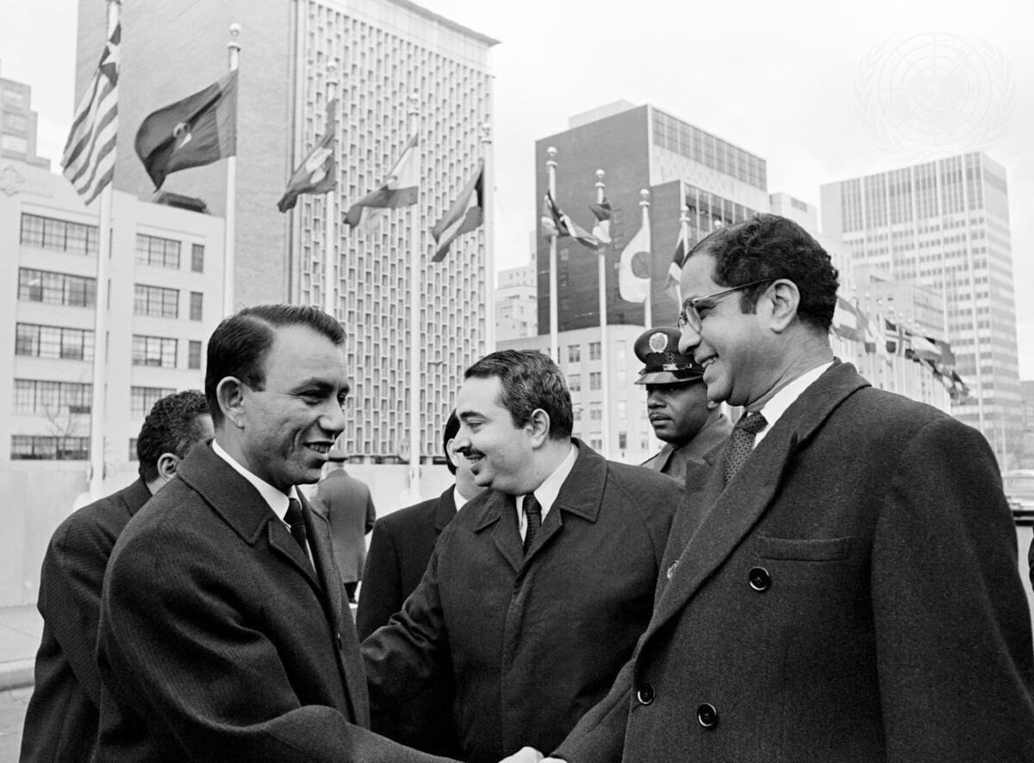
Headline: Flag of The People's Republic of Southern Yemen Raised at United Nations
Caption Description: The Security Council voted unanimously on 12 December to recommend to the General Assembly the admission of the People's Republic of Southern Yemen to the United Nations. The flag of the People's Republic of Southern Yemen was raised at United Nations Headquarters. Saif Ahmad Dhalee, Minister for Foreign Affairs of Southern Yemen, receiving the congratulations of Gopalaswami Parthasarathi, Permanent Representative of India to the UN.
City/Location: New York
Country: United States of America
Production Date: 12/15/1967 10:49:38 AM
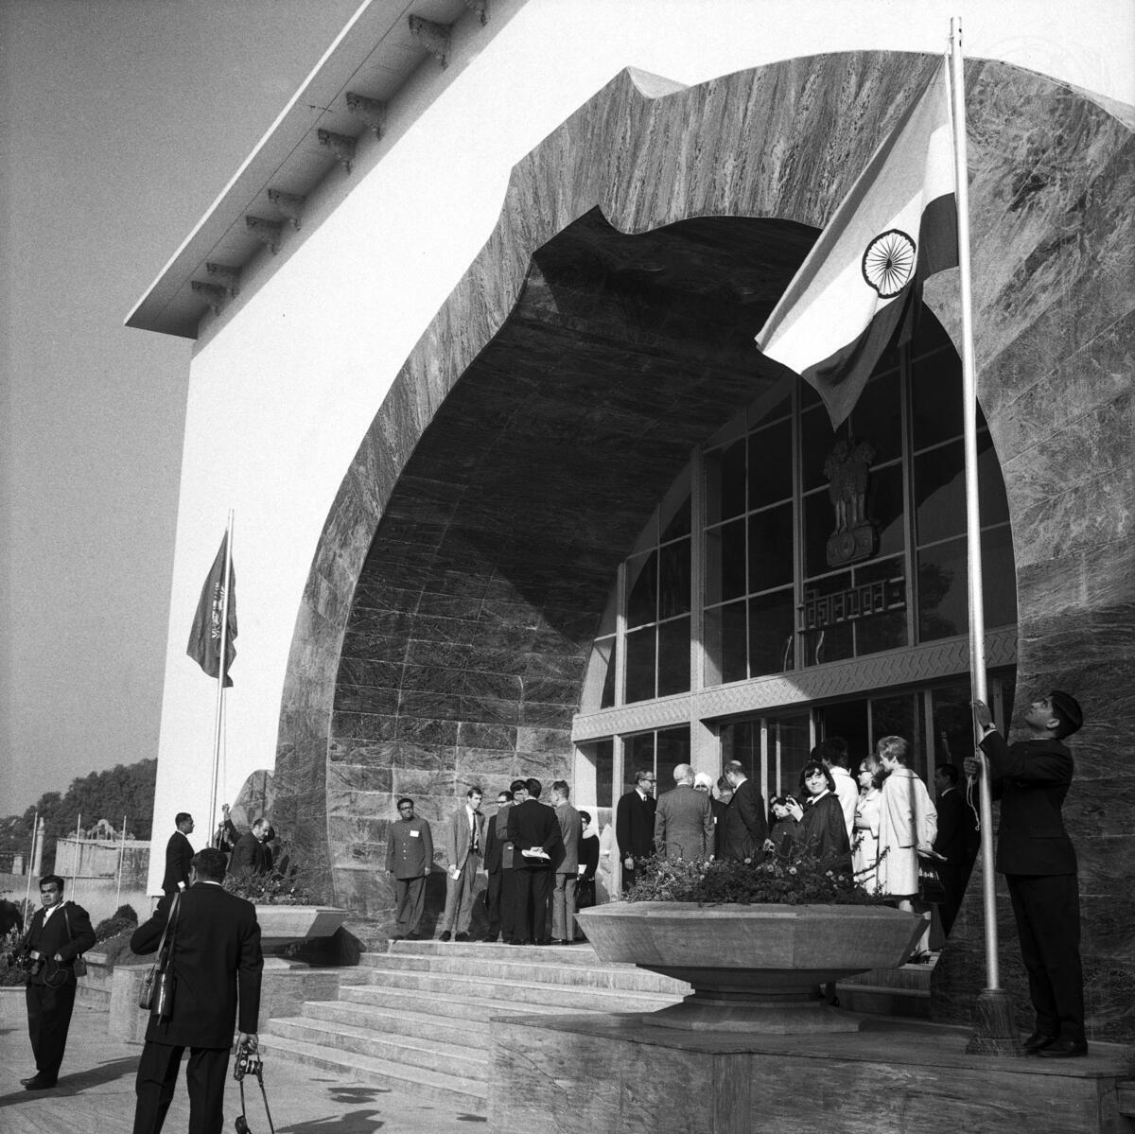
Headline: Second Session of UN Conference on Trade and Development
Caption Description: Indira Gandhi, Prime Minister of India, inaugurates the second session of the UN Conference on Trade and Development (UNCTAD) in New Delhi. A wide range of world trade and development items will be reviewed by approximately 1,400 delegates representing UNCTAD’s 132 member states. In addition, UN specialized agencies, inter-governmental, and non-governmental organizations will also be observing. A view of the “Vigyan Bhavan” building which the Government of India placed at the disposal of the United Nations for the second session of the Conference.
City/Location: New Delhi
Country: India
Production Date: 1/30/1968 8:43:30 PM
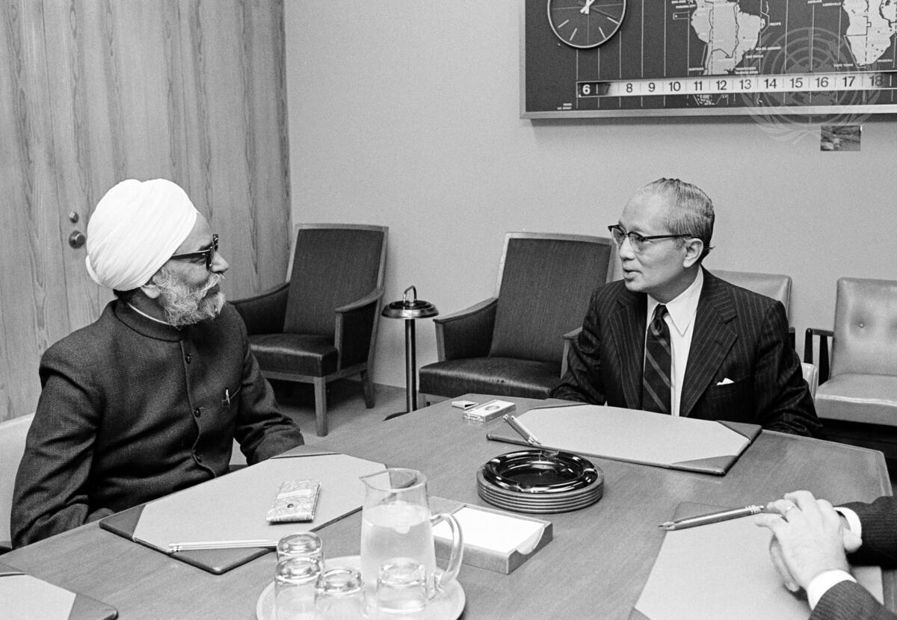
Headline: Foreign Minister of India Meets with Secretary-General
Caption Description: Sardar Swaran Singh, Foreign Minister of India, is seen as he met with Secretary-General U Thant at United Nations Headquarters today.
City/Location: New York Country: United States of America
Production Date: 6/15/1971 12:51:08 PM
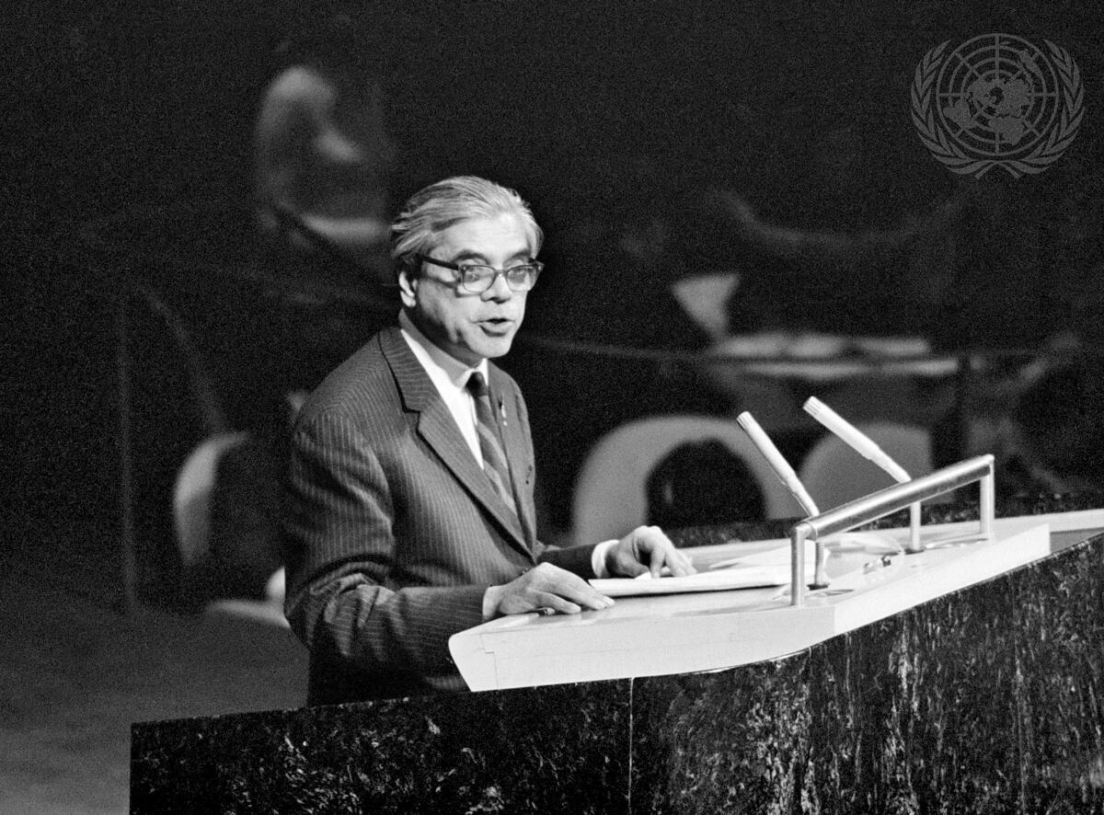
Headline: General Assembly Calls for Cease-Fire Between India and Pakistan
Caption Description: The General Assembly tonight called on India and Pakistan to take all measures forthwith for an immediate cease-fire and withdrawal of their armed forces on the territory of the other to their own side of the India-Pakistan borders. The Assembly also urged that efforts be intensified in order to bring about, speedily and in accordance with the purposes and principles of the Charter of the United Nations, conditions necessary for the voluntary return of the East Pakistani refugees to their homes. The Security Council was called upon to take appropriate action in the light of this resolution. The Assembly acted by adopting a 34-Power proposal circulated during the meeting - by a roll-call vote of 104 in favour to 11 against, with 10 abstentions. Samar Sen, Permanent Representative of India to the United Nations, addresses the General Assembly, at UN Headquarters in New York.
City/Location: New York
Country: United States of America
Production Date: 12/7/1971 1:00:11 PM
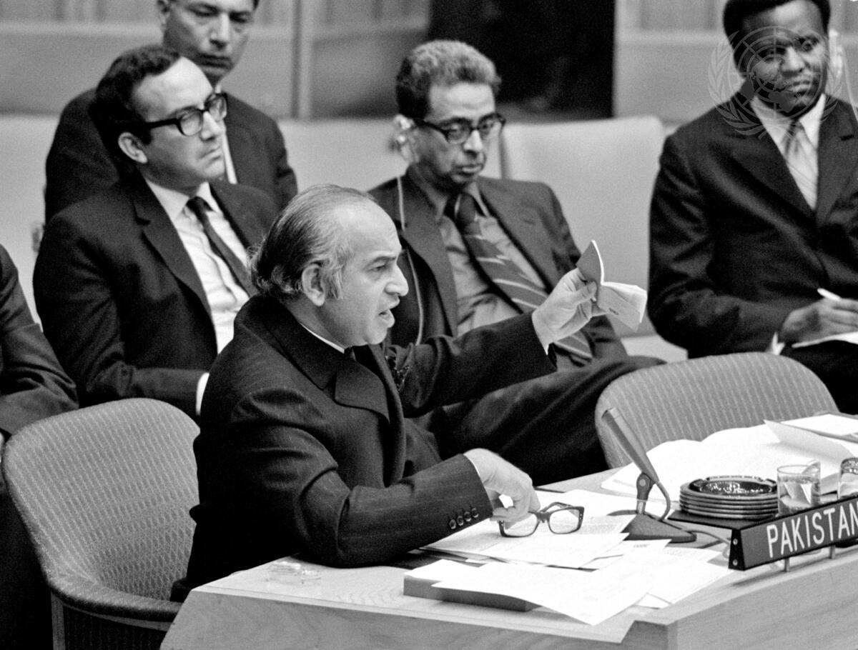
Headline: Security Council Resumes Debate of India and Pakistan; Receives United States Draft on Cease-Fire and Withdrawal Caption Description: The Security Council, resuming consideration tonight of the situation in India and Pakistan at the request of the United States, received a United States proposal calling for an immediate cease-fire and withdrawal of troops. At the meeting which began on the evening of Sunday, 12 December and lasted into the early hours of Monday, 13 December - the Council heard statements
by the Foreign Minister of India and the Deputy Prime minister and Foreign Minister of Pakistan as well as a statement by the United States representatives who introduced the proposal. Zulfikar Ali Bhutto, Deputy Prime Minister and Foreign Minister of Pakistan is seen here as he addressed the Council.
City/Location: New York
Country: United States of America
Production Date: 12/12/1971 12:34:30 PM
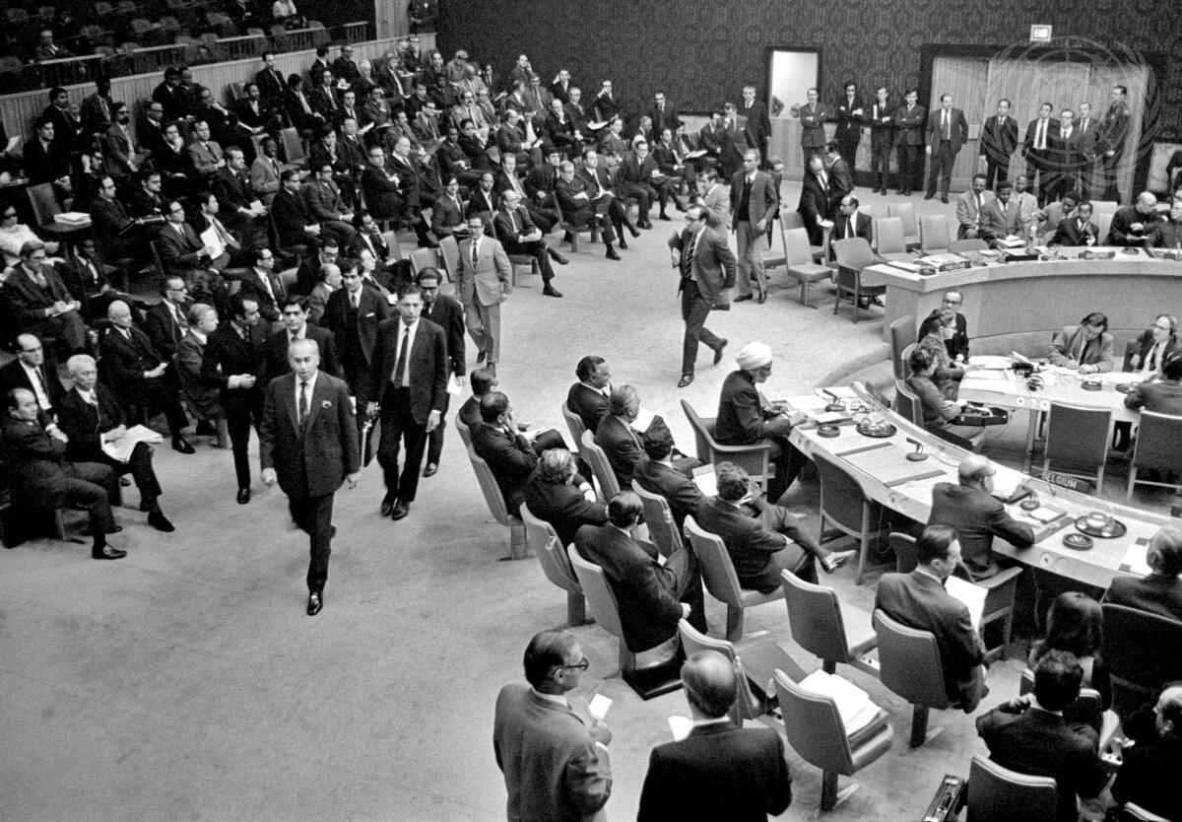
Headline: Security Council Hears Statements by Representatives of Pakistan and Tunisia at Resumed Meeting of India-Pakistan Situation.
Caption Description: The Security Council, shortly after mid-day today, resumed the meeting suspended yesterday for consultations on draft resolutions relating to the situation in the India-Pakistan sub-continent. Statements were made by the representatives of Pakistan and Tunisia. Following his statement on behalf of his Government, Zulfikar Ali Bhutto, Deputy Prime Minister and Foreign Minister of Pakistan, walked out of the meeting with his delegation. This photograph shows Mr. Bhutto leading his delegation from the Security Council chamber.
City/Location: New York
Country: United States of America
Production Date: 12/15/1971 12:13:47 PM
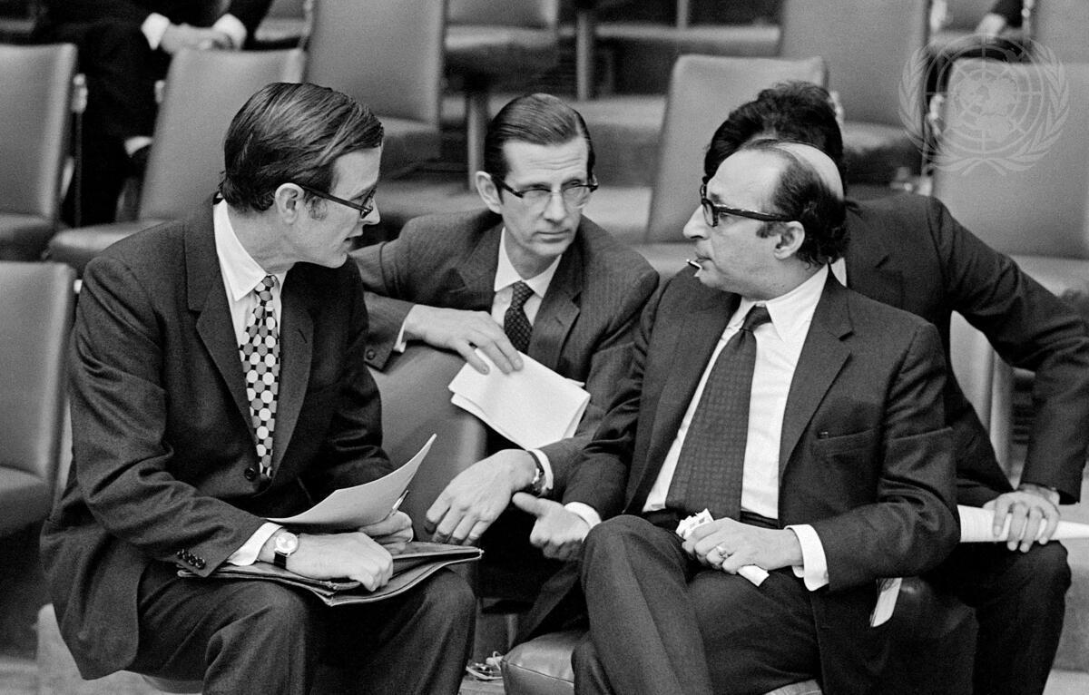
Headline: Security Council Receives Two Draft Resolutions on Situation on India-Pakistan Subcontinent
Caption Description: The Security Council received two more draft resolutions tonight on the situation on the India - Pakistan subcontinent, one submitted by the Soviet Union (document S/10458) and the other by Japan and the United States (document S/10459). Seen here in consultation prior to the meeting, from left to right are: George Bush (USA); Christopher H. Phillips (USA); and Agha Shahi (Pakistan).
City/Location: New York
Country: United States of America
Production Date: 12/16/1971 5:03:00 PM
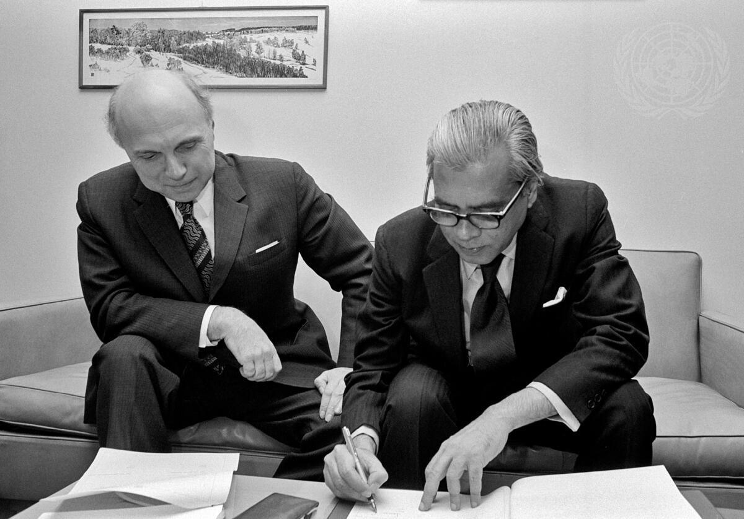
Headline: Agreement between UN and India Signed at UN Headquarters
Caption Description: A regional United Nations panel meeting on satellite instructional television systems, will be held in New Delhi and Ahmadabad from 12/12 to 20/12 at the invitation of the Indian Government. Several countries in the area of the U.N. Economic Commission for Asia and the Far East (ECAFE) will participate.
Ambassador Samar Sen, Permanent Representative of India, signing the agreement on behalf of his government, the Host Government for the meeting. Seated next to him is Mr. Leonid Kutakov, Under- Secretary-General for Political and Security Council Affairs, who signed on behalf of the U.N. City/Location: New York
Country: United States of America
Production Date: 12/8/1972 12:22:28 PM
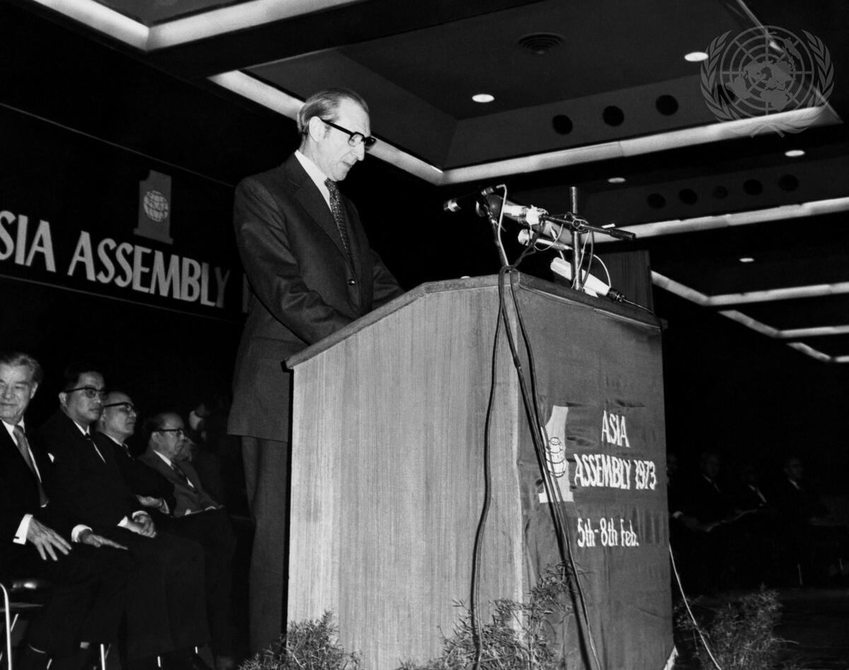
Headline: Secretary-General Visits India
Caption Description: Secretary-General Kurt Waldheim left United Nations Headquarters on 31 January for official visits to India, Pakistan, Bangladesh, Thailand and Japan.
Secretary-General Kurt Waldheim is seen addressing ""One Asia Assembly 1973"" at the Ashoka Hotel Convention Hall, New Delhi, on 5 February.
City/Location: New Delhi
Country: India
Production Date: 2/5/1973 10:08:48 PM
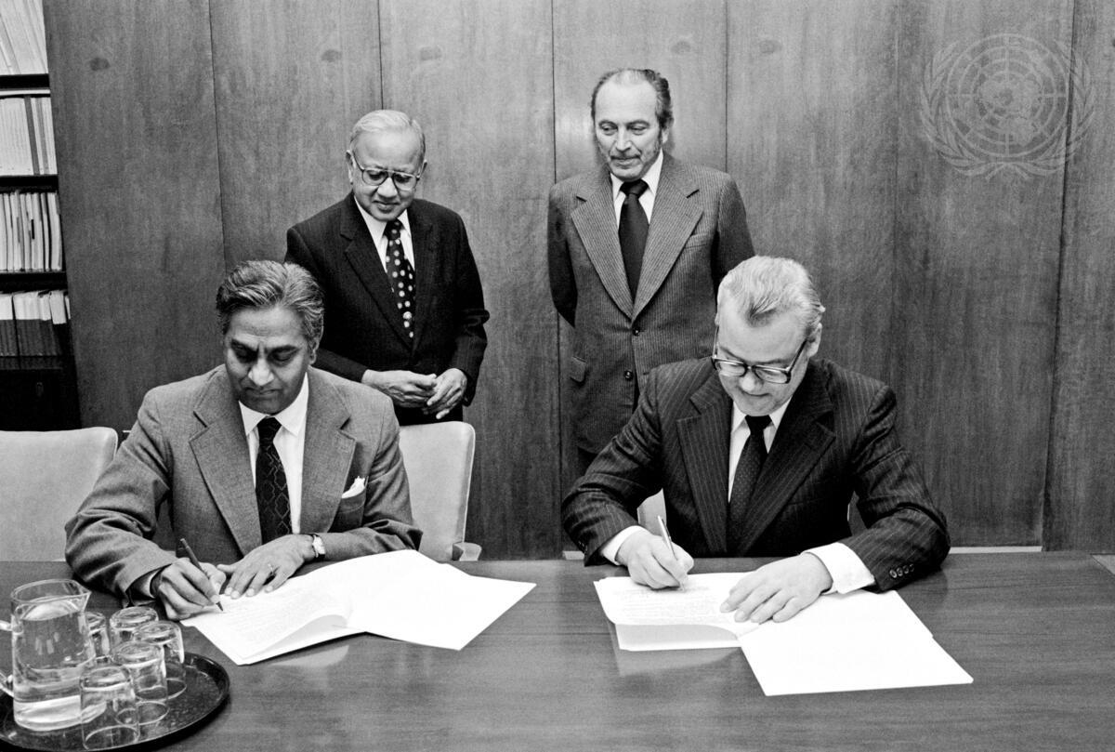
Headline: Agreement Between Government of India and UN on Joint UN/UNESCO Panel Meeting .
Caption Description: An agreement between the Government of India and the United Nations on a Joint UN/UNESCO Panel meeting on Satellite Instructional Television Experiment by India was signed at United Nations Headquarters today. The meeting will be held in Ahmedabad, India from 31 October to 5 November 1977. Ambassador Rikhi Jaipal (left), Permanent Representative of India to the UN, and Mr. Arkady N. Shevchenko, Under-Secretary-General for Political and Security Council Affairs, signing the Agreement. Looking on are Mr. H.G.S. Murthy (left), Expert on Space Applications, UN Outer Space Affairs Division, and Mr. Lubos Perex, Chief of the Outer Space Affairs Division.
City/Location: New York Country: United States of America
Production Date: 10/11/1977 10:27:41 AM
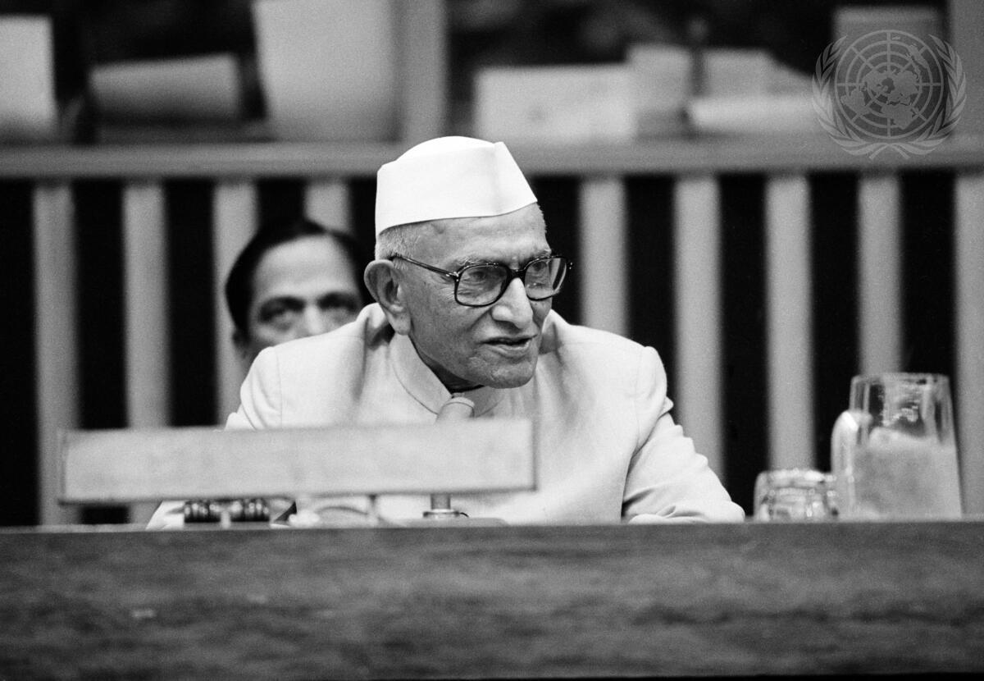
Headline: Prime Minister of India Visits UN Headquarters Caption Description: The Prime Minister of India, Morarji Desai, paid an official visit to United Nations Headquarters today, to confer with the Secretary-General and the President of the General Assembly, and to address the special session of the Assembly on disarmament. He also attended a reception in his honour. The Prime Minister holding a press conference in Conference Room 4 after addressing the Assembly.
City/Location: New York
Country: United States of America
Production Date: 6/9/1978 3:42:26 PM

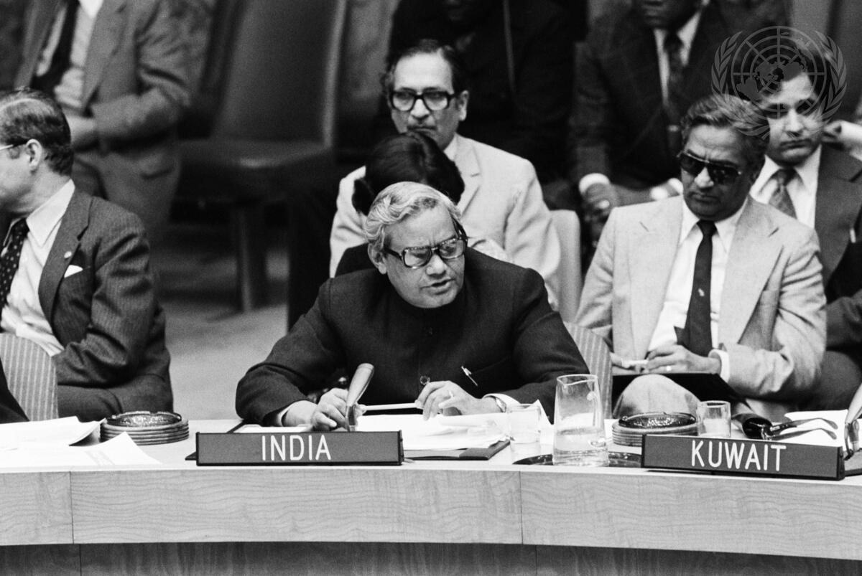
Headline: Security Council Approves Plan for United Nations Operation in Namibia
Caption Description: Atal Bihari Vajpayee, Minister for Foreign Affairs of India, addressing the Council.
City/Location: New York
Country: United States of America
Production Date: 9/29/1978 1:39:13 PM
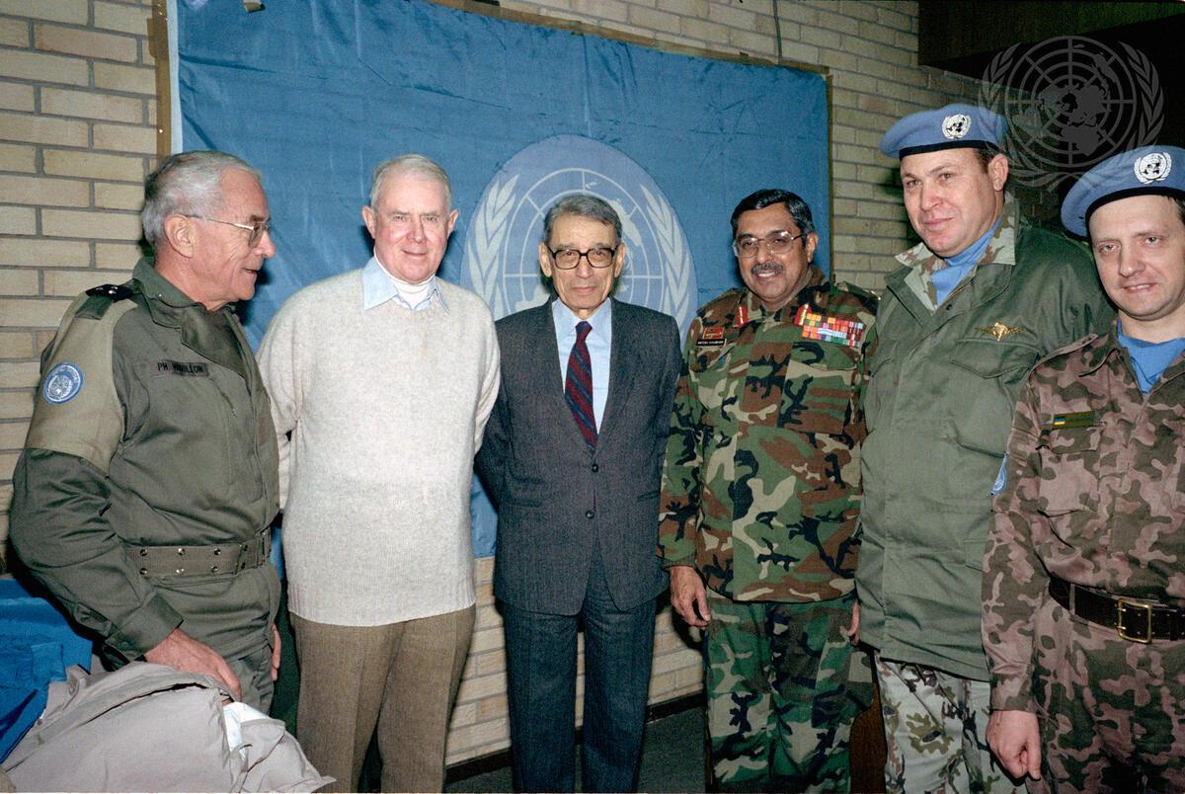
Headline: Secretary-General of the United Nations Visits Sarajevo, Bosnia and Herzegovina
Caption Description: Group photo during the Secretary-General's visits to Sarajevo: Lieutenant General Phillipe Morillon (France), Force Commander of the United Nations Protection Force in Sarajevo (far left); Cyrus Vance (United States), Secretary-General's Personal Envoy and Co- Chairman of the Conference on the Former Yugoslavia, Secretary-General Boutros Boutros-Ghali, Lieutenant-General Satish Nambiar (third from right) of India, Force Commander of UNPROFOR in Croatia and Bosnia and Herzegovina, Brigadier-General Hussein Ali Abdel-Razek (second from right) of Egypt, Commander of the Egyptian Battalion in Sarajevo, and an unidentified officer from the Ukrainian Forces stationed in Sarajevo.
City/Location: Sarajevo
Country: Bosnia and Herzegovina
Production Date: 12/31/1992 12:00:00 AM
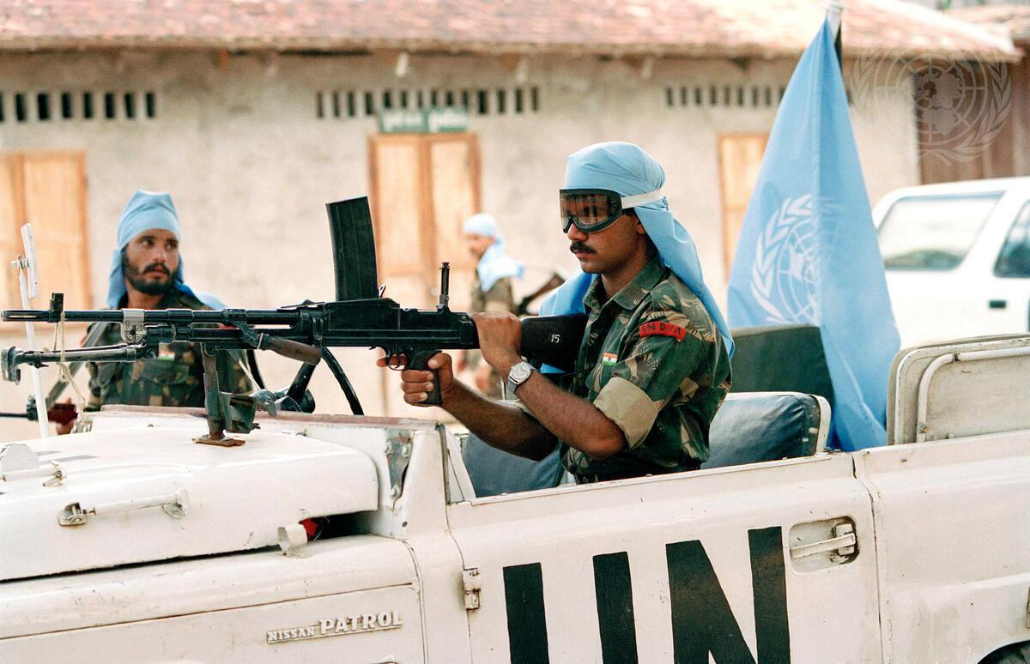
Headline: United Nations Transitional Authority in Cambodia (UNTAC)
Caption Description: The Cambodian people will be voting for a national constituent assembly from 23-28 May 1993. UNTAC soldiers from India patrolling the streets in Prey Veng Province on the second day of voting.
Country: Cambodia
Credit: UN Photo/John Isaac
Production Date: 5/24/1993 12:00:00 AM

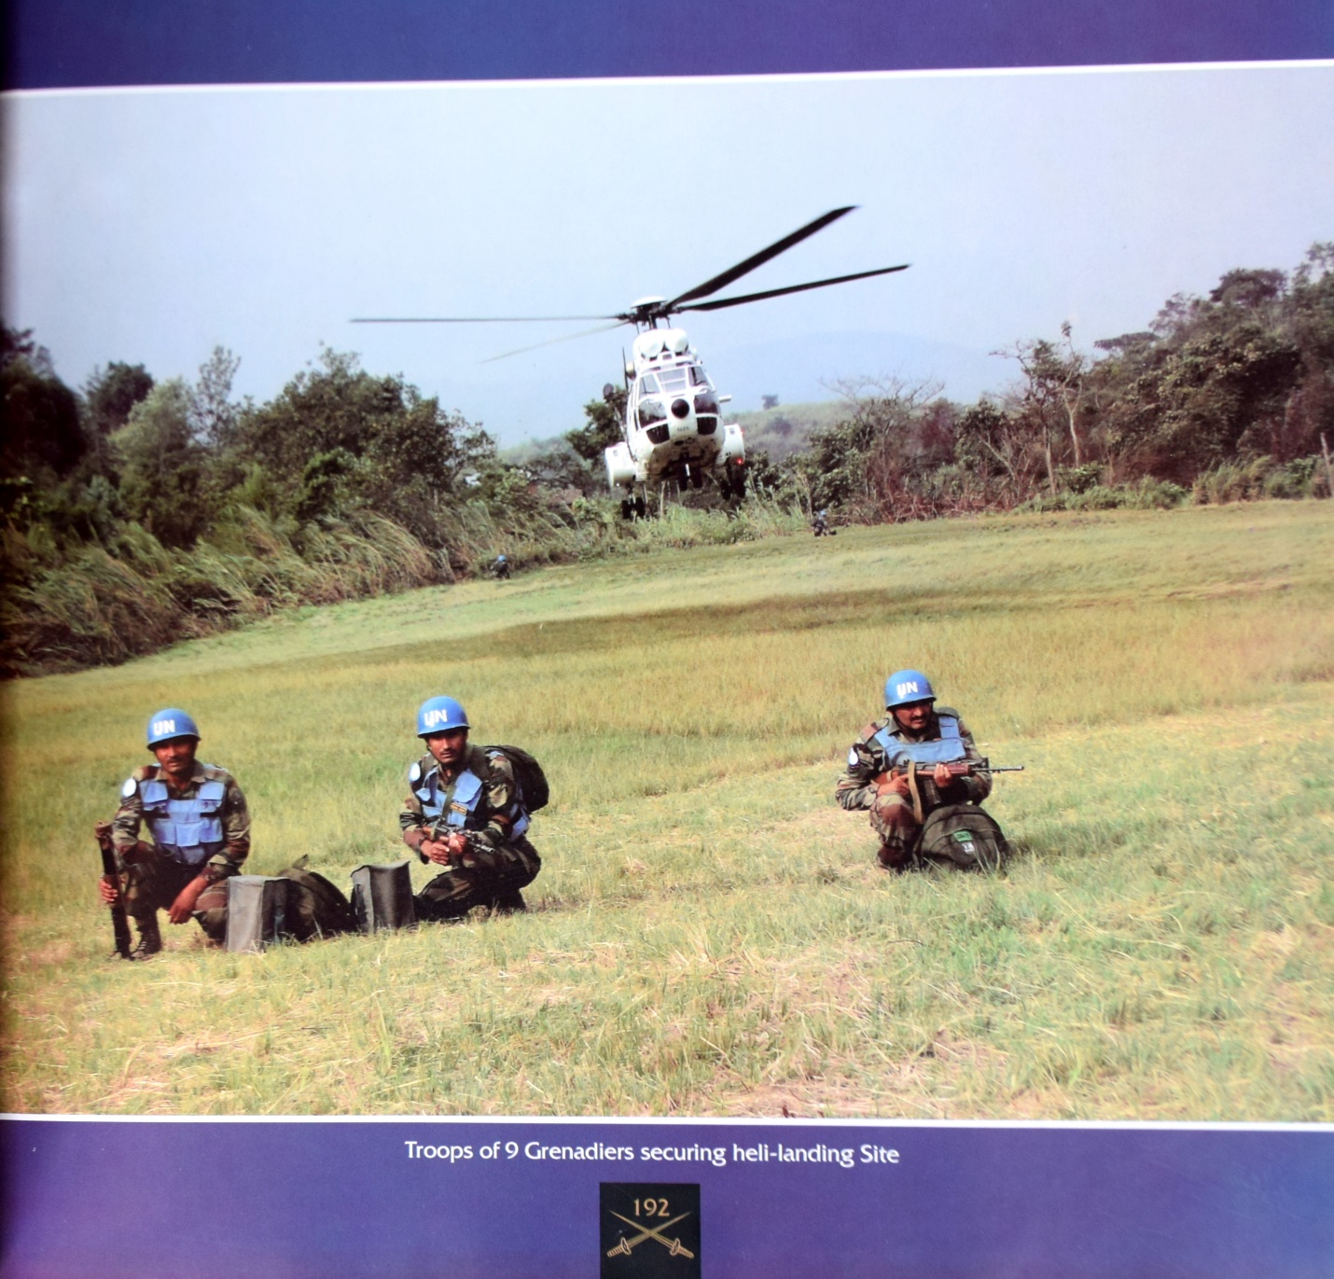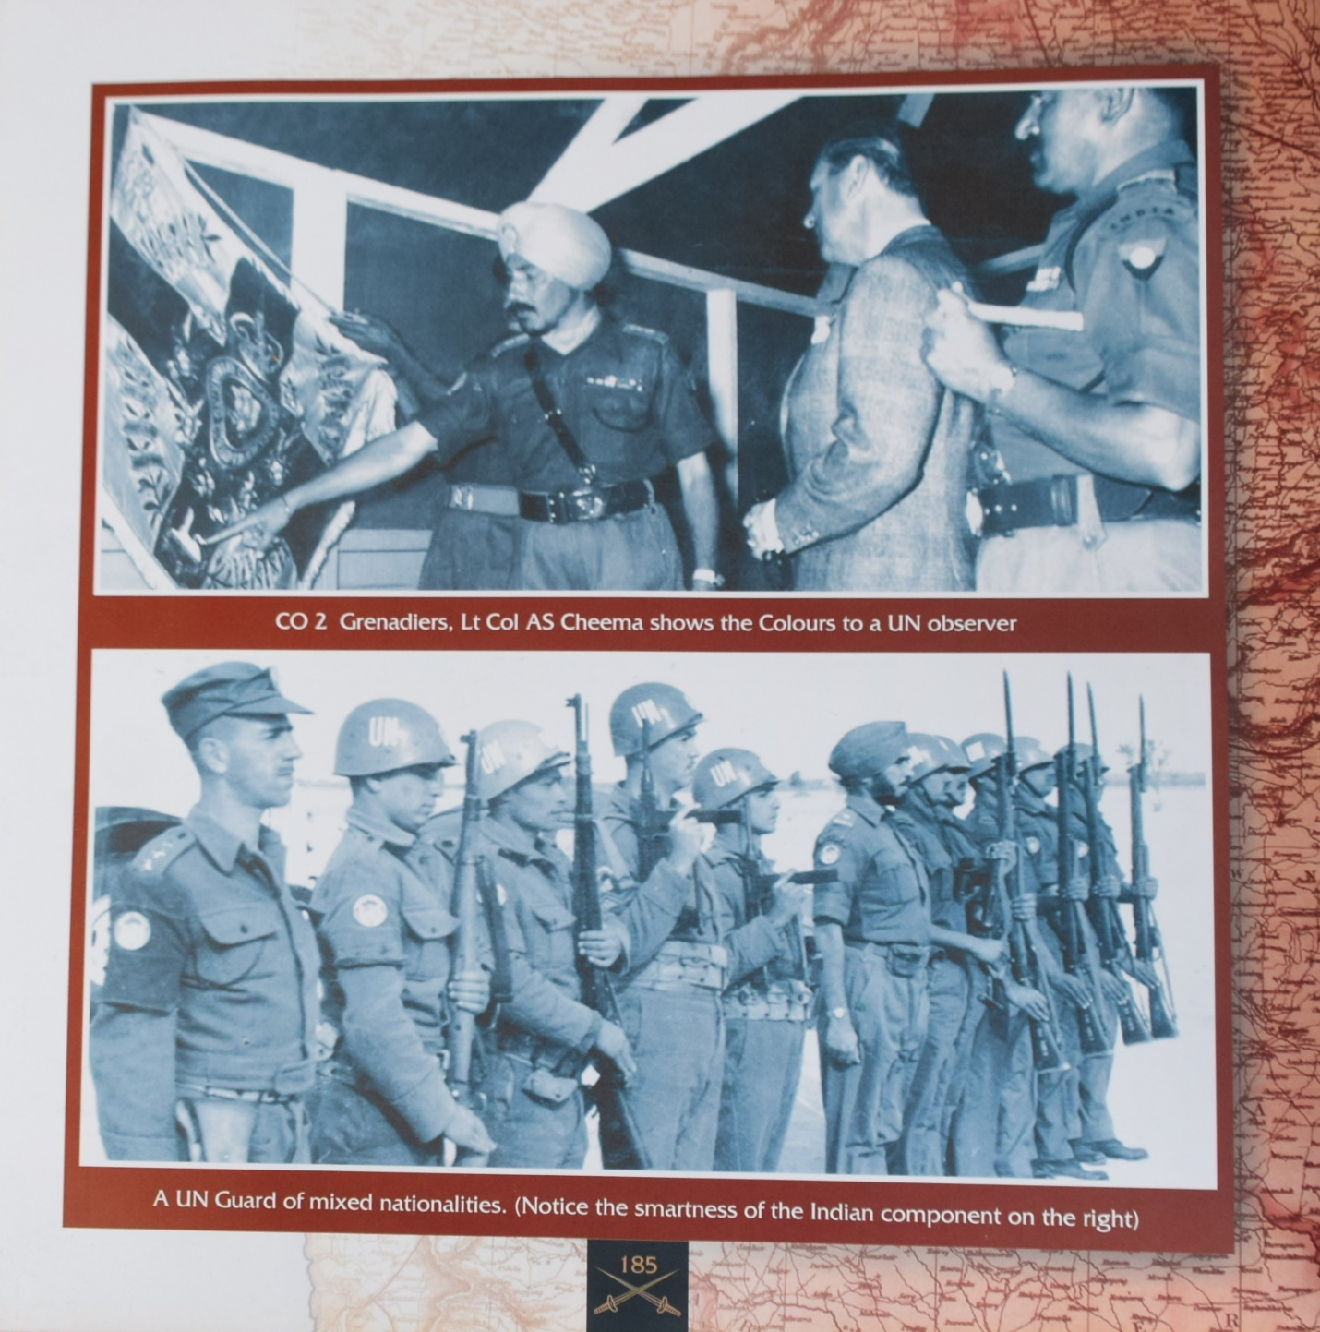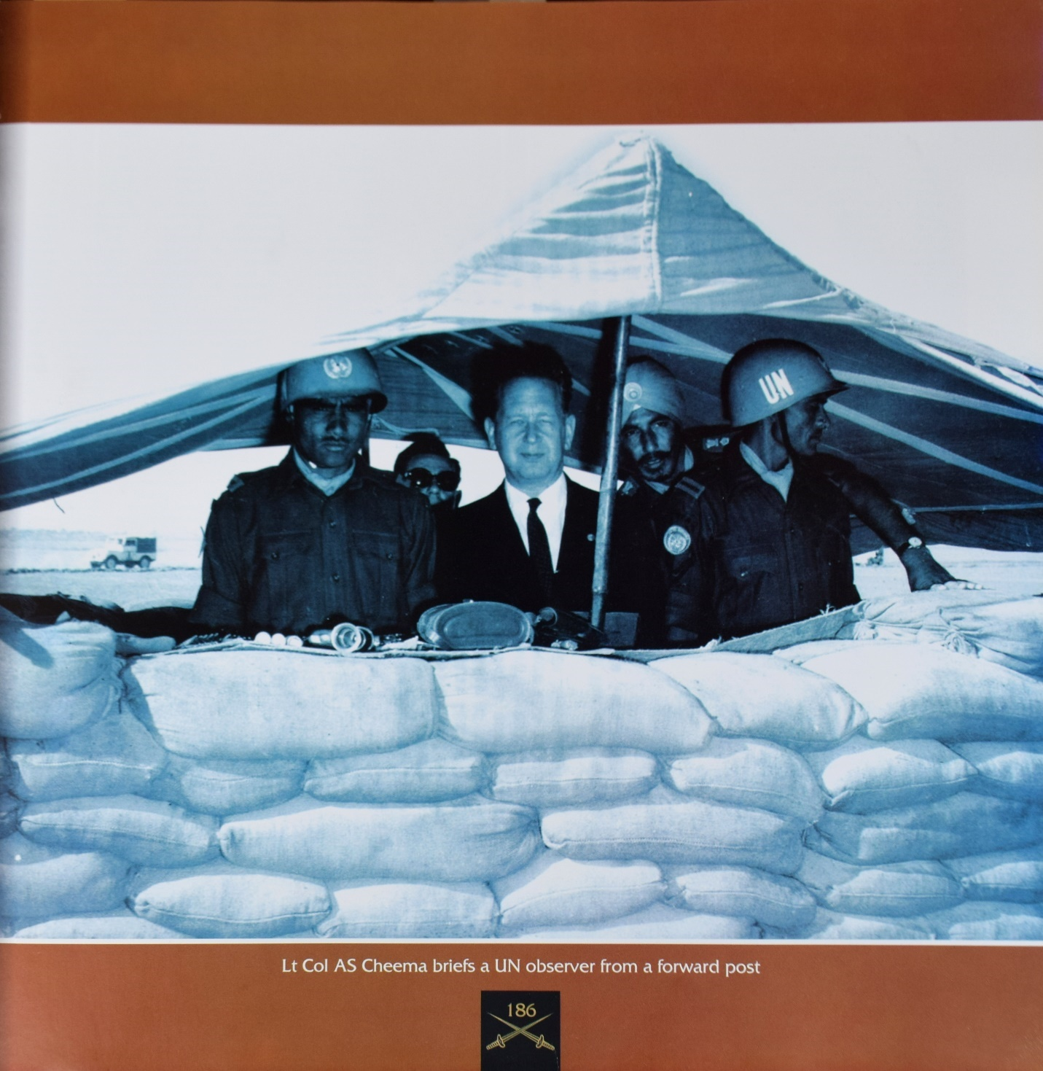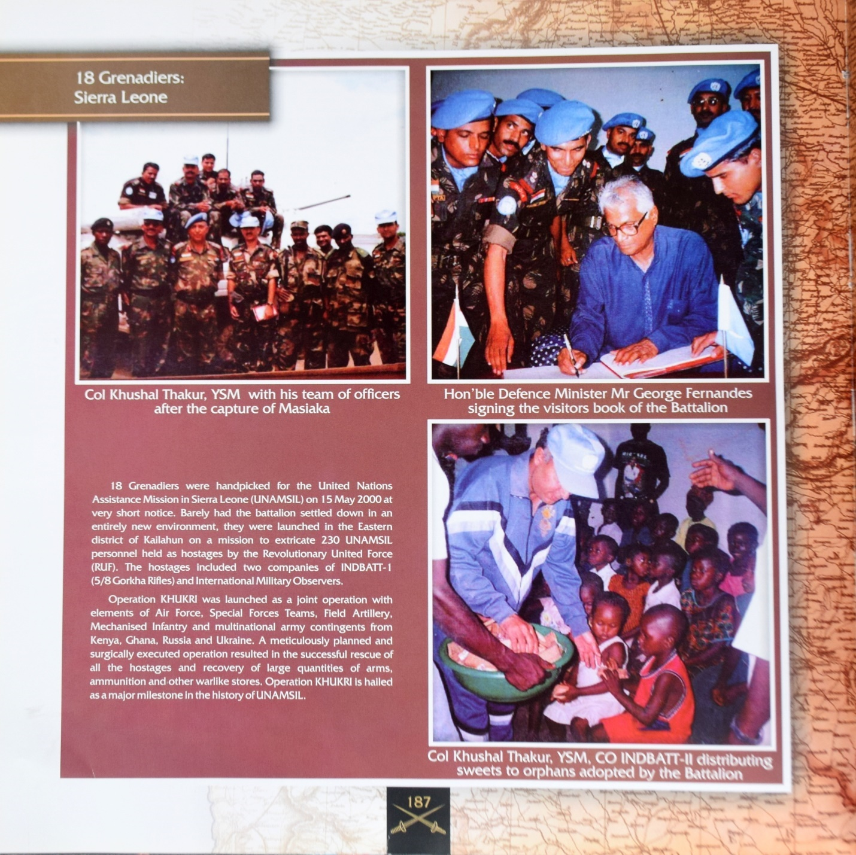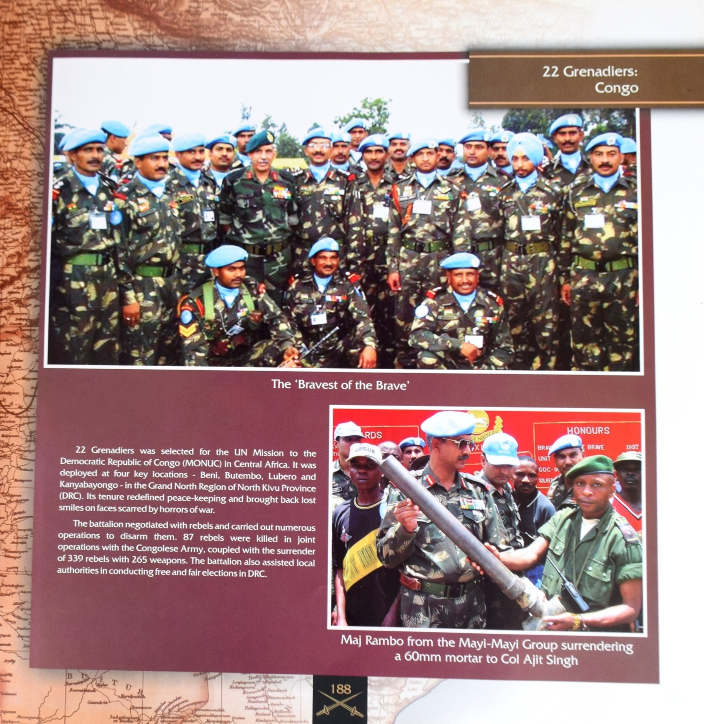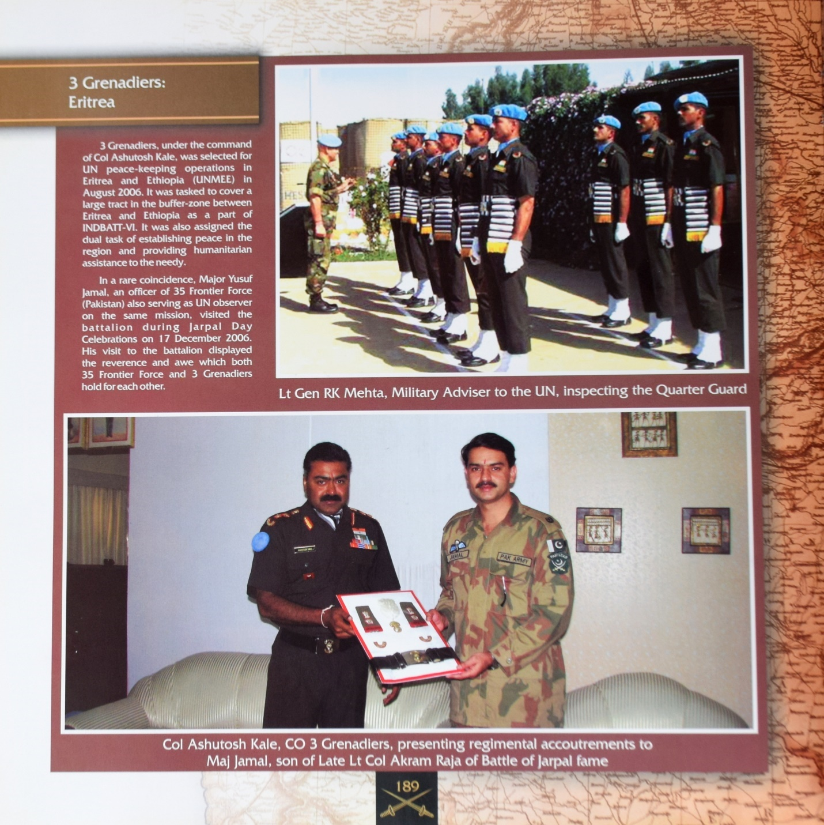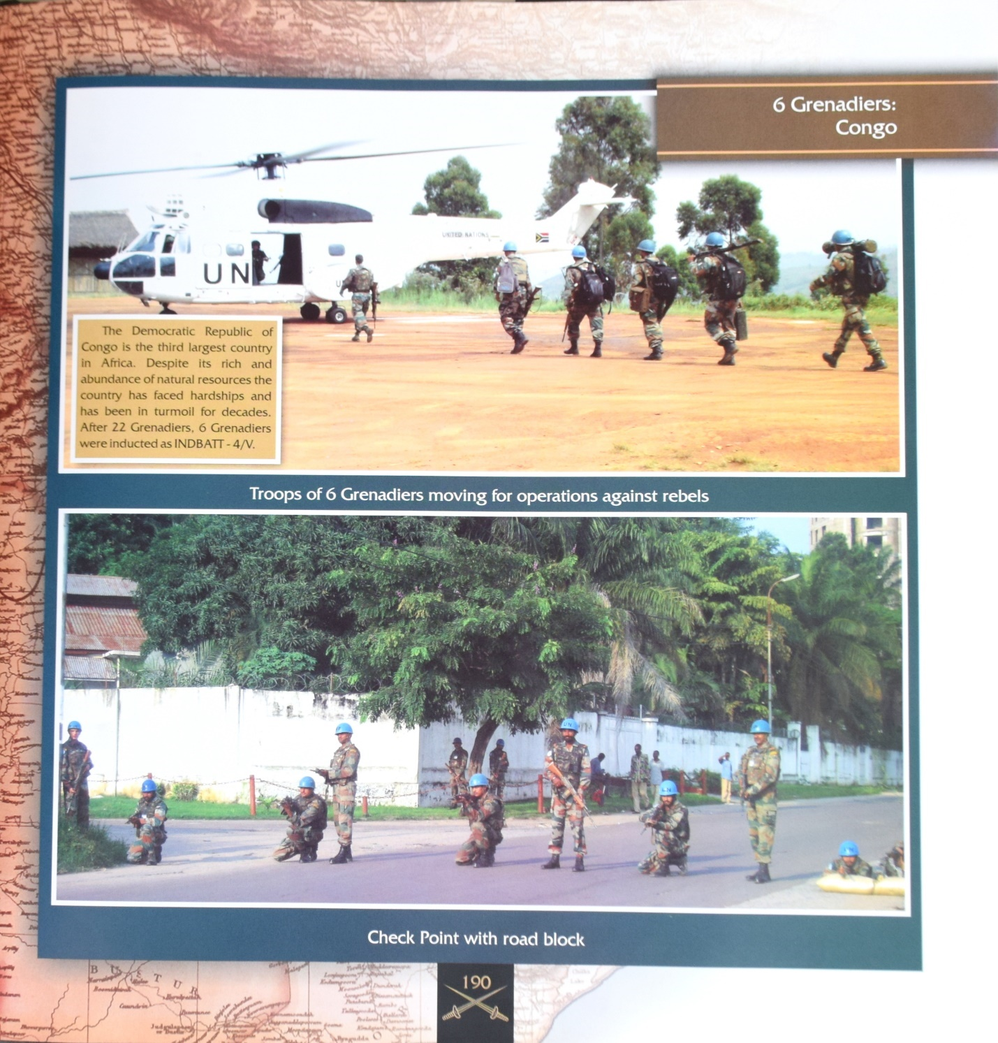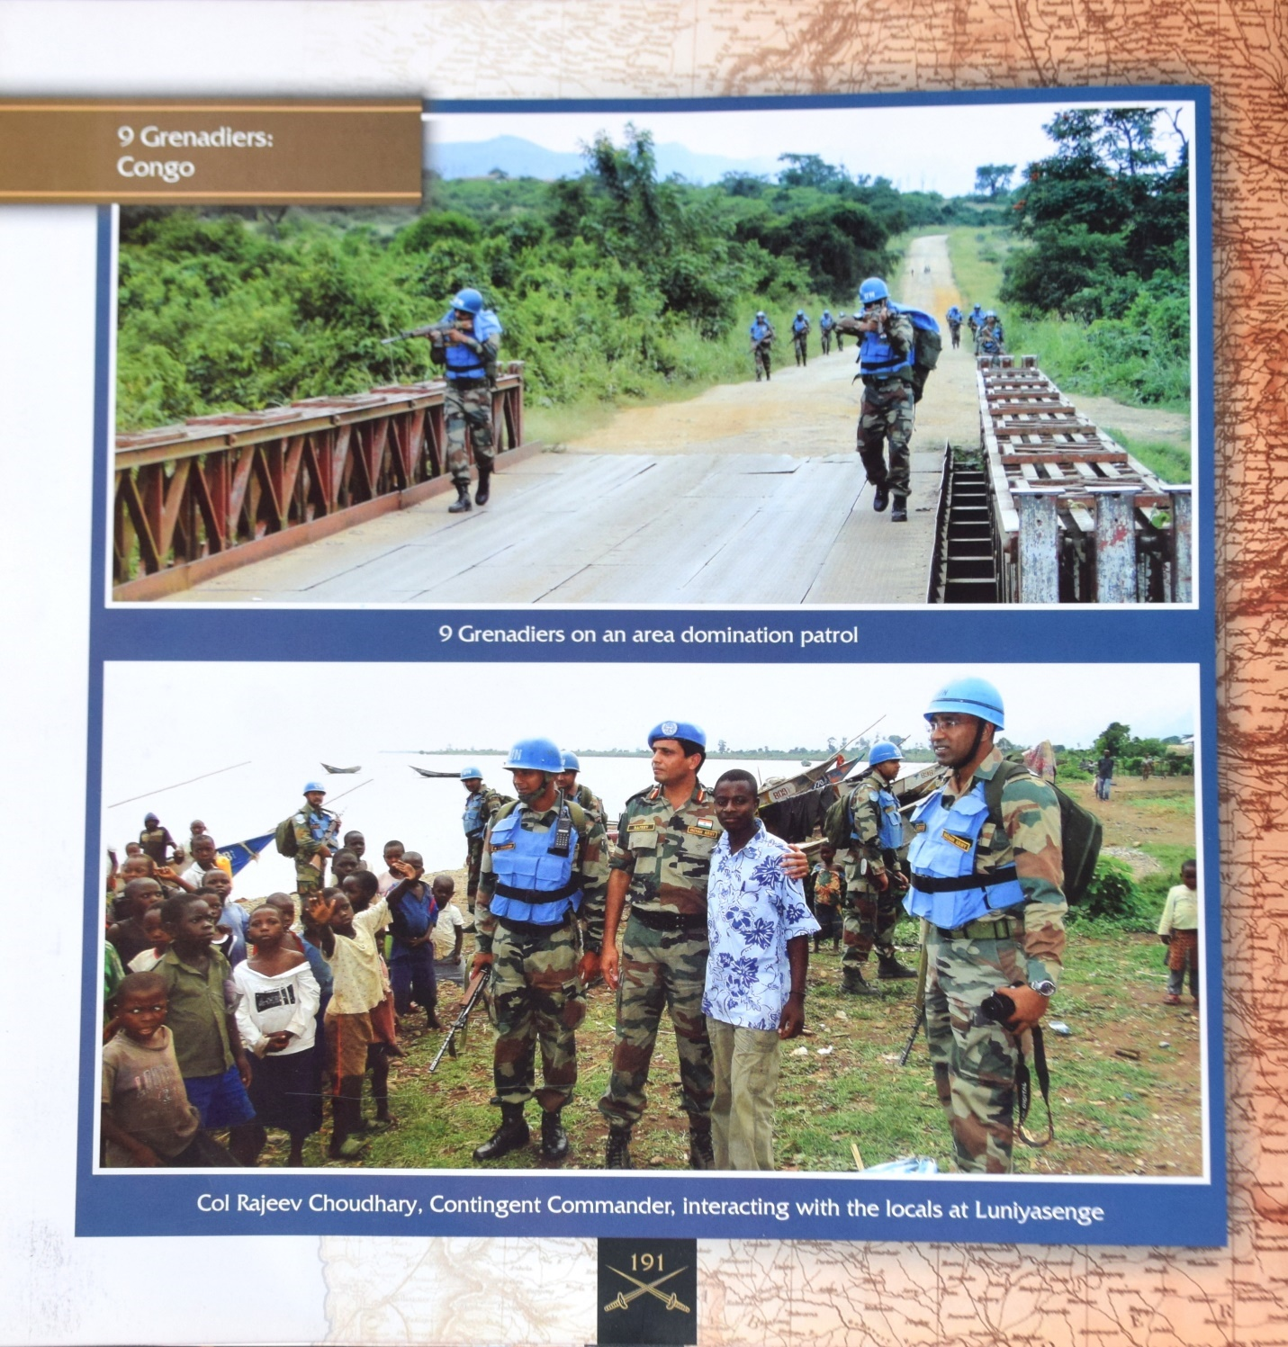
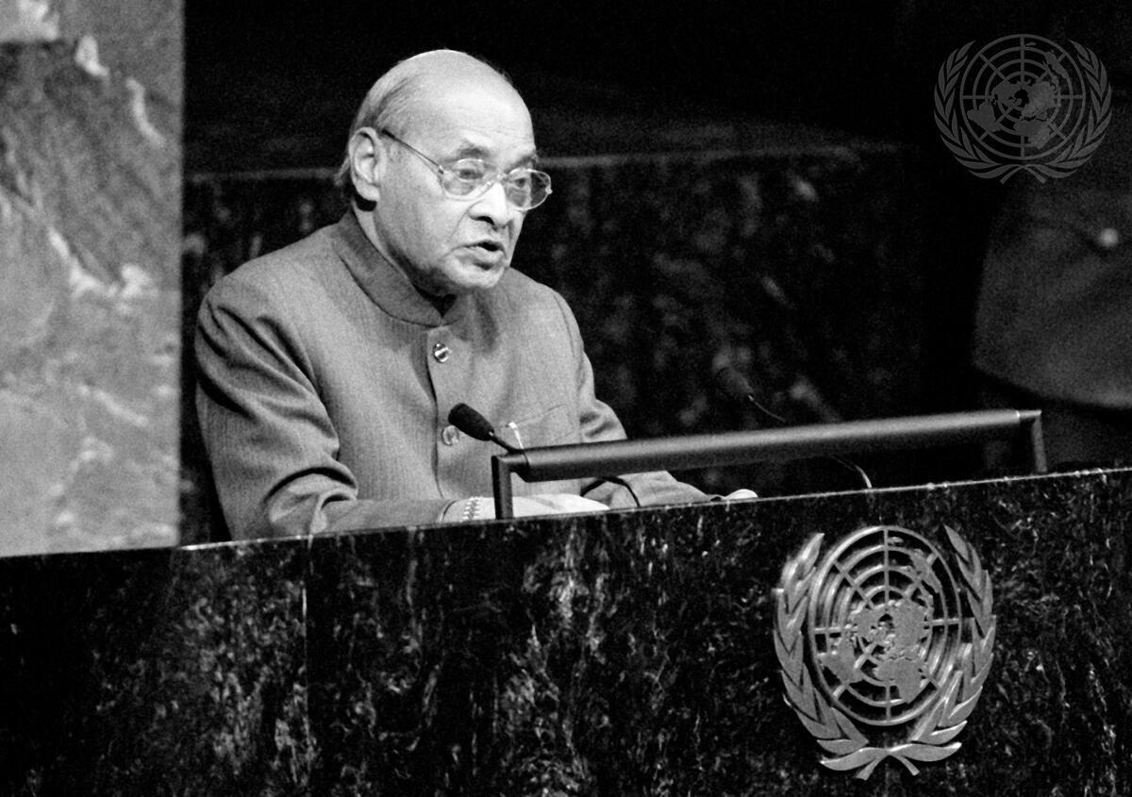
Headline: Prime Minister of India Addresses Fiftieth Anniversary of the United Nations Meeting Caption Description: On the occasion of the fiftieth anniversary of the United Nations, a special commemorative meeting of the General Assembly is being held from 22 to 24 October. P.V. Narasimha Rao, Prime Minister of India, addresses the Special Commemorative Meeting in the General Assembly Hall.
City/Location: New York
Country: United States of America
Production Date: 10/24/1995 11:51:53 AM

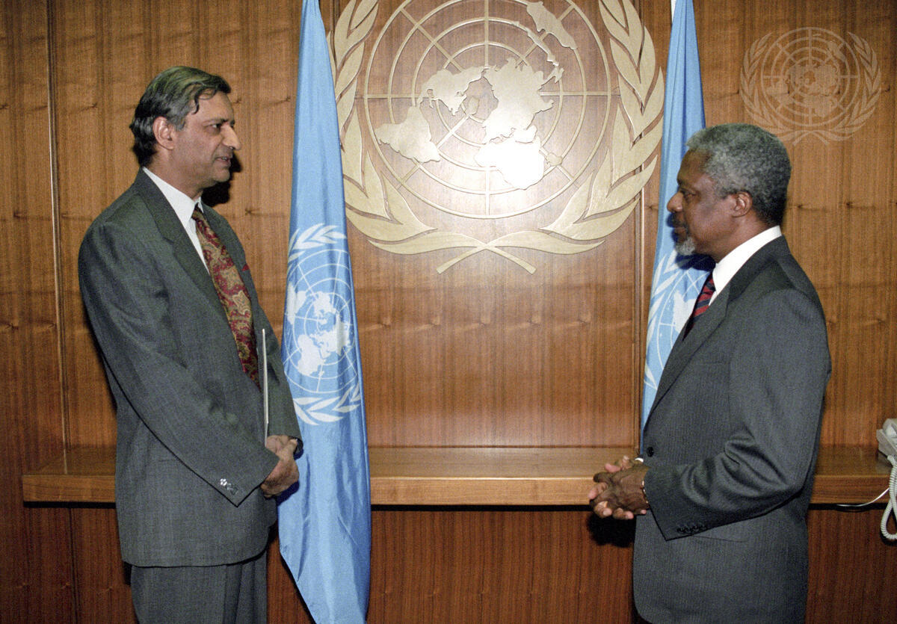
Headline: Permanent Representative of India Presents Credentials
Caption Description: Kamalesh Sharma (left), the new Permanent Representative of India to the United Nations, presents his credentials to Secretary-General Kofi Annan.
City/Location: New York
Country: United States of America
Credit: UN Photo/Eskinder Debebe
Production Date: 8/4/1997 9:55:38 PM
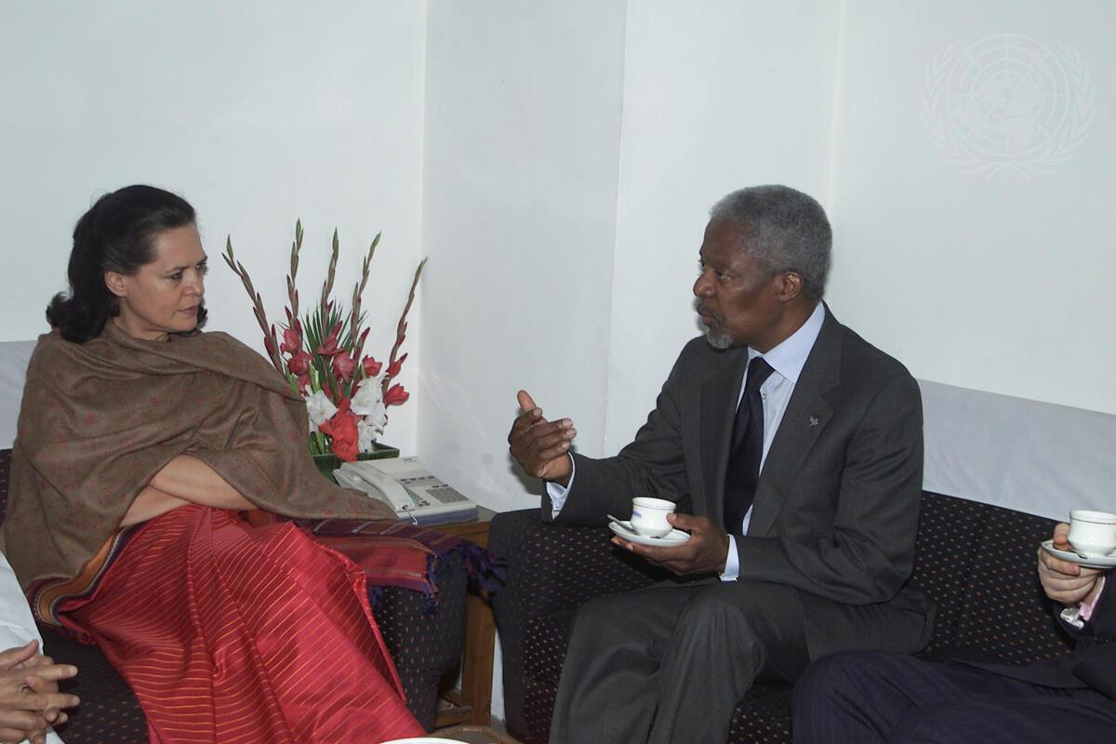
Headline: Secretary-General Visits India
Caption Description: Secretary-General Kofi Annan with Sonia Gandhi (left), leader of the opposition Congress Party.
Country: India
Production Date: 3/16/2001 12:00:00 AM
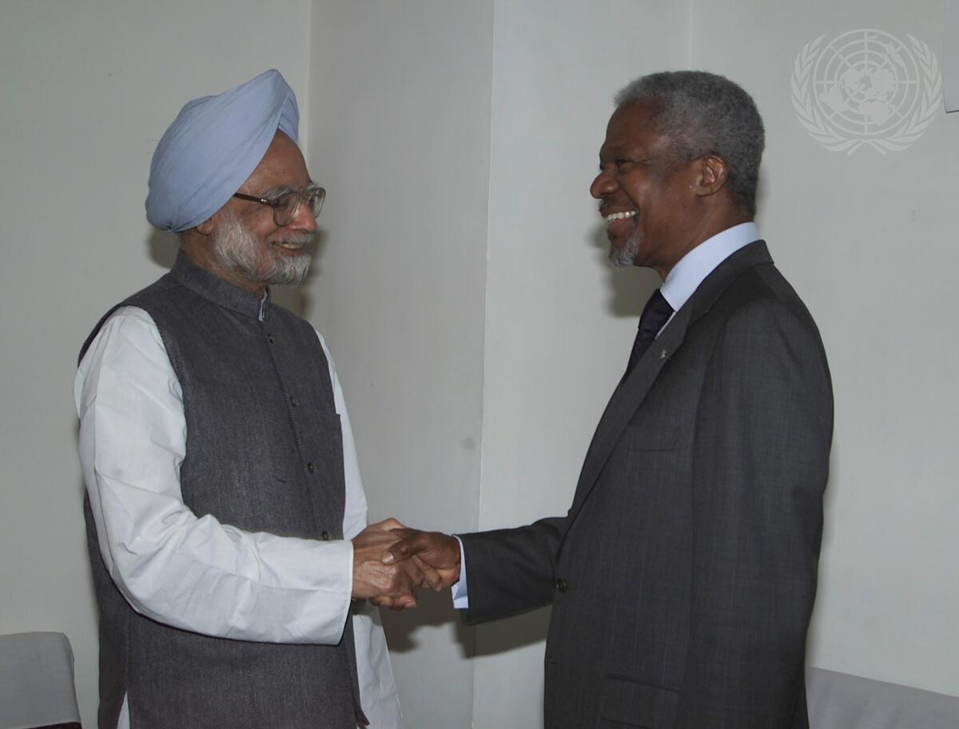
Headline: Secretary-General Visits India
Caption Description: Secretary-General Kofi Annan with Monmohan Singh (left), opposition leader in the Upper House of India's Parliament.
Country: India
Production Date: 3/16/2001 12:00:00 AM
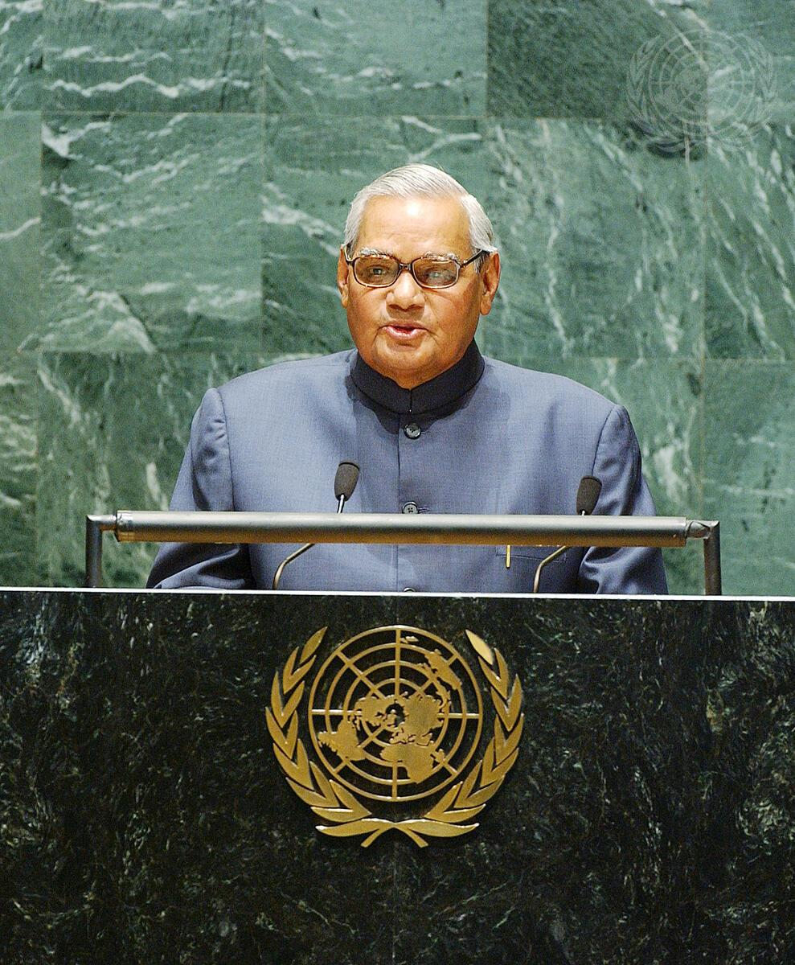
Headline: Prime Minister of India Addresses 57th Session of General Assembly
Caption Description: Atal Bihari Vajpayee, Prime Minister of India, addresses the fifty-seventh session of the General Assembly.
City/Location: New York
Country: United States of America
Production Date: 9/13/2002 11:50:58 PM
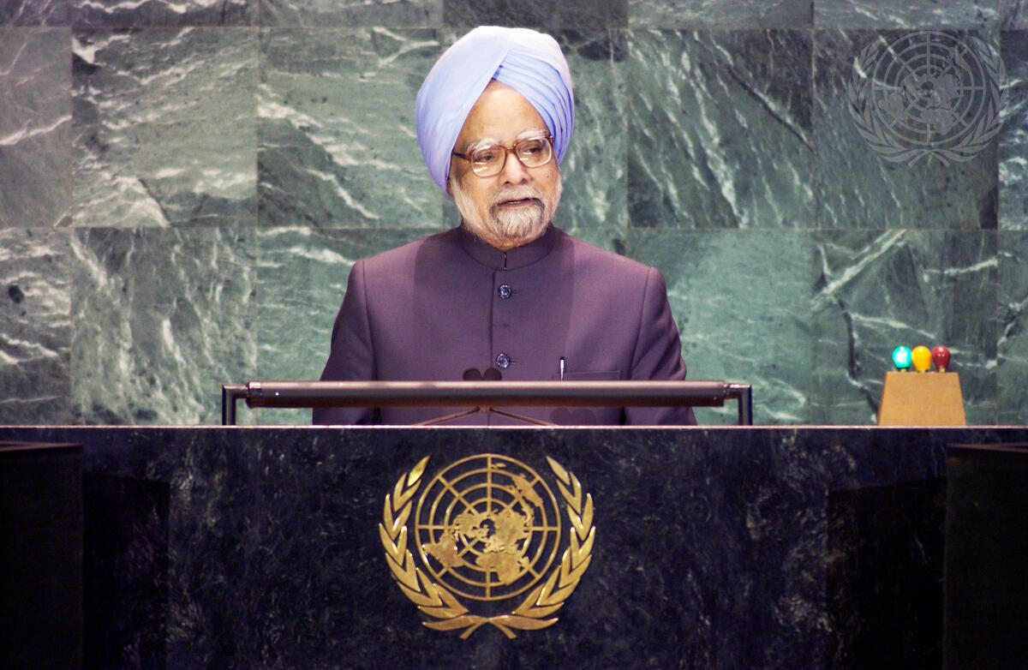
Headline: Prime Minister of India Addresses Fifty-Ninth Session of General Assembly
Caption Description: Manmohan Singh, Prime Minister of India, addressing the General Assembly.
City/Location: New York
Country: United States of America
Production Date: 9/23/2004 10:53:08 AM
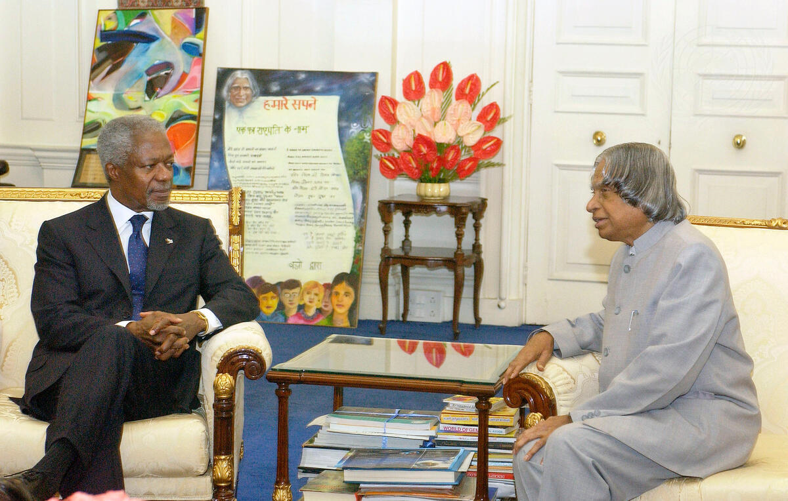

Headline: Secretary-General Meets with President of India
Caption Description: Secretary-General Kofi Annan (left) meets with Avul P. J. Abdul Kalam, President of India, in New Delhi, India, where he is on a state visit.
City/Location: New Delhi
Country: India
Credit: UN Photo/Eskinder Debebe.
Date: 9/23/2004
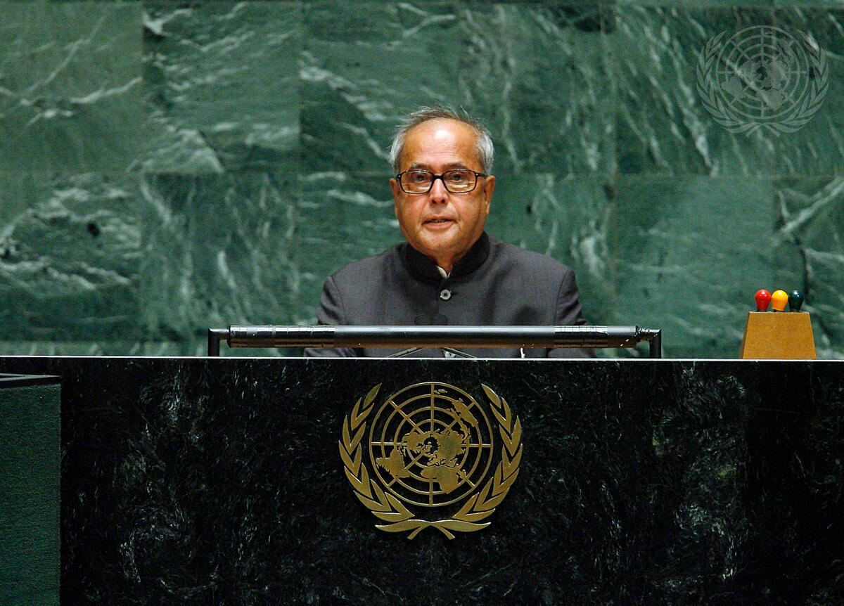
Headline: India Addresses General Assembly
Caption Description: Pranab Mukherjee, Minister for Defence of India, addresses the general debate of the sixty-first session of the General Assembly, at UN Headquarters in New York.
City/Location: New York
Country: United States of America
Production Date: 9/27/2006 2:45:47 AM
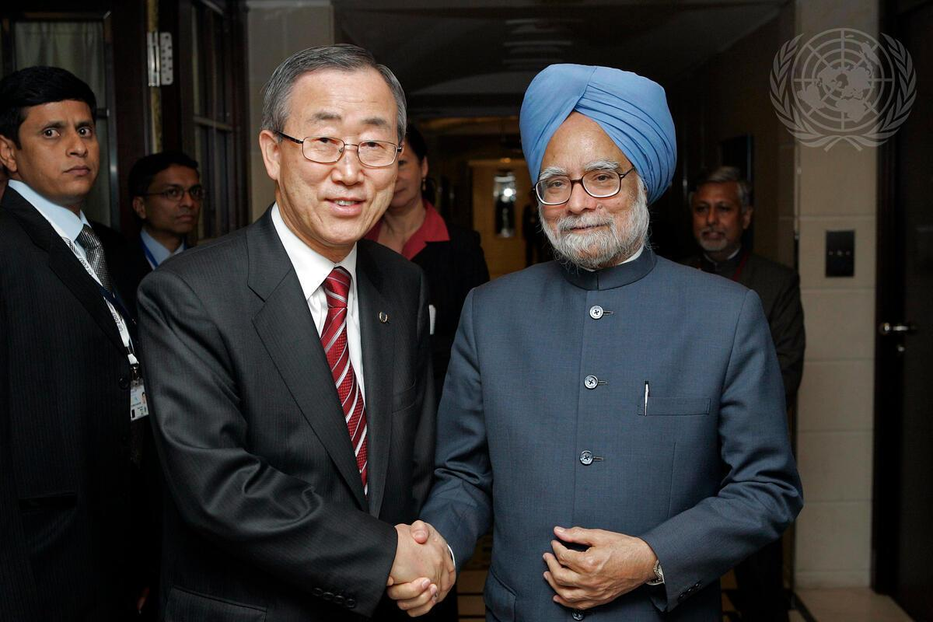
Headline: Secretary-General Meets India's Prime Minister in Germany
Caption Description: Secretary-General Ban Ki-moon (centre) meets with Manmohan Singh, Prime Minister of India at the Adlon Kempinski Hotel in Berlin, Germany.
City/Location: Berlin
Country: Germany
Credit: UN Photo/Evan Schneider
Production Date: 6/7/2007 6:43:15 AM
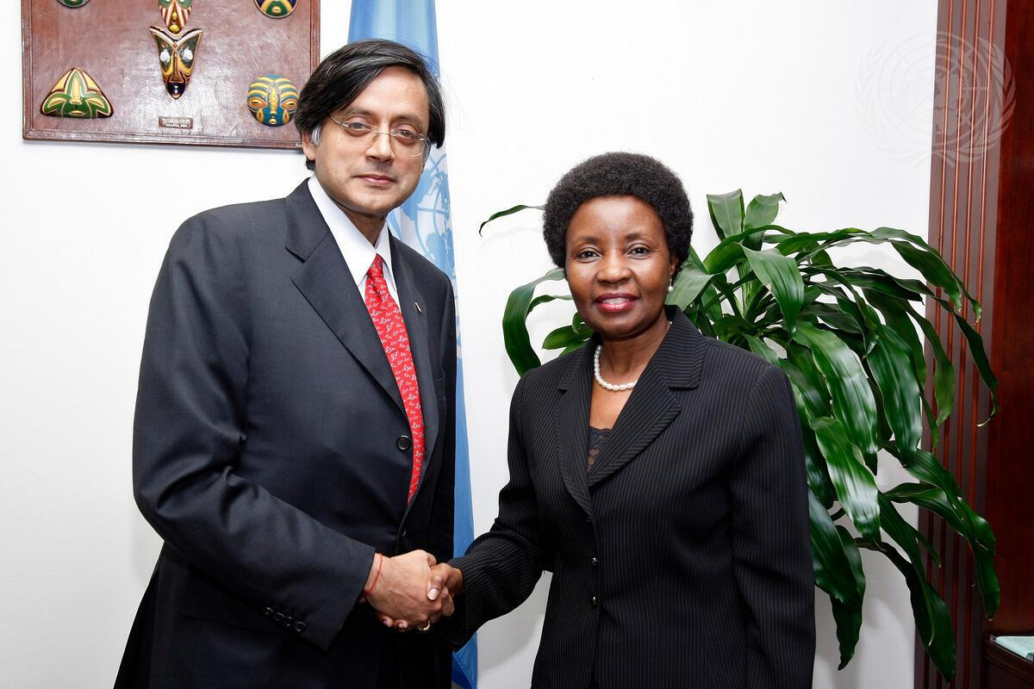

Headline: Deputy Secretary-General Meets Indian Minister of State for External Affairs
Caption Description: Deputy Secretary-General Asha-Rose Migiro (right) meets with Shashi Tharoor, Minister of State for External Affairs of India.
City/Location: New York
Country: United States of America
Production Date: 10/16/2009 10:51:11 AM
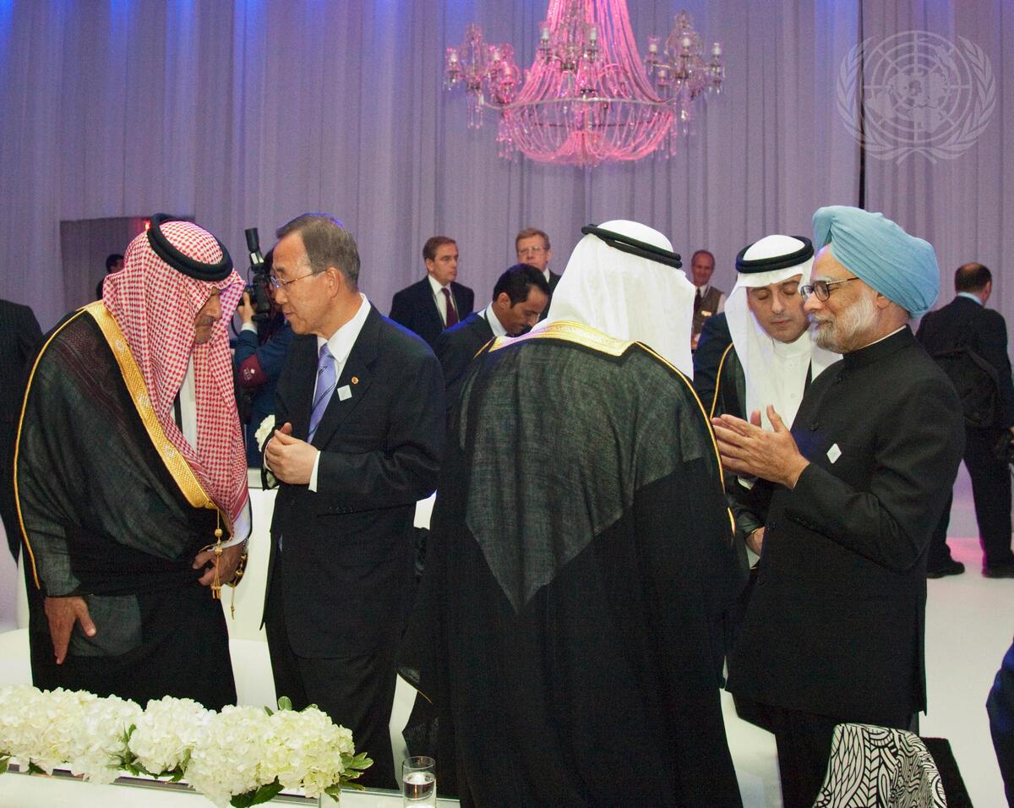
Headline: Secretary-General Speaks with Saudi Foreign Minister at G20 Reception
Caption Description: Secretary-General Ban Ki-moon (second from left) speaks with Prince Saud AlFaisal, Minister for Foreign Affairs of Saudi Arabia, as Saudi King Abdullah Bin Abdulaziz Al Saud (third from right, back to camera) converses with Manmohan Singh, Prime Minister of India.
Country: Canada
Credit: UN Photo/Mark Garten
Production Date: 6/26/2010 7:12:58 PM

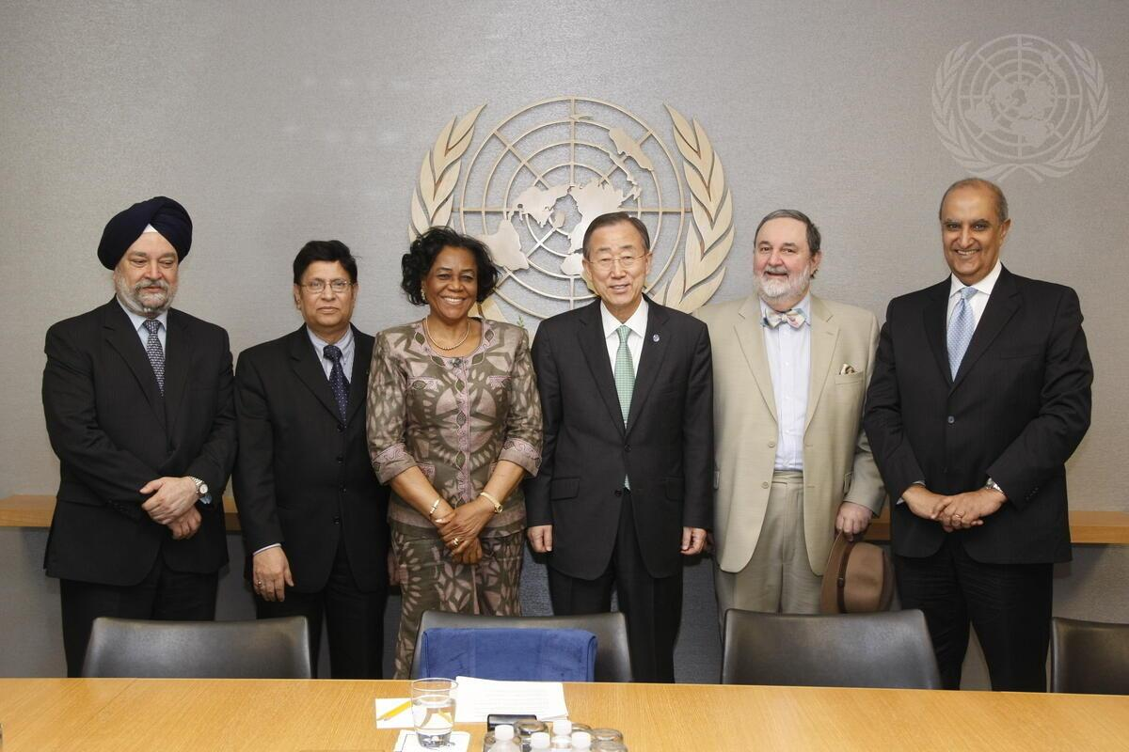
Headline: Secretary-General Meets Representatives of Top Five Troop-Contributing Countries Caption Description: Secretary-General Ban Ki-moon (third from right) meets with the representatives of the top five countries contributing troops to UN peacekeeping operations. From left: Hardeep Singh Puri, Permanent Representative of India to the UN; Abulkalam Abdul Momen, Permanent Representative of the People’s Republic of Bangladesh to the UN; U. Joy Ogwu, Permanent Representative of Nigeria to the UN; Abdullah Hussain Haroon, Permanent Representative of Pakistan to the UN; and Maged A. Abdelaziz, Permanent Mission of the Arab Republic of Egypt to the UN.
City/Location: New York
Country: United States of America
Production Date: 4/11/2011 11:36:52 AM
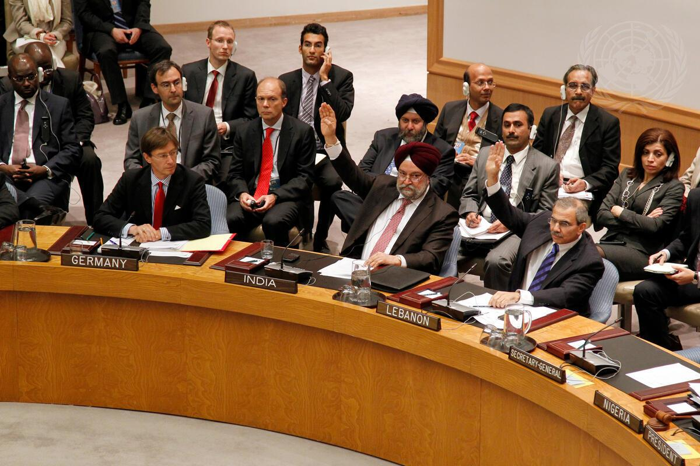
Headline: India and Lebanon Abstain in Security Council Vote on Syria Caption Description: A view of the Security Council as Hardeep Singh Puri (centre), Permanent Representative of India to the UN, and Nawaf Salam, Permanent Representative of Lebanon to the UN, register their abstentions on a draft resolution condemning the ongoing violence perpetrated by Syrian authorities against civilian protesters. The draft resolution was vetoed by China and the Russian Federation, received nine votes in favour and two other abstentions from Brazil and South Africa.
City/Location: New York
Country: United States of America
Production Date: 10/4/2011 6:00:05 AM

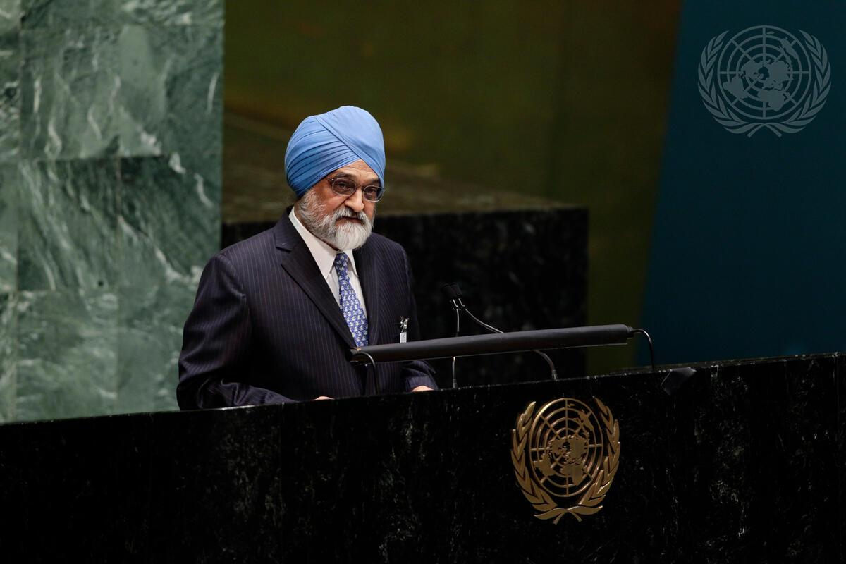
Headline: Deputy Head of India’s Planning Commission Speaks at High-Level Debate on Economy Caption Description: Montek Singh Ahluwalia, Deputy Chairman of the Planning Commission of India, addresses the General Assembly’s debate on “State of the world economy and finance in 2012”.
The high-level event is convened by the President of the Assembly, Nassir Abdulaziz Al-Nassser, and Secretary-General Ban Ki-moon.
City/Location: New York
Country: United States of America
Production Date: 5/17/2012 12:00:00 AM
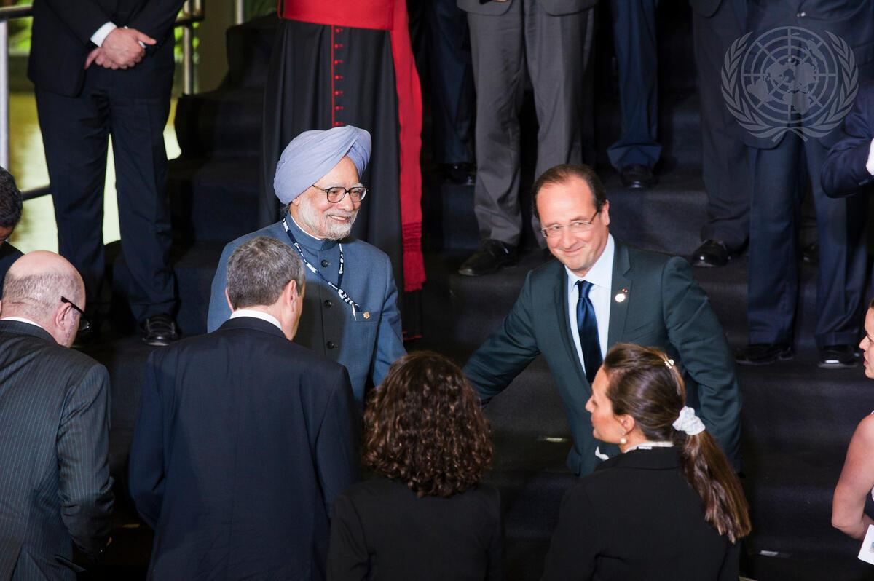
Headline: Heads of State and Global Leaders Gather at Rio+20
Caption Description: Heads of States and Governments gather for a family photo at the opening of the UN Conference on Sustainable Development, dubbed Rio+20. The summit comes twenty years after Rio hosted the UN’s landmark 1992 Conference on Environment and Development and emphasizes global policies for poverty reduction, social equity and environmental protection. World leaders are gathered for the culminating segment in an effort to produce a comprehensive political document based on Sustainable development pillars. Manmohan Singh, Prime Minister of India (left) and François Hollande, President of France.
Country: Brazil
Credit: UN Photo/Mark Garten
Production Date: 6/20/2012 2:02:52 PM
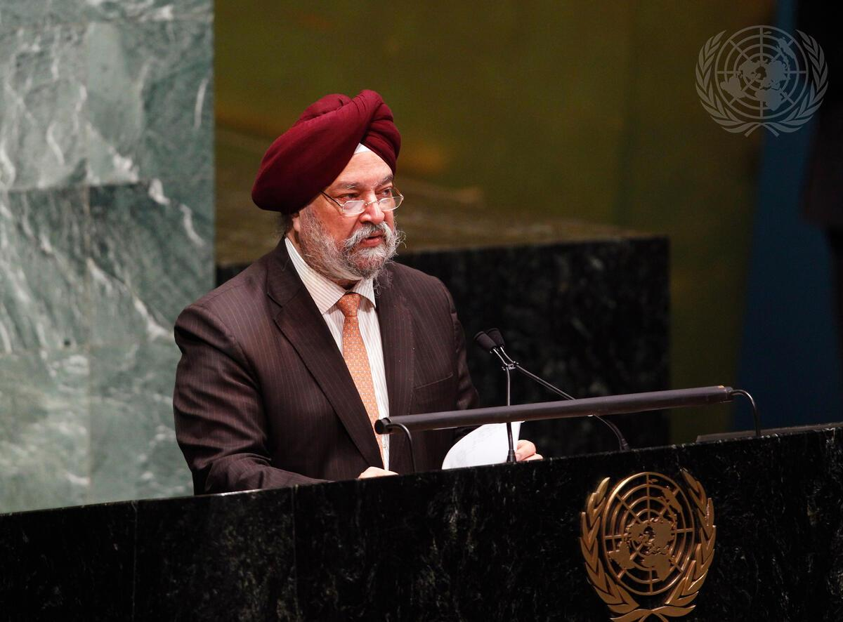
Headline: General Assembly Discusses Situation in Syria
Caption Description: Hardeep Singh Puri, Permanent Representative of India to the United Nations, addresses the General Assembly during a meeting on the situation in the Syrian Arab Republic.
City/Location: New York Country: United States of America
Credit: UN Photo/Rick Bajornas
Production Date: 9/4/2012 12:00:00 AM

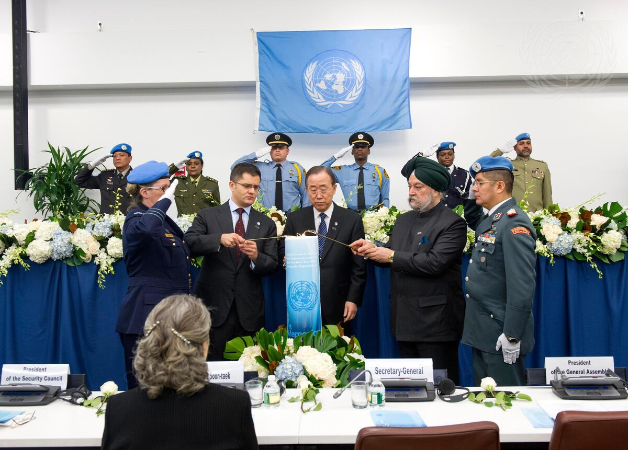
Headline: Annual Memorial Service Held for Fallen Staff Caption Description: The Secretary-General’s annual memorial service for staff who lost their lives in the line of duty is held today, in remembrance of 29 UN colleagues – civilian, military and police – representing 16 nationalities. Secretary-General Ban Ki-moon (centre) is joined by Vuk Jeremic (left of Mr. Ban), President of the sixty-seventh session of the General Assembly, and Hardeep Singh Puri, Permanent Representative of India and Security Council President for November, in lighting a candle during the service.
City/Location: New York
Country: United States of America
Credit: UN Photo/Eskinder Debebe
Production Date: 11/14/2012 11:07:35 AM
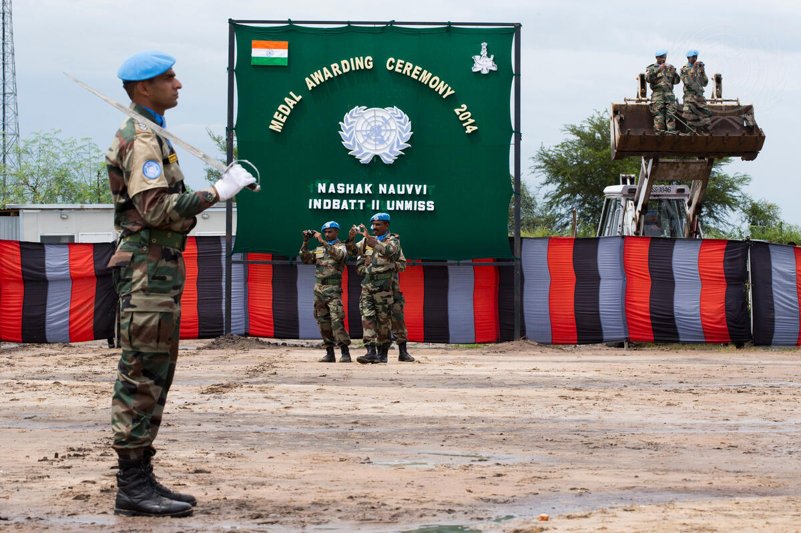
Headline: UNMISS Peacekeepers Attend Memorial Service in Bor
Caption Description: Ellen Margrethe Løj (not pictured), Special Representative of the Secretary- General and Head of the United Nations Mission in South Sudan (UNMISS) attends a memorial ceremony followed by a medal parade in Bor, Jonglei State, for seven Indian peacekeepers who lost their lives while protecting civilians and humanitarian workers in Jonglei’s Akobo and Pibor counties. Peacekeepers from India serving with UNMISS at the memorial ceremony.
Country: South Sudan
Credit: UN Photo/JC McIlwaine
Production Date: 9/29/2014 2:06:28 PM
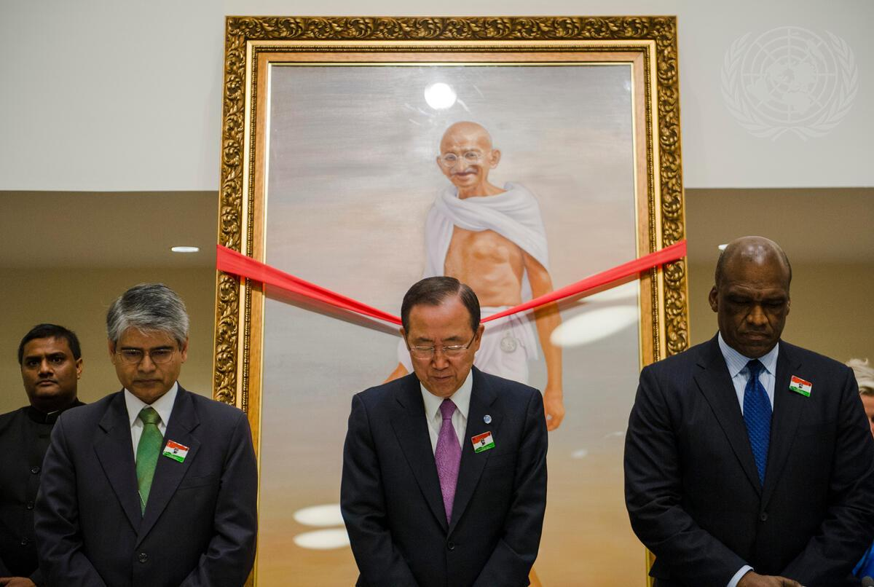
Headline: Observance of International Day of Non-Violence
Caption Description: A special event at the UN marked the annual International Day of Non-Violence on 2 October, the birthday of non-violence pioneer Mahatma Gandhi. From left: Asoke Kumar Mukerji, Permanent Representative of India to the UN; Secretary-General Ban Ki-moon; and John Ashe, President of the sixty-eighth session of the General Assembly; observe a moment of silence and introspection during the event.
City/Location: New York
Country: United States of America Credit: UN Photo/Amanda Voisard
Production Date: 10/2/2013 7:34:47 AM
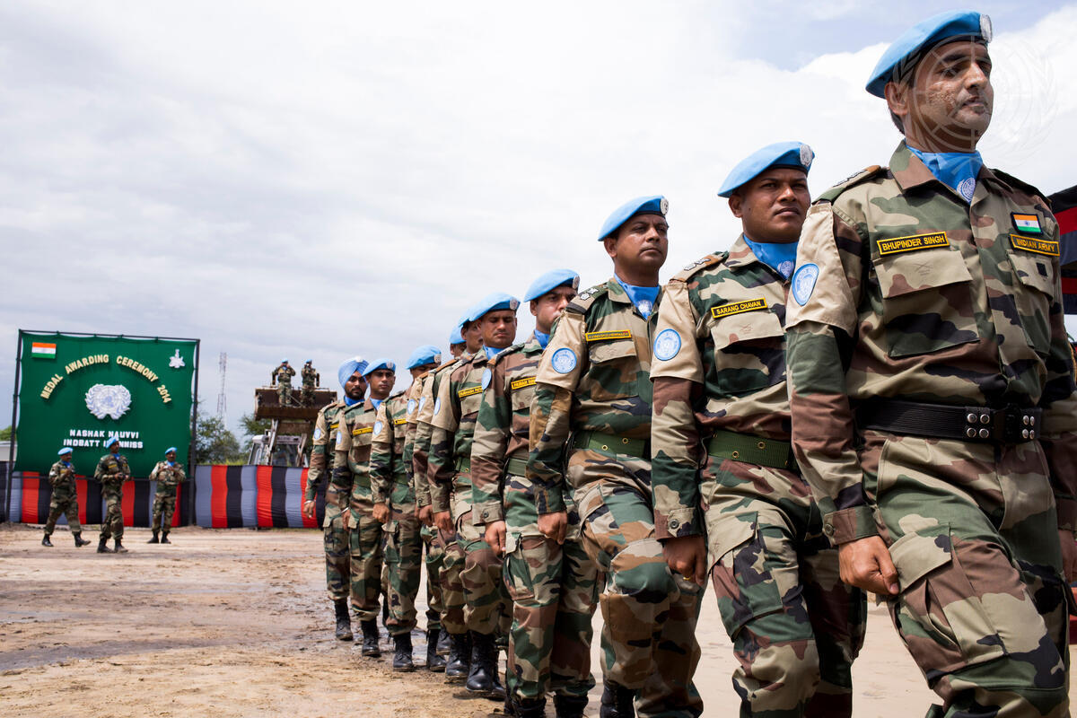
Headline: UNMISS Peacekeepers Attend Memorial Service in Bor
Caption Description: Ellen Margrethe Løj (not pictured), Special Representative of the Secretary- General and Head of the United Nations Mission in South Sudan (UNMISS) attends a memorial ceremony followed by a medal parade in Bor, Jonglei State, for seven Indian peacekeepers who lost their lives while protecting civilians and humanitarian workers in Jonglei’s Akobo and Pibor counties. Peacekeepers from India serving with UNMISS at the memorial ceremony.
Country: South Sudan
Credit: UN Photo/JC McIlwaine
Production Date: 9/29/2014 2:14:37 PM

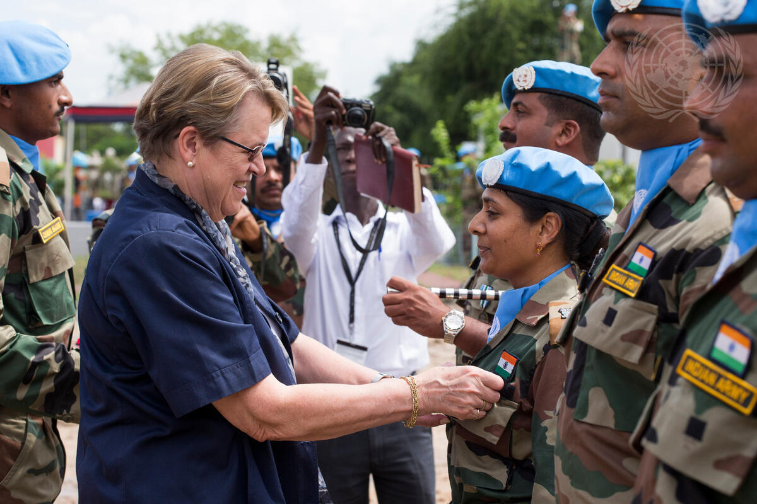
Headline: Head of UNMISS Attends Memorial Service in Bor
Caption Description: Ellen Margrethe Løj, Special Representative of the Secretary-General and Head of the United Nations Mission in South Sudan (UNMISS) attends a memorial ceremony followed by a medal parade in Bor, Jonglei State, for seven Indian peacekeepers who lost their lives while protecting civilians and humanitarian workers in Jonglei’s Akobo and Pibor counties. Ms. Løj (left) awards a medal to a peacekeeper from India serving with UNMISS.
Country: South Sudan
Credit: UN Photo/JC McIlwaine
Production Date: 9/29/2014 2:16:07 PM

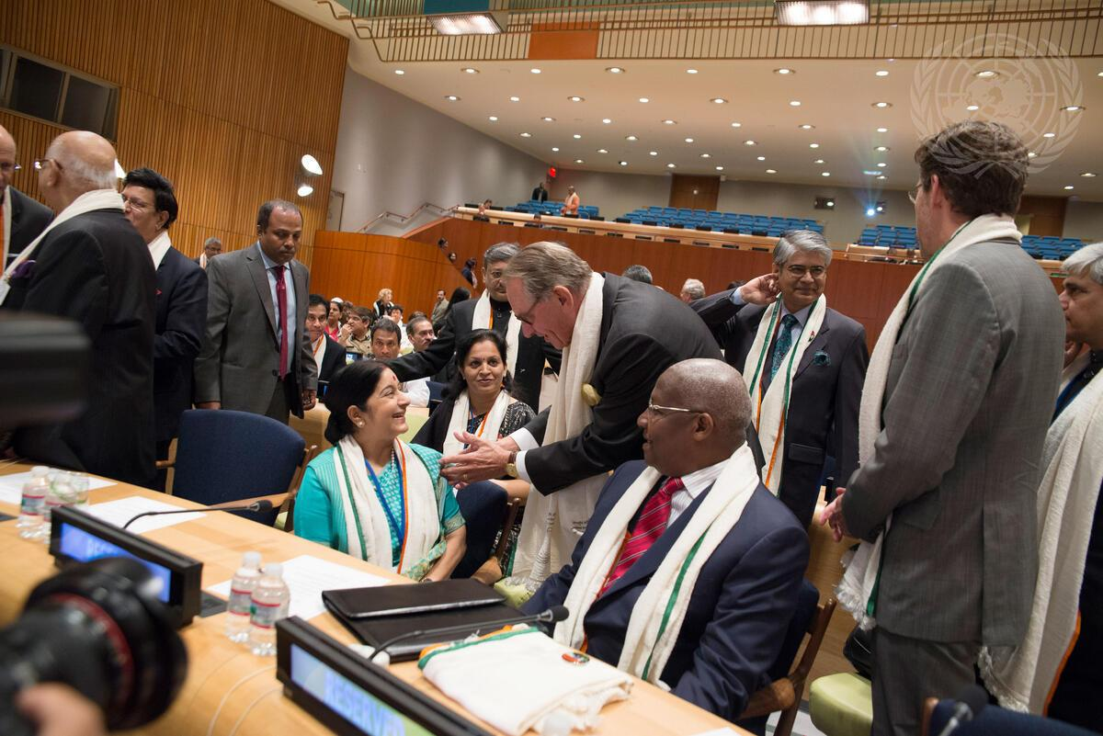
Headline: Commemoration of International Day of Non-Violence
Caption Description: Deputy Secretary-General Jan Eliasson (centre, leaning forward) greets Sushma Swaraj (seated centre left), Minister for External Affairs of India, at the special event on the occasion of the International Day of Non-Violence. The event was organized by the Permanent Mission of India. The Day of Non-Violence is commemorated on 2 October, the birthday of Mahatma Gandhi, leader of the Indian independence movement and pioneer of the non-violence philosophy, as an occasion to disseminate the message of non-violence. Sam Kahamba Kutesa (seated centre right), President of the sixty-ninth session of the General Assembly, looks on.
City/Location: New York
Country: United States of America
Credit: UN Photo/Cia Pak
Production Date: 10/2/2014 11:02:44 AM
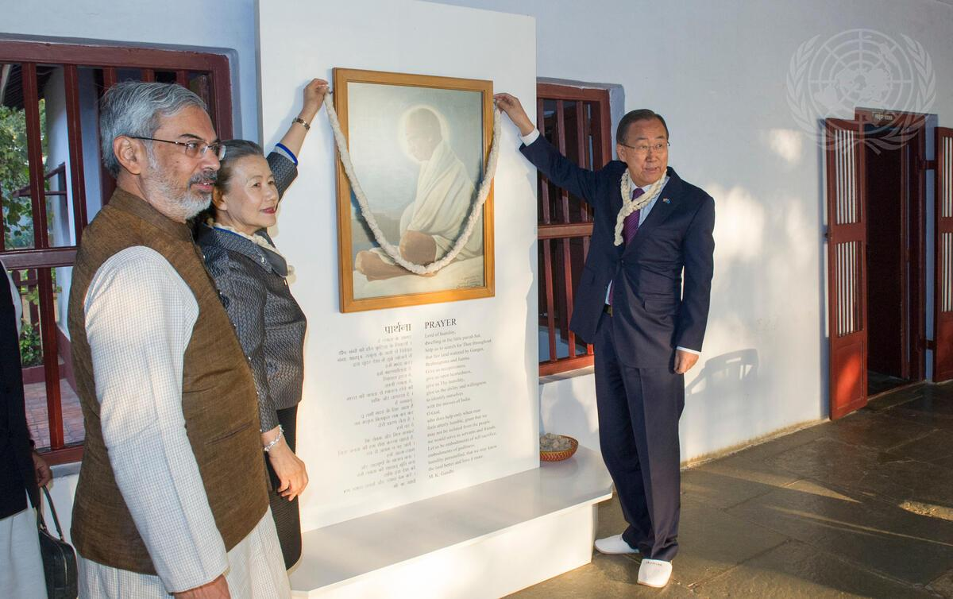
Headline: Secretary-General Visits Sabarmati Gandhi Ashram
Caption Description: Secretary-General Ban Ki-moon stopped at Sabarmati Gandhi Ashram in Gujarat, during his three-day visit to India. The ashram houses a library and museum chronicling the life, work, and teachings of Mahatma Gandhi, the legendary leader of India's independence movement and pioneer of the philosophy and strategy of non-violence. Mr. Ban (right) and his wife, Yoo Soon-taek, during their visit to Sabarmati Gandhi Ashram.
Country: India
Credit: UN Photo/Mark Garten
Production Date: 1/10/2015 9:37:34 PM

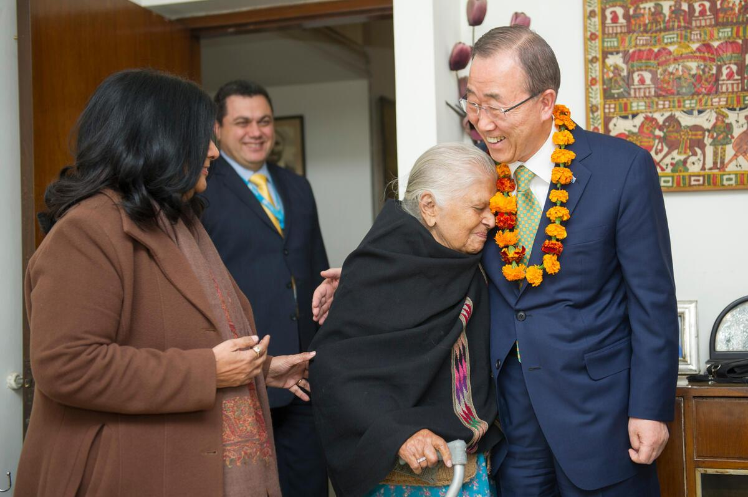
Headline: Secretary-General Visits His First Residence in India
Caption Description: Secretary-General Ban Ki-moon visits his first residence in India and meets with family and residence owners in Delhi, India
City/Location: New Delhi
Country: India Credit: UN Photo/Mark Garten
Production Date: 1/13/2015 4:17:44 AM

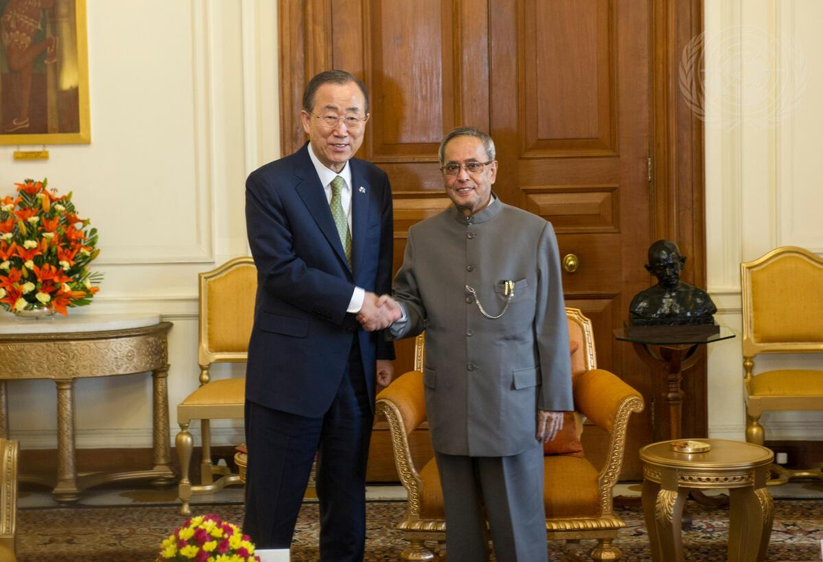
Headline: Secretary-General Meets President of India
Caption Description: Secretary-General Ban Ki-moon (left) meets with Pranab Mukherjee, President of India.
City/Location: New Delhi
Country: India Credit: UN Photo/Mark Garten
Production Date: 1/13/2015 2:01:08 AM

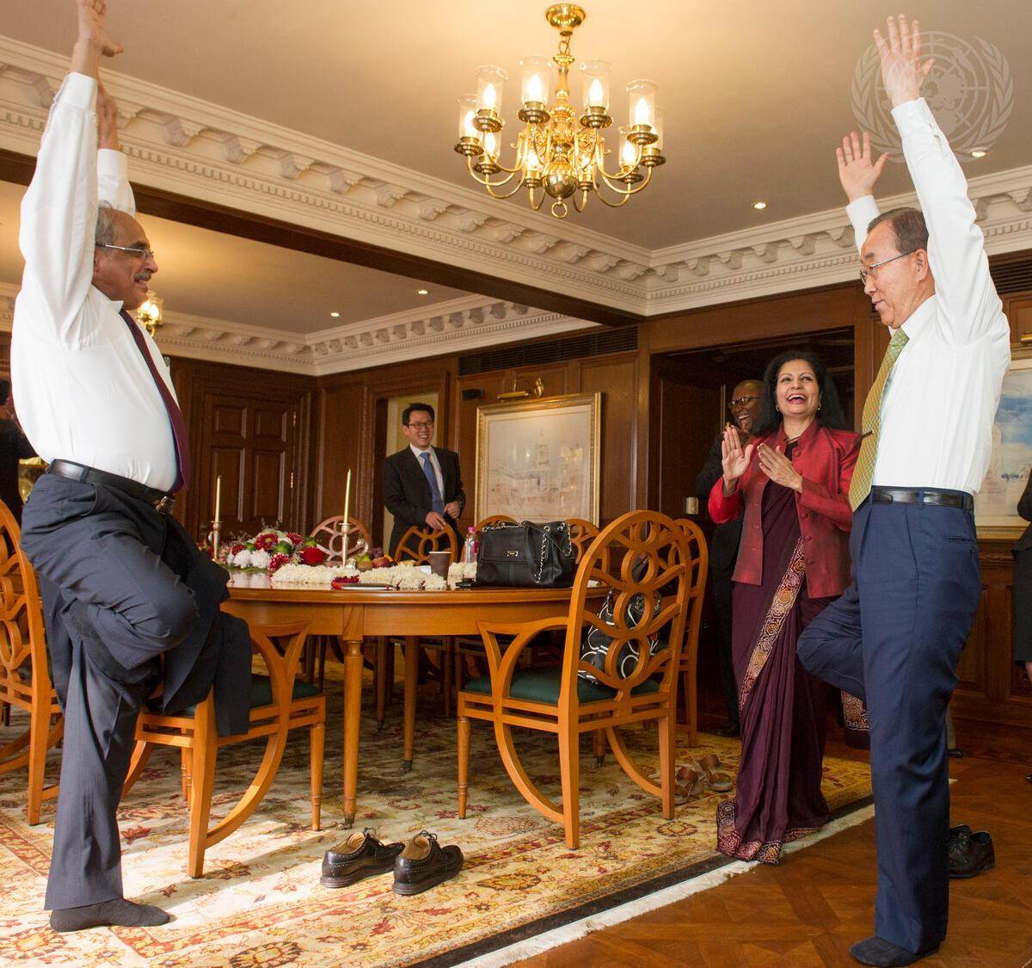
Headline: Secretary-General Gets Yoga Lesson From Vijay Nambiar
Caption Description: Secretary-General Ban Ki-moon gets a yoga lesson from Vijay Nambiar, the Secretary-General's Special Adviser on Myanmar.
City/Location: New Delhi
Country: India
Credit: UN Photo/Mark Garten
Production Date: 1/13/2015 12:03:51 AM
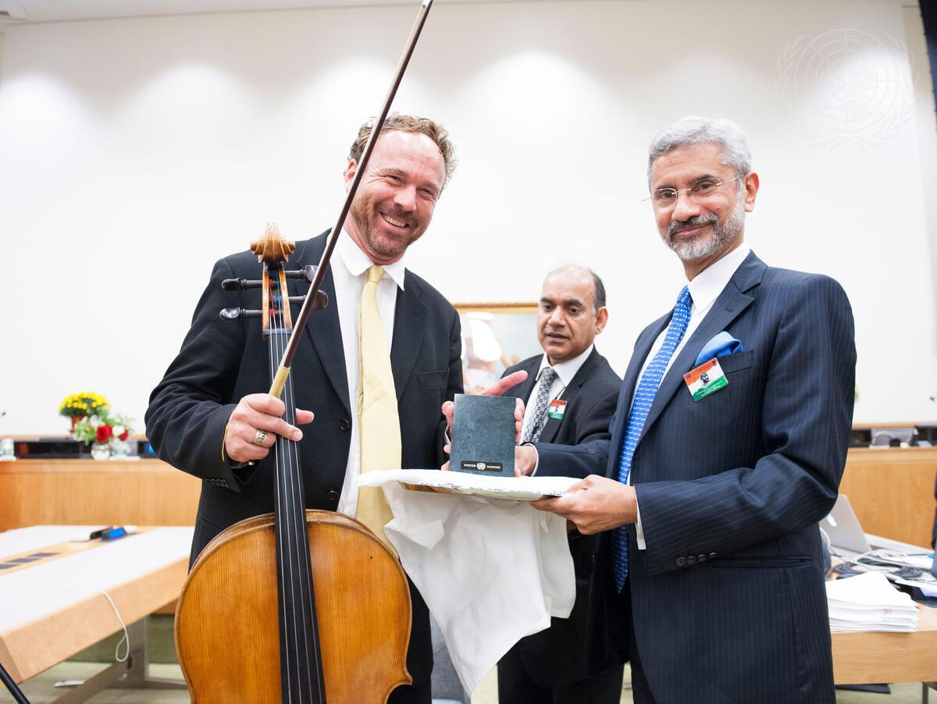
Headline: Commemoration of International Day of Non-Violence
Caption Description: Subrahmanyam Jaishankar (right), Foreign Secretary of India, presents cellist Michael Fitzpatrick (left) a gift after his moving performance during the International Day of Non- Violence, organized by the Permanent Mission of India to the United Nations. The Day of Non-Violence is observed on 2 October, the birthday of Mahatma Gandhi, leader of the Indian independence movement and pioneer of the non-violence philosophy, as an occasion to disseminate the message of non-violence.
City/Location: New York
Country: United States of America
Credit: UN Photo/Kim Haughton
Production Date: 10/2/2015 11:21:28 AM
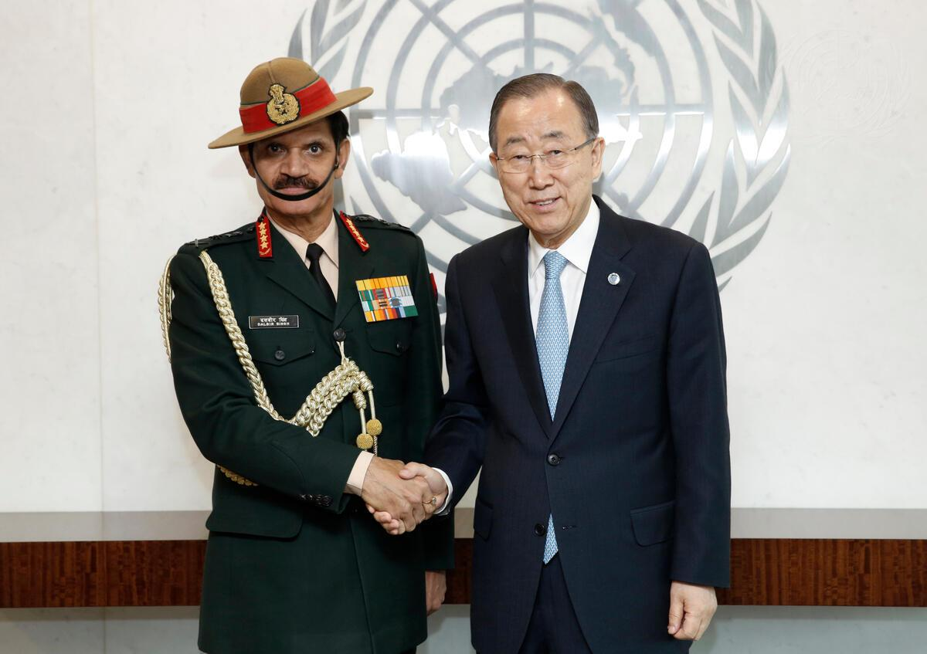
Headline: Secretary-General Meets Indian Army Chief
Caption Description: Secretary-General Ban Ki-moon (right) meets with General Dalbir Singh, Chief of the Army Staff of India.
City/Location: New York
Country: United States of America
Credit: UN Photo/Evan Schneider
Production Date: 4/4/2016 9:40:20 AM

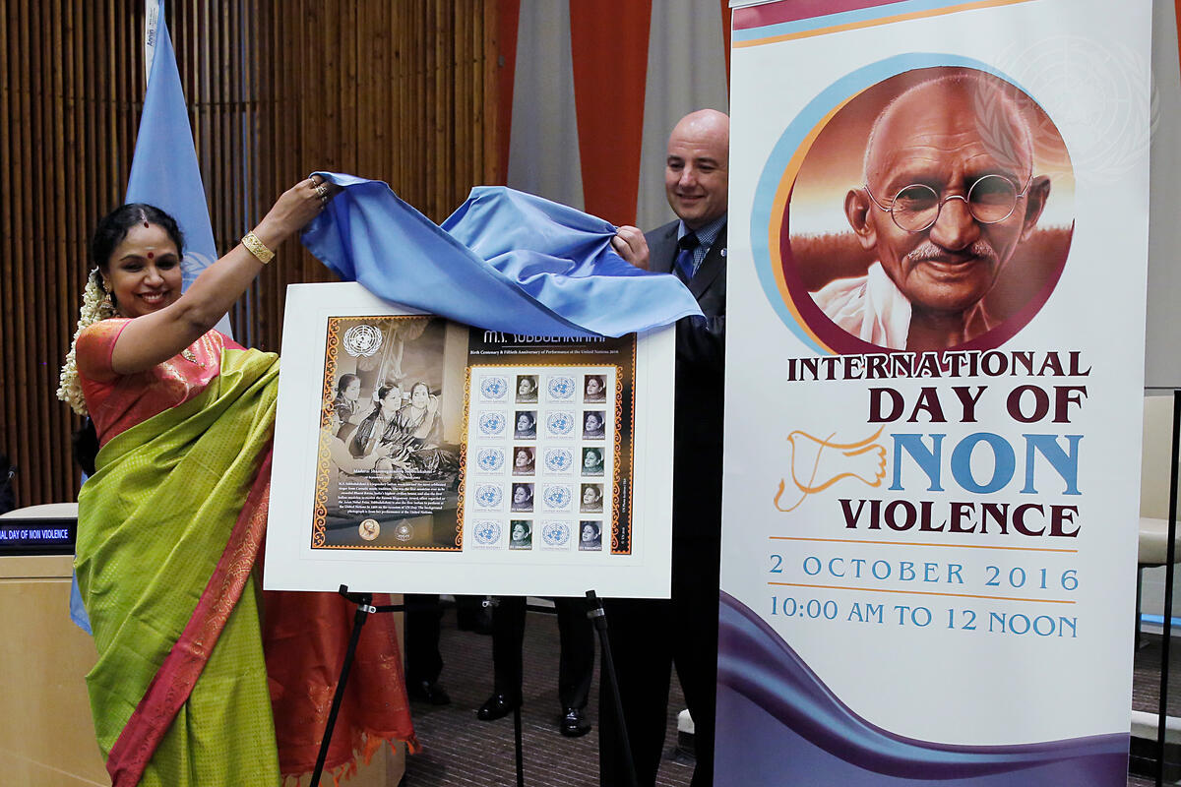
Headline: Commemoration of International Day of Non-Violence
Caption Description: At the special event marking the International Day of Non-Violence, organized by the Permanent Mission of India to the United Nations, Sudha Ragunathan, musician, and Stephen Cutts, Assistant Secretary-General for the Office of Central Support Services, unveil the commemorative stamp of M.S. Subbulakshmi, Indian music legend, on the 50th anniversary of her performance at the UN in 1966. The Day of Non-Violence is observed on 2 October, the birthday of Mahatma Gandhi, leader of the Indian independence movement and pioneer of the non-violence philosophy, as an occasion to disseminate the message of non-violence.
City/Location: New York
Country: United States of America
Credit: UN Photo/Evan Schneider
Production Date: 10/2/2016 11:10:09 AM
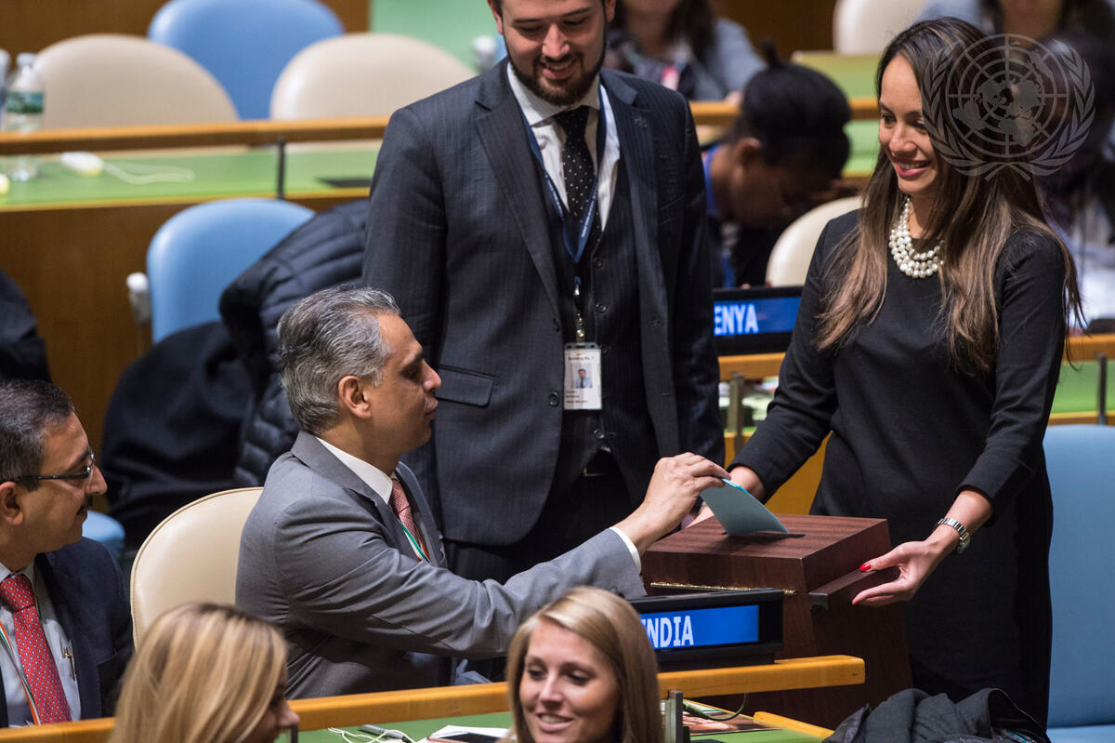
Headline: General Assembly, Security Council Fill Fifth Vacancy on World Court
Caption Description: The General Assembly and the Security Council, meeting concurrently but independently from each other, filled the final vacancy on the International Court of Justice (ICJ). Dalveer Bhandari (India) was elected by both bodies for a nine-year term beginning on 6 February 2018, joining the four justices elected on 9 November from a list of six candidates. Syed Akbaruddin, Permanent Representative of India to the UN, casts his country’s ballot in the General Assembly.
City/Location: New York
Country: United States of America
Credit: UN Photo/Kim Haughton
Production Date: 11/20/2017 4:41:44 PM

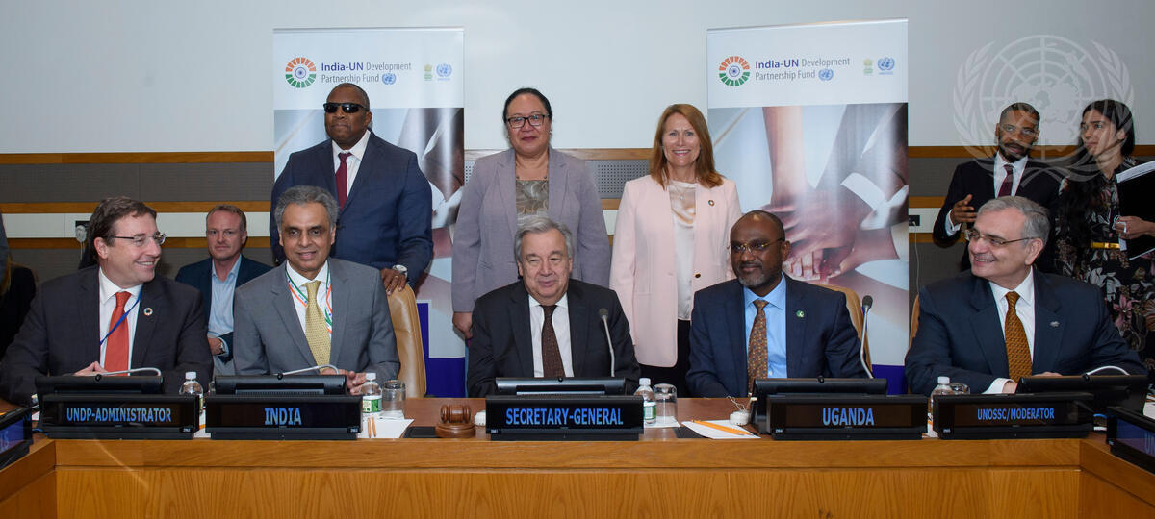
Headline: First Anniversary of India-UN Development Partnership Fund
Caption Description: Secretary-General António Guterres (centre) participates in the
commemoration of the first Anniversary of the India-United Nations Development Partnership Fund. Left to right seated: Achim Steiner, Administrator of the United Nations Development Programme (UNDP); Syed Akbaruddin, Permanent Representative of India to the UN: Mr. Guterres; Adonia Ayebare, Permanent Representative of the Republic of Uganda; Jorge Chediek, Director of the United Nations Office for South-South Cooperation (UNOSSC) and Envoy of the Secretary-General on South- South Cooperation.
City/Location: New York
Country: United States of America
Credit: UN Photo/Loey Felipe
Production Date: 6/8/2018 1:16:08 PM

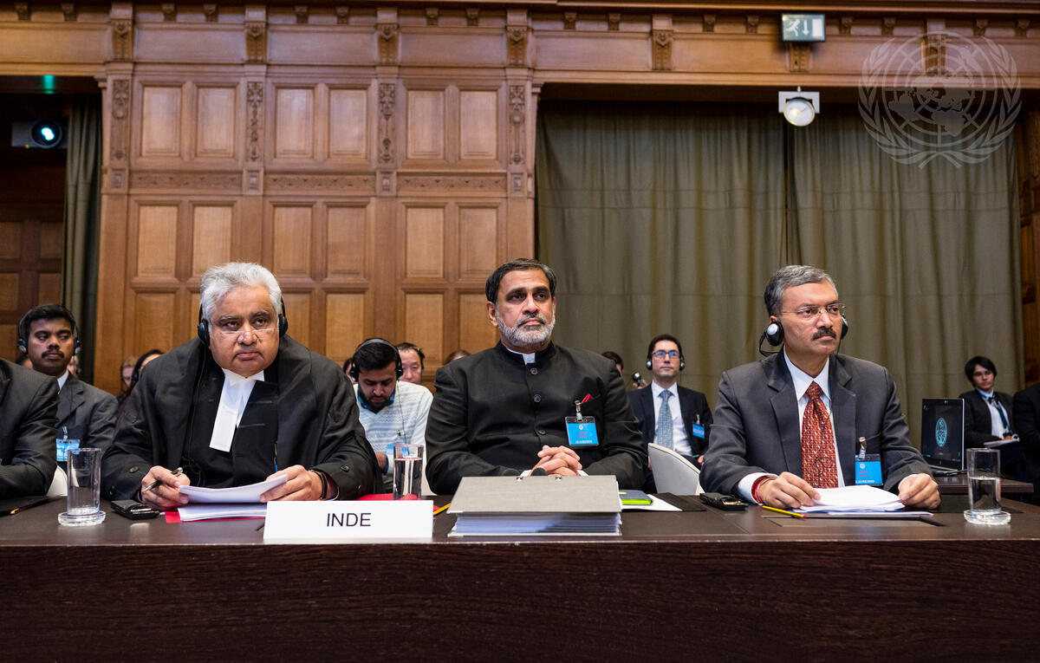
Headline: International Court of Justice Hears Jadhav Case
Caption Description: The International Court of Justice (ICJ), principal judicial organ of the UN, holds public hearing in the Jadhav Case (India v. Pakistan) from 18 to 21 February 2019 at the Peace Palace in The Hague, the seat of the Court. The hearings, held under the presidency of Judge Abdulqawi Ahmed Yusuf, concern the merits of the case. The Court’s role is to settle, in accordance with international law, legal disputes submitted to it by States (its Judgments are final and binding) and to give advisory opinions on legal questions referred to it by authorized UN organs and agencies.
Members of the Delegation of India on the first day of the hearings.
Country: Netherlands
Production Date: 2/18/2019 10:10:10 AM

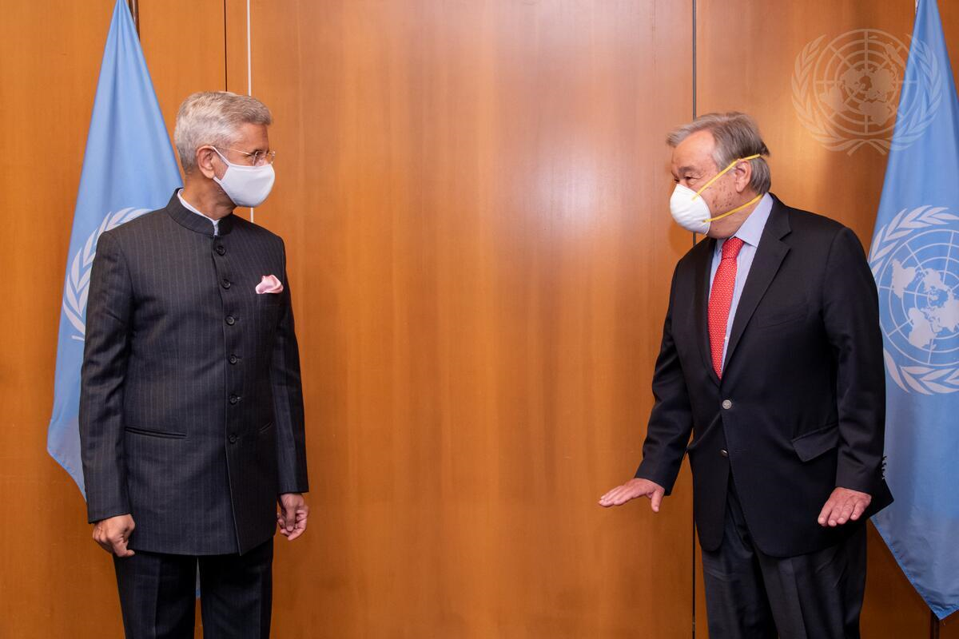

Headline: Secretary-General Meets with Minister for External Affairs of India
Caption Description: Secretary-General António Guterres (right) meets with Subrahmanyam Jaishankar, Minister for External Affairs of the Republic of India. City/Location: New York Country: United States of America
Credit: UN Photo/Mark Garten
Production Date: 5/25/2021 9:50:27 AM

We thank the United Nations Photo Library for assisting us and providing photos which expedited the project and its objective. This album was prepared by student members of Jindal Society of International Law Ayman Khan, Arjan Chonker, Sai Akshantala and President and Co-Founder, Ankit Malhotra.

